**Google's tool for Keyword Planning**

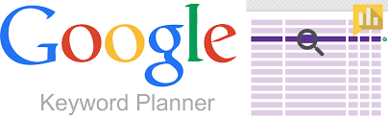

**BY**

**FARDINA KABIR**

**1910080005**

**1910080005@students.stamford.edu**

**Course Instructor: Dr. Surekha Lanka**

**Department: Information Technology**

# September,2022

**UNDERTAKING**

I declare that the work presented in this project titled “Google's tool for Keyword Planning”, submitted to the Name of the Department, Faculty of Business & Technology, Stamford International University, This is my original work. I have not plagiarized

September, 2022

Stamford International University



________________________________

(Fardina Kabir & 1910080005 )



**CERTIFICATE**

Certified that the work contained in the project titled “*Google's tool for Keyword Planning*”, by Fardina Kabir, has been carried out under my supervision and that this work has not been submitted elsewhere for a degree and university can use the project for references and any other works.

By Student Name: Fardina Kabir

Student ID number: 1910080005

Semester & Year : Term 1-2022

Dr. Surekha Lanka

Dept.BSc-IT Program

**INDEX PAGE**

**1.Abstract 6**

**2.Introduction 6**

**3.Architectural goals and constraints 8**

**4.Architectural Representation 11**

**5.Analysis and Design 68**

**6.Architectural View Decomposition 85**

**7.Implementation View 101**

**8.Data View 105**

**9.Testing 111**

**10.Size and Performance 120**

**11.Quality 121**

**12.Limitation of the system 121**

**13.Conclusion 121**

**14.Bibliography 121**

**15.Extended work 122**

**References 123**

**1. Abstract**

In this architecture report, I will be presenting the design of Google Keyword Planner (GKP), which is a good place to arrange our keywords for research. GKP is a free tool, that serves dual functions, gives competitive information, and makes it simple to create Google Ads campaigns. Although GKP may provide insights into keyword targeting, being aware that campaign performance is dependent on some factors. The information that we would be able to find in Google Keyword Planner includes exact monthly search volumes or ranges, , mobile search volumes, keyword ideas based on your main seed keyword, competition in Google Ads, suggested bids, Ad impression share forecasts for impressions and clicks based on our bids, forecasts for locations and devices, organic average position and impression share. The success of our campaigns may be determined by elements like bidding, budgeting, product, and consumer behavior. In this report, we can observe the design of the GKP, how the tool works, the functional and non-function requirements of the tool, and how google would be able to deploy the tool as well.

**2. Introduction**

**2.1. Purpose**

The Google Keyword Planner (GKP) tool is useful for coming up with effective keyword lists and helping users begin their PPC (pay-per-click) campaign for Ads. The free tools provided by Google Ads for generating keyword recommendations and bid estimations would be used to organize our marketing strategy. We would use the Google Ads Keyword Planner to find ideas for keywords and ad groups, analyze the performance of a list of keywords, and even combine keyword lists to generate new ones. The GKP Tool allows us to assess how a list of keywords could perform in addition to all of these other aspects. There are a number of strategies we would employ to develop our campaign that is part of the principles of using the Google Ads Keyword Tool.

Features like simple filters that help us concentrate on our target and budget are being looked at when a potential consumer searches for what users have to offer. Four alternatives are shown to us when we first use the Keyword Planner: search for new keywords, which enables us to enter a phrase, website, or category to get new ideas. Then, acquire search volume and trends, which provide the historical trending and search volume statistics of keywords, merge two different lists that we'll enter to build new keyword combinations. After that, receive a click and cost performance projection to get estimates of how well our keyword lists will perform depending on our budget and average bids [1].

When we enter keywords into any of these options, we will get a list or report that we can filter depending on a variety of factors. One of these criteria is reach, which includes firstly, the location, which offers search traffic data and trends based on a specified geographic region or range. Additionally, the language offers details on trends and search activity for that particular language. This would be really useful if our website has many language versions or pages. The later search network establishes the origin of the provided data. The data supplier is Google by default, but we can also choose Google and Google Search Partners. Finally, Negative Keywords remove any words or phrases that we don't want to appear in our results from the list.

We would enter a specific date range in the data range element to view the usual monthly searches for a certain time frame. We compare two different time periods. This will be particularly useful in determining whether various keywords perform better during particular times of the year, which will assist us to schedule the timing of our advertisements. The keyword filters element also includes organic impression share, which measures the proportion of times a page from our website appeared in a regular, unpaid web search for a keyword, and ad impression share, which divides the number of times people will see our ad by the total number of searches that exactly matched our keyword in the last month for our selected location and network.

The number of searches is another aspect that filters keywords based on typical monthly searches for selected dates; keywords with a particularly high search volume are more difficult to rank for and have higher suggested bids. The cost-per-click (CPC) that other advertisers are paying for keywords with the same location and search network settings as those we've selected is taken into account when determining our suggested bid, as well as the organic average position, which shows how pages from our website rank in comparison to other pages in organic, unpaid searches. The ability to view keyword alternatives as one of the components of keyword filters and to better manage our budget are both made possible by suggested bid.

We would arrange keywords based on how difficult it will be to rank highly with them by utilizing competition as one of the keyword criteria. For small companies, it is often advisable to filter for this range since it tends to have a lower suggested bid, allowing us to spend more of our money. We can choose to filter by high, medium, or low difficulty. Last but not least, we would further filter our search results using the element keyword options to only show ideas that are closely related to the search terms or content we input, as well as any keywords that are already in our strategy [2]. The preference for good keywords over many of them is another trait. GKP doesn't fully exploit many keywords; instead, it employs high-quality ones, allowing us to generate unique keyword suggestions, select keywords that are relevant to our sector, and identify brand-new terms and phrases that prospective customers are using to search for businesses like ours for example.

**2.2 Scope**

The GKP tool gives us the opportunity to investigate Google-recommended keywords as a feature created by Keywords in order to gain new insights or longer-form keywords we may not have previously considered by entering terms or phrases pertinent to our business or website. Select the product categories that most properly describe the items offered by our company from the list of terms that are often searched in our sector. By doing this, we can learn the keywords that customers used to find companies like ours. When a page from our website (or any other website) is inserted into a landing page, the software will read that page and provide pertinent keywords.

Customers can utilize the feature that displays our advertisements to our geographic audience when the Keyword Planner's filters enable us to select where our ads appear based on language or region. If, for example, our business has a physical location and we want to reach more people who are searching nearby, this would be extremely useful. We may use a feature in GKP to foresee what our competitors will charge. The level of keyword competition might greatly raise their costs. The level of competition for a term is categorized as low, medium, or high based on the number of other bidders. If we pick high competition keywords, it could be harder—and more expensive—for our ad to get a top viewing position. For terms with intense competition, the average bid costs rise.

The Google Ads keyword tool can assist us in finding profitable terms that are within our price range by displaying the keyword prices paid by marketers that are our rivals. The suggested bid column for the tool displays the average cost to be ranked first for a specific keyword. We can organize our campaign around the relevant keywords that are within the scope of our financial capabilities to increase the likelihood that potential consumers will find us. To help us make the most of our money resources, we can analyze our approach and identify phrases that are likely candidates. After adding the keywords to the plan, we would set a daily spending cap, maximum bid, and location to get a complete analysis of the potential of the keywords we've chosen [3]. Thus, the Google Ads Keyword Planner is a useful tool for establishing an effective PPC campaign. This tool will help us change our keywords for more success regardless of our budget or the size of our organization. Remember these suggestions for utilizing the Keyword Planner tool in order to make sure that our internet marketing campaign is successful.

**2.3Acronyms or abbreviations:**

*PPC(Pay-per-click)

*CPC(Cost-per-click)

*GKP(Google Keyword Planner)

*Google Ads (On Google Ads, an online marketplace for advertising, companies may put bids to have their movies, service offerings, or short ads displayed to website visitors. Ads may be found on videos, non-search websites, mobile applications, and the search engine results pages of search engines like Google Search.)

**3. Architectural goals and constraints**

**3.1. Technical platform**

Google's massive relational tables (smart spreadsheets), data storage, processing, and machine learning capabilities are used to arrange the keyword data. Marketers are now able to quickly and accurately find the best keywords for their brand thanks to this amazing computational achievement. It shares this information without charge via the Google Ads API, according to its documentation, in order to "freely promote innovation."

Giving out raw data and offering free software training has been quite profitable for Google. In the history of open source, it is an enormous business move. Google will be able to sell more advertisements the more people who understand search engine marketing and how to leverage keyword data [1].

Google's preferred desktop operating system is Ubuntu Linux. San Diego, CA: Most Linux users are aware that Google uses Linux on its servers, desktop PCs, Apple iOS, and Android OS platforms [2]. Some individuals are aware that Google favors the Goobuntu Linux distribution of the Ubuntu operating system. Internet access, an Android, Apple, or Linux desktop/laptop combination, and smartphones with the ability to install the Google app are commonly necessary pieces of hardware for utilizing the GKP.

**3.2 Transaction**

Even though it is created for advertising, Google Keyword Planner has a lot of SEO value. To begin with, it is absolutely free and serves as a good starting point for locating keywords for the organization. [3]. We don't need to use any transaction methods to use GKP because we may use it for free to identify new keywords related to the firm and get estimates of the searches they receive as well as the cost to target them.

**3.3 Security**

In Google's early years, all Google Ads clients, regardless of ad expenditure, had free access to Keyword Planner data. However, Google has significantly curtailed what is offered in the keyword planner for free in order to "protect user privacy" and business interests. Before using Google Keyword Planner, a Google account is required for security reasons, and after creating an account, Google Ads will ask us to build a campaign. By choosing "Create an account without a campaign," the user may skip this stage. In order to save money on advertising, this is done. Enter the company's location, currency, and time zone. After filling out the form, place the mouse pointer over the "Submit" button and click. After that, the process of creating a Google Ads account will be finished. The creation of a Google Ads account will then be completed. We'll be sent to the Google Ads screen after selecting "Explore Your Account" [4]. As a result, the tool's security needs a user authentication account with credentials input.

**3.4 Persistence**

As long as we have a Google Ads account and are signed in, we are permitted to use the tool. Google advises delivering planning notifications weekly rather than monthly or quarterly until markets settle if users are affected by market fluctuations.

The daily forecasts from Keyword Planner are based on the preceding 7–10 days and take seasonality into consideration. Any market developments that have taken place over this time period will be taken into account in the users' estimations. Google's seasonal model has been modified to take into account the state of the market [5].

**3.5 Reliability/Availability**

Google started classifying keywords in 2016 to raise the standard of website content. The most important tools for keyword research are keyword planners. They are used by a variety of online marketers and websites to attract visitors. Buyers must use different tools to cross-check their keyword choices if they want guaranteed results[4].

The majority of keyword research tools use the Google Keyword Planner for their data. Given that Google is the most used search engine and holds a market share of more than 70%, this makes it reasonable. Based on their queries, Google compiles a lot of user data.

For individuals who spend money on Google Ads, Google has changed its tools in recent years to make them more beneficial. Users require a Google Ads account even though they don't need to have an active ad campaign to access their features. Google only offers a range of search volumes, such as "10-1000," when users are not active Adwords marketers. This is clearly much less effective given the potential wideness of the ranges.

Another element impacting accuracy is that Google frequently combines related keywords together. This might make choosing which precise keyword or key phrase is best for customers difficult. For example, "using social media" and "how to use social media" might be combined. This may appear to be a little distinction, but knowing the search volume of each word allows users to be more accurate in their SEO.

This keyword combination may dramatically overstate the volume of some keywords relative to their actual value. Additionally, it may be annoying since terminology with completely different meanings may be used, obscuring the issue and making it challenging to determine what the users are actually seeking. Users should thus always combine keyword research tool data with a semi-manual examination of search engine results pages (or SERPs) to ascertain the kinds of material Google expects to find for a given query.

When we simply consider Google's statistics, we are leaving out information. We are unable to determine if users of other search engines engage in comparable or dissimilar browsing

habits. In addition, different keyword search tools may produce wildly dissimilar results even when they get their information from Google Ads.

Although search traffic data is significant, employing the tools truly makes it impossible to determine how precise each result is. Nevertheless, many companies have succeeded in making planning decisions based on the facts they discover [6].

**3.6 Performance**

Customers will be able to acquire click and cost performance estimates when they first utilize the Keyword Planner, which provides users with performance forecasts for their keyword lists based on standard bids and their budget [7].

The keyword planner is one of the suggested and required setups when utilizing Google Ads. The next part focuses on the hardware specifications of the device for proper system performance. [8]

Computer models with at least an EPEAT Silver certification are employed for sustainability (preferably EPEAT Gold). The Google program works well on these PCs since they are meant to be readily recycled and fulfill the most recent ENERGY STAR criteria.

Use the following components for the best system performance on a laptop computer[8]:

The following minimum laptop computer specifications, which clients may use to connect to a big network is supported.

CPU: Intel Core i5 (sixth generation or newer) or equivalent. The operating system is Microsoft Windows 10 x64. Memory features 8 GB RAM. The internal storage drive has a capacity of 500 GB. With a 13-inch LCD display. Wireless adapter 802.11ac 2.4/5 GHz for network adaptor. A lock and a carrying bag are also included.

The following desktop PC specifications are supported.

CPU: Core i3 (sixth generation or newer) from Intel or a comparable model. The OS is Windows 10 x64 from Microsoft. Memory comes with 8 GB of RAM. Drive for internal storage with a 500 GB capacity.

For display, a 15-inch LCD monitor is employed. Another choice is to use a wireless 802.11ac 2.4/5 GHz adaptor.

Tablet computers are gaining popularity in all settings and offer an innovative method of taking notes. Tablets with the aforementioned qualities are occasionally used in place of a laptop when paired with a keyboard. Windows, iOS, and Android are the operating systems of modern tablet computers. The operating system and the hardware of the device define the device's capabilities and the number of apps available.

**3.7 Internationalization**

Google today operates in 219 countries, offering its features including the Google Ads Keyword Planning tool and other services to customers globally, with the exception of four countries, namely China. North and South Korea, as well as Russia. Many of us consider Google to be a vital and omnipresent service [9]. However, internet users in the four countries listed above use other apps as alternatives to google.

**4. Architectural Representation**

**Logical View**

**Entity Relations** Relationship diagrams for Google Ads entities are shown on this page, along with images[1].

**Notation legend**

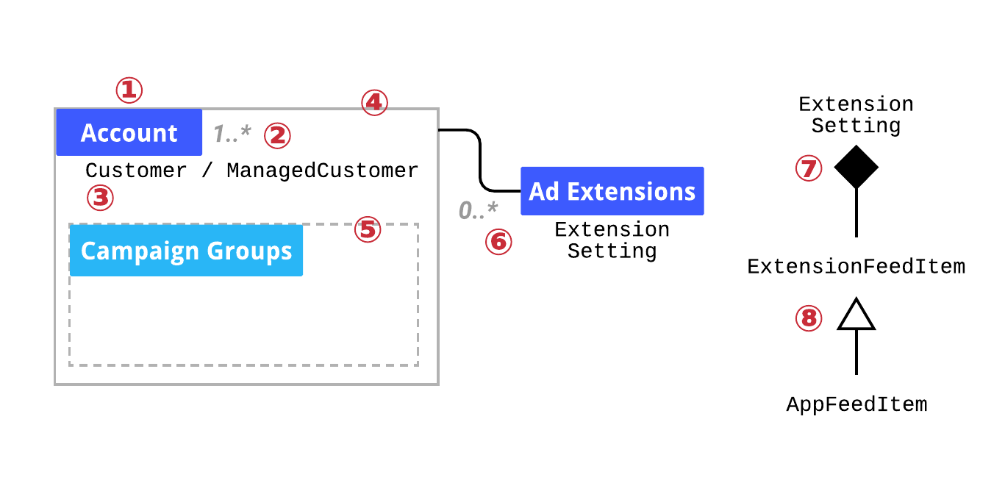

**Entity**: refers to the best suitable guidance.

**Cardinality:** The maximum count. 1....* means one or more are allowed. This does not imply no limits. Object/Class is the latest reference page.

**Mandatory:** The maximum count. 1....* means one or more are allowed. This does not imply no limits. Object/Class is the latest reference page.

**Connection:** A strong line connects two boxes. Underlined is the relationship's significance. An Account may have 0–many Ad extensions.

**Composition:** A solid rhombus shows a composite link. ExtensionSetting contains ExtensionFeedItem objects.

**Inheritance:** A hollow triangle indicates an "IS-A" subtype relationship. ExtensionFeedItem subclasses AppFeedItem.

**Entity diagrams**

**Top Level**

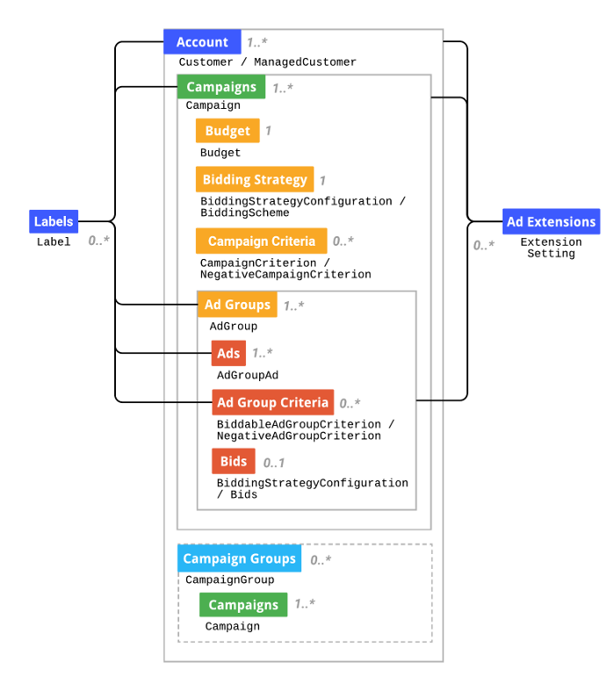

**Labels**

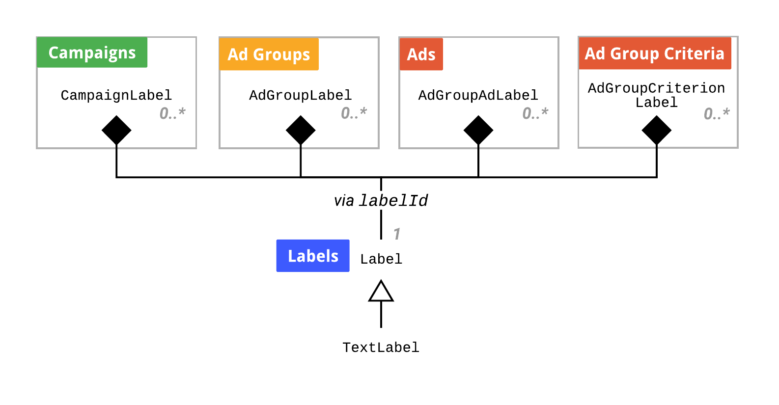

**Ad extensions**

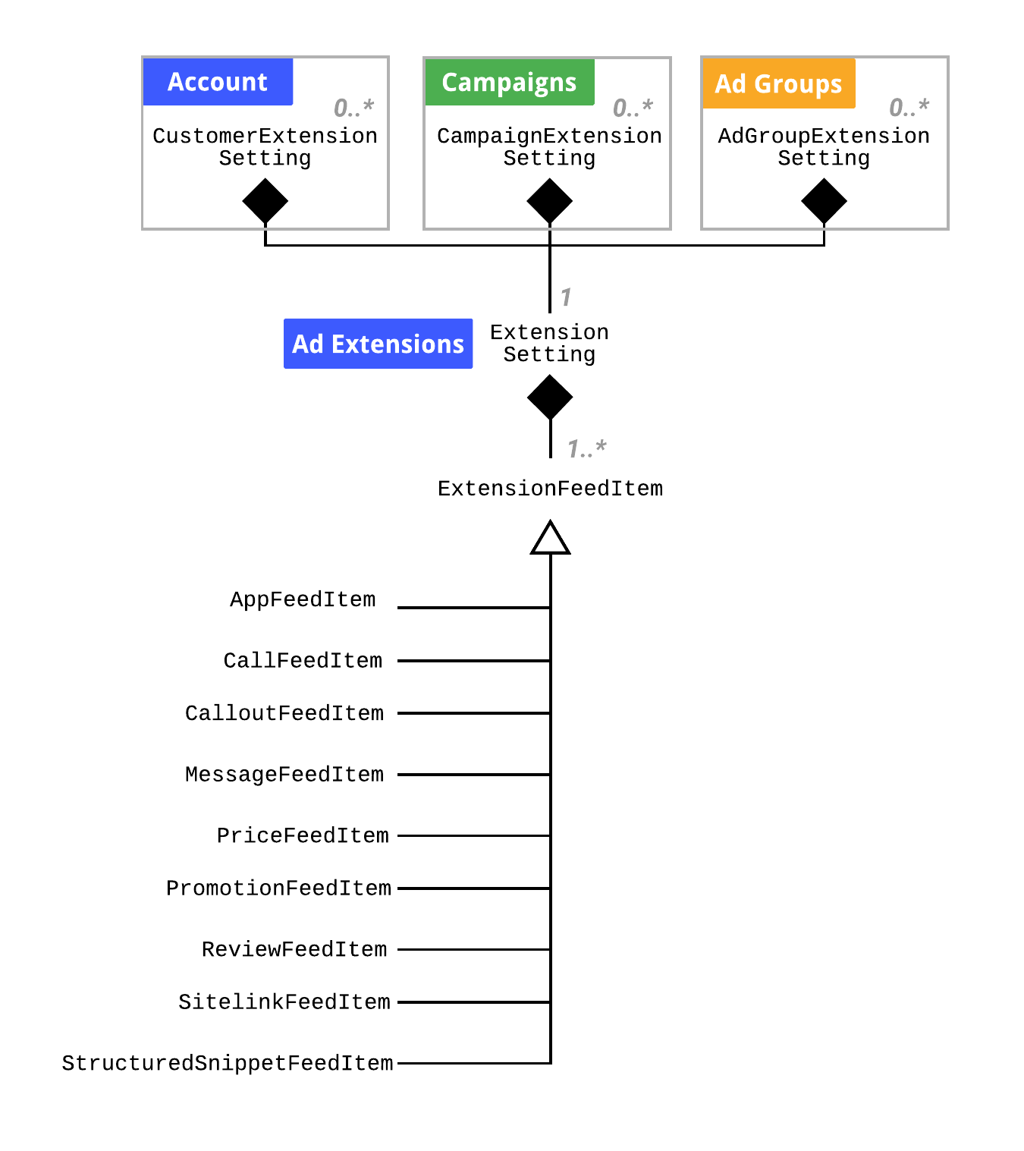

**Bidding strategy configuration and bidding**

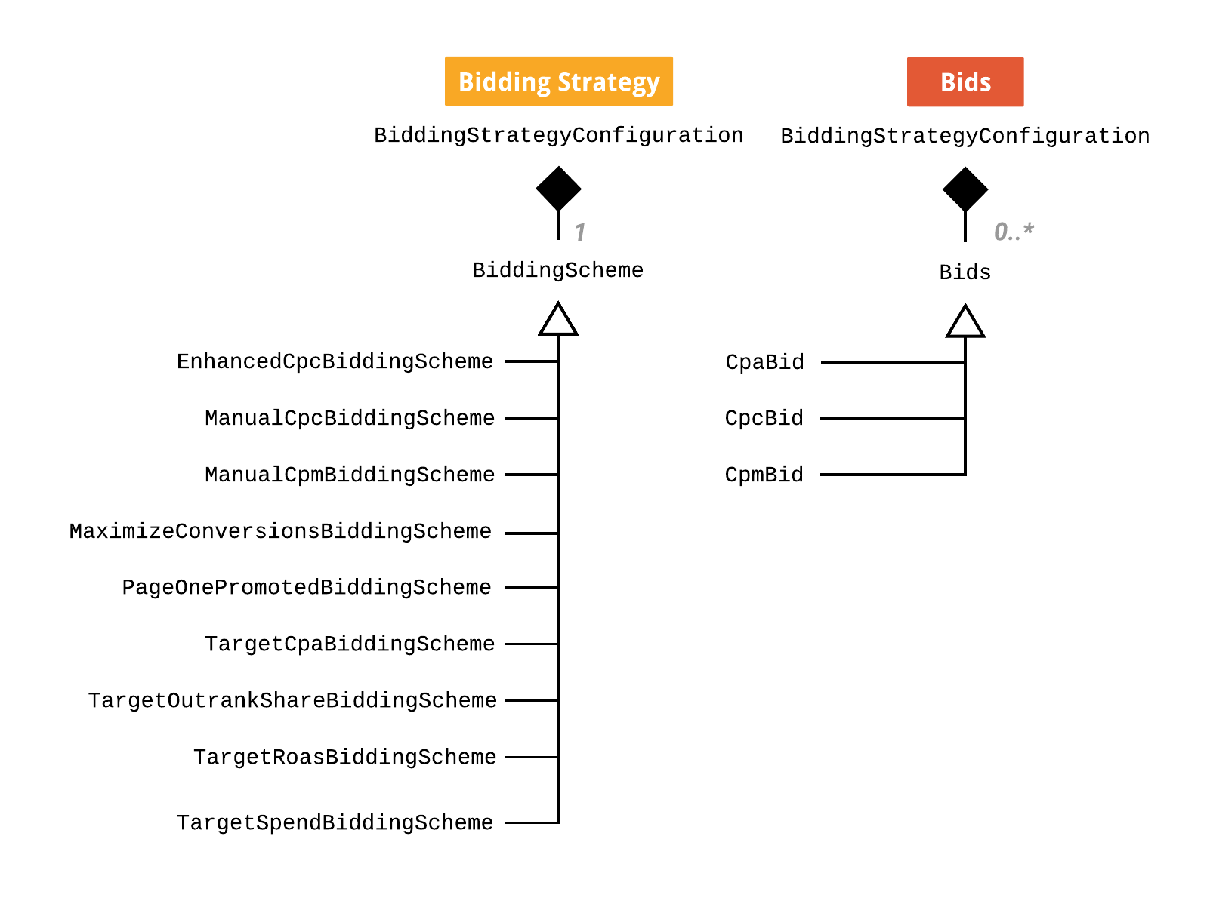

**Ads**

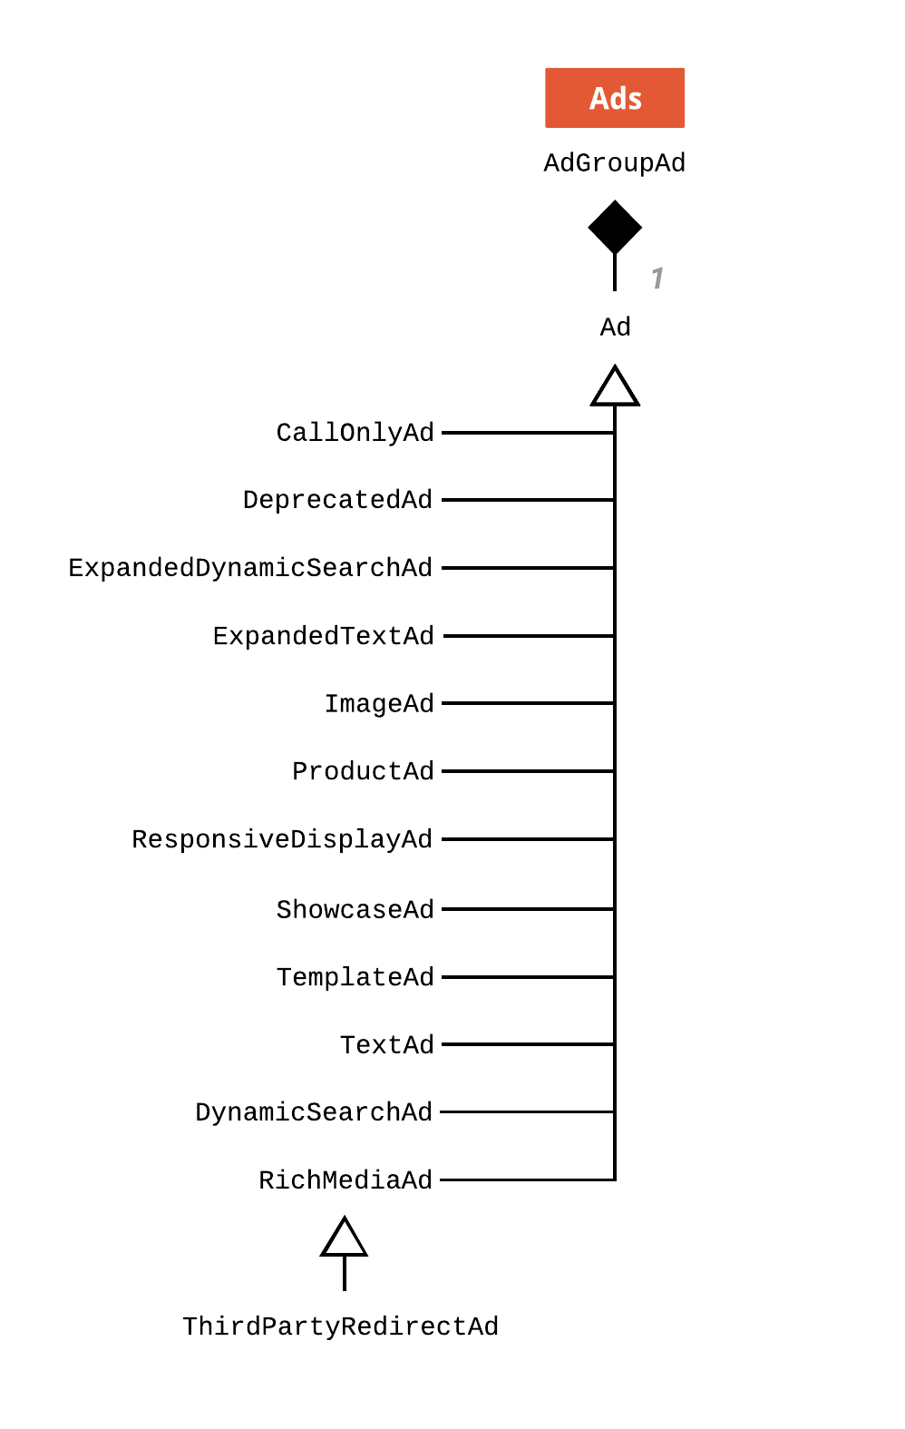

**Instances, Operations, and Services**

This paper introduces AdWords API classes and functions via campaign management. It lists API services and links to reference sites. AdWords API is for advanced users.

**Scope and hierarchy of objects**

Every Google Ads account can be thought of as a tree structure containing various objects.

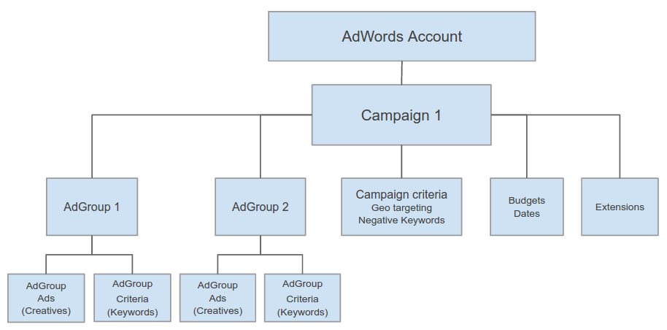

Each account has one or more Campaigns for advertising. AdGroups categorize ads for people in several campaigns. AdGroups have AdGroupAds and AdGroupCriteria. AdGroupAd is our ad. AdGroupCriterion represents a term that activates advertising. We may specify campaign parameters for triggering ads. Campaign dates and budgets may be selected. Finally, campaign-level ad extensions enable you to include phone numbers, addresses, etc. [2].

**Object ID Uniqueness**

Each Google Ads item has a unique ID. Some IDs are unique across all Google Ads accounts,

while others are unique only under certain situations. The list below demonstrates how

uniqueness differs by product and account.

| **Object ID** | **Scope of**  **uniqueness** | **globally unique?** |
| --- | --- | --- |
| Budget ID | Global | Yes |
| Campaign ID | Global | Yes |
| AdGroup ID | Global | Yes |
| Ad ID | Ad Group | No. (AdGroupId, AdId) pair is globally unique. |
| AdGroupCriterion  ID | Ad Group | No. (AdGroupId, CriterionId) pair is globally  unique. |
| CampaignCriterio  n ID | Campaign | No. (CampaignId, CriterionId) pair is globally  unique. |
| Ad Extensions | Campaign | No. (CampaignId, AdExtensionId) pair is  globally unique. |
| Feed ID | Global | Yes |
| Feed Item ID | Global | Yes |
| Feed Attribute ID | Feed | No |
| Feed Mapping ID | Global | Yes |
| Label ID | Global | Yes |
| UserList ID | Global | Yes |

These ID rules may help you create a local database for Google Ads objects. Inherited objects have a Type field. TextAd's Type field shows that it descends from Ad. Whether you're using a dynamic language, utilize this field to identify an object's type, such as if an Ad object is a TextAd object [2].

**Methods and operations**

Google Ads API manage items. AdGroupService manages AdGroups, etc. CampaignService runs ads. All such services offer get() and modify() in Java,C#, Python, PHP, Perl, Ruby & VB.NET [3].

**The get() procedure**

get() returns Google Ads-related objects. CampaignService.get() returns a list of campaigns (). Each get() function returns a page from a selection.The AdWords API does not return every object field by default when producing a selection. You may filter results using predicates, rank them with orders, and limit the time range with dateRange.When obtaining several items, set paging. SizeLimitError from AdWords API. If you try to obtain many things without paging, you'll receive an error. Each campaign's subroutine code is run. Google's Developer client libraries contain code examples for all campaign management get() functions. Here are examples of Java, C#, Python, PHP, Perl, Ruby, and VB.NET client libraries for campaign management services.

**The method query()**

query() replaces selectors with AdWords Query Language (AWQL), similar to SQL. AWQL often encodes requests more efficiently. Most services provide inquiry(). AWQL prohibits modified data. Examine the given sample to assess how effective AWQL is. Instead of four lines, the option might be written as a single string. No FROM clause. So you may choose among the service's query() possibilities. ONLY AWQL reports utilize the FROM clause. Use the service's query function to use this string. The above code's output matches get( )'s. AWQL queries are shorter and easier than get queries ().

**The method mutate()**

mutate() modifies a Google Ads object (made, updated, or destroyed). For object modification, construct an Operation object. To edit a Campaign, create a CampaignOperation. Operator field indicates operation type (ADD, SET, or REMOVE). The object's field is called the operand. This code adds campaigns. Start a campaign. A bid strategy is necessary. Optionally, you can give a bidding method in lieu of the type. Please note that just the budgetId is necessary. Create a Search Network campaign with Display Select. Omit networkSetting and use DISPLAY advertisingChannelType and NetworkSetting to build a Display Only campaign (optional). Type of advertising channel (required). Frequency cap (non-required). Enhanced location targeting configurations (non-required). Additional attributes (non-required). Set campaign status to PAUSED to suspend it. Instantly provide ads. lists product restrictions. Instead of hard-coding these limits into your software,

use them when creating campaigns.When using the modify() method, send numerous operations per request rather than many requests at once. Your program will operate faster if you send many actions per request. Grouping requests by operation into a parent entity improves efficiency. Instead of sending a single request to numerous ad groups, batch your ad requests to a single group.

**A field for operators.**

As indicated, the operator argument indicates ADD, SET, or REMOVE. ADD, SET, and

Delete add, update, and remove items. Some operators aren't suited for all services. Once aGoogle Ads campaign is begun, it can't be deleted but listed as REMOVED. REMOVED data may still be queried. Because the AdWords API lacks a REMOVE operator in CampaignService, you must use SET. Unlike campaign objectives, you can only ADD and REMOVE them.

The following table shows how to coordinate the movement of numerous Google Ads objects.

| Type | Add new object | Enable | Pause | Remove / Disable |
| --- | --- | --- | --- | --- |
| Campaign | action : mutate()  operation: ADD  status : ENABLED | mutate() is an action.  operation: SET  status : ENABLED | action : mutate()  operation: SET  status: PAUSED | action : mutate()  operation : SET  status: REMOVED |
| Budget | action : mutate()  operation: ADD  status : ENABLED | N/A | N/A | action : mutate()  operation : SET  status: REMOVED |
| AdGroup | action: mutate()  operation: ADD  status: ENABLED | action : mutate()  operation: SET  status : ENABLED | action: mutate()  operation: SET  status : PAUSED | action : mutate()  operation: SET  status: REMOVED |
| AdGroupAd | action : mutate()  operation: ADD  status: ENABLED | action : mutate()  operation : SET  status : ENABLED | action : mutate()  operation : SET  status : PAUSED | action: mutate()  operation : REMOVE  status: DISABLED |
| BiddableAdGroupCriterion | action: mutate()  operation: ADD  status: ENABLED | action: mutate()  operation: SET  status: ENABLED | action: mutate()  operation: SET  status: PAUSED | action: mutate  operation: REMOVE  status: REMOVED |
| UserList | action: mutate()  operation: ADD  status: OPEN | N/A | N/A | action: mutate()  operation: SET  status: CLOSED |
| Feed | action: mutate()  operation: ADD  status: ENABLED | N/A | N/A | action: mutate()  operation: REMOVE  status: REMOVED |
| FeedMapping | action: mutate()  operation: ADD  status: ENABLED | N/A | N/A | action: mutate()  operation: REMOVE  status: REMOVED |
| FeedItem | action: mutate  operation: ADD  status: ENABLED | N/A | N/A | action: mutate()  operation: REMOVE  status: REMOVED |
| CustomerFeed | action: mutate()  operation: ADD  status: ENABLED | N/A | N/A | action: mutate()  operation: REMOVE  status: REMOVED |
| CampaignFeed | action: mutate()  operation: ADD  status: ENABLED | N/A | N/A | action: mutate()  operation: REMOVE  status: REMOVED |
| AdGroupFeed | action: mutate()  operation: ADD  status: ENABLED | N/A | N/A | action: mutate()  operation: REMOVE  status: REMOVED |

**Concurrent/Simultaneous mutations**

Understanding how Google Ads handles concurrent modify requests for the same object is critical if your app has several users updating the same object or if you're using multiple threads to change Google Ads objects concurrently for increased throughput. Google Ads objects can't be modified by multiple sources. The item may be updated by several threads or programs (for example, your app and a simultaneous AdWords Editor session). API doesn't lock objects before updating. If two sources alter the same object at once, the API returns a CONCURRENT MODIFICATION ERROR.

**The language used by AdWords (AWQL)**

AWQL may be used to query AdWords API services. All services have query(). AWQL is inspired. by SQL but doesn't cover the whole vocabulary. Absent are JOIN and GROUP BY.

Selector Fields on Google keyword planner's developer page lists queryable fields for each service. AWQL may query reports. Google Developer's Report Types lists all queryable fields.

**Service calls utilizing AWQL**

AWQL is efficient for coding identical calls. A FROM clause is unnecessary as the server knows the data source. DURING clauses are allowed for reporting but not service calls. Utilizes account time zone. WHERE is not case-sensitive, unlike literals like ENABLED and column field names like Name. IN and NOT IN operators limit WHERE clause to 10,000 entries[4].

**Using reports and AWQL**

Reporting uses AWQL. Instead of the "__rdxml" POST argument, offer these two parameters: "__rdquery" contains AWQL query string. "__fmt" defines report download format. Example:

__rdquery=SELECT+Criteria+FROM+KEYWORDS PERFORMANCE REPORT+DURING+20150101,20150325& fmt=CSV

AWQL reporting has several versions. The FROM clause of the query must specify a report type.

SELECT Criteria, AdGroupName, and Id CONTAINS KEYWORDS PERFORMANCE REPORT

FROM is prohibited in service calls but required for report downloads. DURING specifies report date ranges. Date ranges are given two ways. Here's a custom date range using AWQL syntax:

SELECT Id, Criteria, AdGroupName

FROM KEYWORDS_PERFORMANCE_REPORT

DURING 20190101,20190325

By utilizing a date range type, for example:

SELECT Id, Criteria, AdGroupName

FROM KEYWORDS_PERFORMANCE_REPORT

DURING LAST_7_DAYS

DateRangeTypes all-time and custom-date aren't supported. Remove the DURING clause from your query to get ALL TIME data. SELECT clause without Date and Week columns. ORDER BY and LIMIT aren't supported (sorting and paging). These clauses cause errors in queries. Add "Impressions > 0" to WHERE to exclude zero-impression entries[4].

**Official grammar**

**Here is AWQL's official grammar for user reference**[4]**:**

Statement -> SelectClause WhereClause FromClause1?

DuringClause2, OrderByClause3, and LimitClause4,

SELECT ColumnList in SelectClause

SourceName: fromClause -> FROM

Using WhereClause -> WHERE ConditionList

during clause to throughout date range

OrderByClause: ORDER BY Ordering (Ordering)*

StartIndex, PageSize, and LimitClause -> LIMIT

ConditionList: Condition (AND Condition)

ColumnName Operator Value -> Condition

Value: ValueLiteral; String; ValueLiteralList; StringList

ColumnName (DESC | ASC) in the ordering menu?

Using the format DateRange -> DateRangeLiteral | Date,Date

ColumnList > ColumnName

Literal for ColumnName

Literal from SourceName

StartIndex: Non-negative integer

-> PageSize -> Non-negative integer

The following operators are available: = |!= | > | >= | | = | IN | NOT IN | STARTS WITH | STARTS WITH IGNORE CASE |

DOES NOT CONTAIN | CONTAINS IGNORE CASE | CONTAINS

DOES NOT CONTAIN IGNORE CASE BUT CONTAINS ANY, ANY, NONE, OR ALL

String to StringSingleQ and StringDoubleQ

string singleQ = "(char)"

-> StringDoubleQ "(char)"

Using [StringList -> [String (, String)*]

5

ValueLiteral -> *[a-zA-Z0-9_.

ValueLiteralList: [ValueLiteral (, ValueLiteral)]

5

Literally -> [a-zA-Z0-9_]*

DateRangeLiteral -> TODAY, YESTERDAY, LAST WEEK, LAST BUSINESS WEEK, THIS MONTH, LAST 7 DAYS,

THE LAST MONTH | THE LAST 14 DAYS | THE LAST 30 DAYS | THIS WEEK SUNDAY |

THIS WEEK'S MONDAY | LAST WEEK'S SUNDAY

Date to eight-digit integer: YYYYMMDD

**Code Architecture**

We've addressed API request circumstances. This article explores AdWords API code. Open IDE GetCampaigns.java.

The code gets adwords.properties credentials:

# Get AdWords API Client, credentials will be read from ~/adwords.properties.

my $client = Google::Ads::AdWords::Client->new({version => "v201809"});

In step 1, we set adwords.properties' client customer ID. How about several consumer accounts? Delete client customer ID from adwords.properties and set it programmatically using set client id.

# Get AdWords API Client, credentials will be read from ~/adwords.properties.

my $client = Google::Ads::AdWords::Client->new({version => "v201809"});

$client->set_client_id("123-456-7890");

Then, we'll discuss common use cases that illustrate how the code samples may be used to include any API function in the project.

**Structure of an example API code**

Client library code examples give API functions. They automate most back-end activities, simplifying AdWords API development[5]. AdWords API code example structure. Choose language below. Open GetCampaigns.java in IDE. In GetCampaigns.java, boilerplate code does several tasks: Accreditation. Sessions. Services examples.

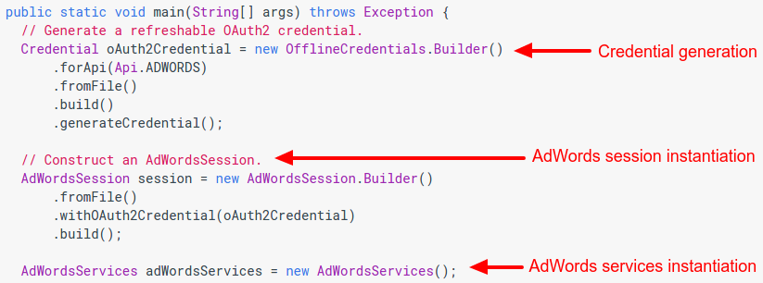

You'll see client library code samples. GetCampaigns needs one additional line. How many customer accounts does your manager have? Using the session object, set the client customer ID. Set object characteristics dynamically using setClientCustomerID. Start AdWords. Use sample codes. Account management, campaign direction, error management, Optimization,Reporting, and Targeting are API examples.These examples of API functions are a useful starting point for your own software. Now that you know a typical AdWords API code sample, we'll explore use cases that illustrate how it may be used for practically every

function. API functions include reporting and automation. First, the report comes.

**Code examples are used for reporting.**

This section explains how to utilize the Report Types page to produce and download a website compliance report. The code sample may create, generate, and download any report using the data. In DownloadCriteriaReport.java, we generate a report definition and send it to a ReportDownloader object. IDE console prints the file's location. In this class' RunExample method, we specify the kind of report we desire. IDE terminal displays file location. The example code gives the report type—in this case, a criteria performance report reportDefinition.setReportType(ReportDefinitionReportType.CRITERIA PERFORMANCE REPORT);——and a few report fields, such as selector.getFields(), "AdGroupId," etc.

**Query Language for AdWords (AWQL)**

AdWords Query Language (AWQL) resembles SQL and offers less verbose report production than objects. Shorter AWQL query returns identical report. All report kinds, fields, and metadata are used.

Java code:

String query = "SELECT CampaignId, AdGroupId, Id, Criteria, CriteriaType, "

+ "Impressions, Clicks, Cost FROM CRITERIA_PERFORMANCE_REPORT "

+ "WHERE Status IN [ENABLED, PAUSED] "

+ "DURING YESTERDAY";

**Using examples of code for automation**

Here, we'll examine how these examples may serve as the basis for virtually any type of machine learning or AI-based automation.

**Pause and resume ad groups.**

Ad group halting and starting is a typical API use. You may stop an ad when a product's supply is low to save money. UpdateAdGroup.java demonstrates how to integrate with the AdWords API. The ad group ID placeholder is situated in the main function. Refresh an OAuth2 credential. main throws an exception (String[]args).

**Construct an AdWords session.**

Through the get() method of the AdGroupService interface, you may obtain the ID from the Google Ads user interface URL. RunExample contains the relevant code. AdGroupService updates ad groups. Status-updated advertising. The ad group's ID is then supplied to the new object and its status is changed to PAUSED (adGroup.setStatus(AdGroupStatus.PAUSED)). AdGroupOperation code. Your operations. Execute the code after replacing the placeholder with a test client adgroup ID. The newly-created ad group object is the operand, and the SET operator creates a new operation. Before joining the test account, change the ad group to view only relevant adverts.

**Looking at the pattern**

Knowing the trend will facilitate future changes like altering an ad group's bid. Change an entity's ID. Change this object's attribute. The service's alter() function should receive the action object. Add or delete data with ADD and REMOVE.

**Adjust an ad group's bids**

CampaignService and BudgetService may add AdWords campaigns and budgets to your app. As these are new entities without IDs, IDs aren't needed yet. A frequent use case is programming a bid. During rainfall, bids for umbrella ads rise.

**Process View**

**BatchJobService**

Use BatchJobService to check the status, results, or statistics of programmers' recent jobs and to plan asynchronous AdWords campaign changes. This service stops an application from actively waiting for a synchronous response. Our program may execute other activities or halt while we make asynchronous changes. We may call get to check on a submitted task's status. Avoid polling too often to avoid client rate restrictions. We can retrieve a job's outcomes once it's DONE[6]. Operations:

* get
* mutate
* query

**Get method:**

Ask about the status of active BatchJobs. Parameters:

| **Field** | **Type** | **Description** |
| --- | --- | --- |
| selector | [Selector](https://developers.google.com/adwords/api/docs/reference/v201809/BatchJobService.Selector) | The selector defines which BatchJobs should be returned. |

Response

| **Field** | **Type** | **Description** |
| --- | --- | --- |
| rval | [BatchJobPage](https://developers.google.com/adwords/api/docs/reference/v201809/BatchJobService.BatchJobPage) | The selected jobs list. |

**Mutate method:**

Creates or modifies a Batch task. The REMOVE operator is not supported by BatchJobOperation.BatchJobs is unnecessary to remove. Parameters:

| **Field** | **Type** | **Description** |
| --- | --- | --- |
| operations | [BatchJobOperation](https://developers.google.com/adwords/api/docs/reference/v201809/BatchJobService.BatchJobOperation)[] | A list of procedures/operations |

Response

| **Field** | **Type** | **Description** |
| --- | --- | --- |
| rval | [BatchJobReturnValue](https://developers.google.com/adwords/api/docs/reference/v201809/BatchJobService.BatchJobReturnValue) | The list of newly created and modified jobs. |

**Query Method:**

Returns a set of Batch jobs that are relevant to the query. Parameters:

| **Field** | **Type** | **Description** |
| --- | --- | --- |
| query | xsd:string | The AWQL query string is similar to SQL. |

Response

| **Field** | **Type** | **Description** |
| --- | --- | --- |
| rval | BatchJobPage | Here is the list of jobs that have been picked. |

**Processing in Bulk**

While most services provide synchronous APIs that require submitting a request and waiting for a response, BatchJobService lets you perform groups of actions across numerous services without waiting for each action to complete in order. A single BatchJobService job may operate on a diverse collection of campaigns, ad groups, advertising, criteria, labels, and feed items. Operations that fail due to transient difficulties such as rate limit failures are instantly retried by BatchJobService. Each API activity counts against your daily limit, following the API's regulations. BatchJobService allows temporary IDs so related operations may be submitted as a single task. BatchJobService may reduce requests, but its appropriateness must be assessed. Batch processing reduces API requests and retries failed processes. Better performance doesn't guarantee quicker work or higher throughput. To discover the optimal solution, blend batch and non-batch processing[7].

**Operations**

BatchJobService implements most MutateOperation actions. All jobs use the Google Ads API with partial failure. MutateOperation actions cannot accept partial failure since they are atomic. So, don't include them in batch tasks. If you must do any of these things, use the updated GoogleAdsService function and set partial failure to false.[7].

**Implementation View**

**Improved URLs Overview**

Upgraded URLs provide you more flexibility over landing page and tracking components. Destination URLs show where customers land on your website after clicking an ad. Encoded data linked performance to ad clicks. Upgraded URLs' common tracking templates allow tracking data upgrades without editorial oversight[8].

**Specification**

You may define tracking and landing page components in updated URLs. [9]: Final URL lists landing pages for your ad, keyword, or site link. A user must see the final URL after clicking an ad in the browser's address bar[9].

**Final mobile URL**: This number shows probable final mobile URLs for your ad, keyword, or site link after cross-domain redirection.

**Final App URL**: Displays the final app URLs that users of loaded mobile devices may access.

**Tracking template**: A template for adding redirects or tracking. This template will create the ad's destination URL.

**Custom parameters**: ValueTrack parameters with optional IDs.

**type Keyword**

**Service**

AdGroupCriterionService [AdGroupExtensionSettingService](https://developers.google.com/adwords/api/docs/reference/v201809/AdGroupExtensionSettingService.Keyword) [CampaignCriterionService](https://developers.google.com/adwords/api/docs/reference/v201809/CampaignCriterionService.Keyword) [CampaignExtensionSettingService](https://developers.google.com/adwords/api/docs/reference/v201809/CampaignExtensionSettingService.Keyword) [CustomerExtensionSettingService](https://developers.google.com/adwords/api/docs/reference/v201809/CustomerExtensionSettingService.Keyword) [FeedItemTargetService](https://developers.google.com/adwords/api/docs/reference/v201809/FeedItemTargetService.Keyword) [SharedCriterionService](https://developers.google.com/adwords/api/docs/reference/v201809/SharedCriterionService.Keyword) [TargetingIdeaService](https://developers.google.com/adwords/api/docs/reference/v201809/TargetingIdeaService.Keyword) [TrafficEstimatorService](https://developers.google.com/adwords/api/docs/reference/v201809/TrafficEstimatorService.Keyword)

**Inheritance**

Criterion

▼

[AgeRange](https://developers.google.com/adwords/api/docs/reference/v201809/AdGroupCriterionService.AgeRange) [AppPaymentModel](https://developers.google.com/adwords/api/docs/reference/v201809/AdGroupCriterionService.AppPaymentModel) [CriterionCustomAffinity](https://developers.google.com/adwords/api/docs/reference/v201809/AdGroupCriterionService.CriterionCustomAffinity) [CriterionCustomIntent](https://developers.google.com/adwords/api/docs/reference/v201809/AdGroupCriterionService.CriterionCustomIntent) [CriterionUserInterest](https://developers.google.com/adwords/api/docs/reference/v201809/AdGroupCriterionService.CriterionUserInterest) [CriterionUserList](https://developers.google.com/adwords/api/docs/reference/v201809/AdGroupCriterionService.CriterionUserList) [Gender](https://developers.google.com/adwords/api/docs/reference/v201809/AdGroupCriterionService.Gender) [IncomeRange](https://developers.google.com/adwords/api/docs/reference/v201809/AdGroupCriterionService.IncomeRange) Keyword [MobileAppCategory](https://developers.google.com/adwords/api/docs/reference/v201809/AdGroupCriterionService.MobileAppCategory) [MobileApplication](https://developers.google.com/adwords/api/docs/reference/v201809/AdGroupCriterionService.MobileApplication) [Parent](https://developers.google.com/adwords/api/docs/reference/v201809/AdGroupCriterionService.Parent) [Placement](https://developers.google.com/adwords/api/docs/reference/v201809/AdGroupCriterionService.Placement) [ProductPartition](https://developers.google.com/adwords/api/docs/reference/v201809/AdGroupCriterionService.ProductPartition) [Vertical](https://developers.google.com/adwords/api/docs/reference/v201809/AdGroupCriterionService.Vertical) [Webpage](https://developers.google.com/adwords/api/docs/reference/v201809/AdGroupCriterionService.Webpage) [YouTubeChannel](https://developers.google.com/adwords/api/docs/reference/v201809/AdGroupCriterionService.YouTubeChannel) [YouTubeVideo](https://developers.google.com/adwords/api/docs/reference/v201809/AdGroupCriterionService.YouTubeVideo)

**Associated entities**

The support for certain Upgraded URL fields in various Google Ads entities is listed in the table below[12].

| **Google Ads Entity** | **Final URL** | **Final mobile URL** | **Final app URL** | **Custom parameters** | **Tracking template** |
| --- | --- | --- | --- | --- | --- |
| [Customer](https://developers.google.com/adwords/api/docs/reference/latest/CustomerService.Customer) |  |  |  |  | Checkmark |
| [Campaign](https://developers.google.com/adwords/api/docs/reference/latest/CampaignService.Campaign) |  |  |  | Checkmark | Checkmark |
| [AdGroup](https://developers.google.com/adwords/api/docs/reference/latest/AdGroupService.AdGroup) |  |  |  | Checkmark | Checkmark |
| [Ad](https://developers.google.com/adwords/api/docs/reference/latest/AdGroupAdService.Ad) | Checkmark | Checkmark | Checkmark | Checkmark | Checkmark |
| [AdGroupCriterion](https://developers.google.com/adwords/api/docs/reference/latest/AdGroupCriterionService.BiddableAdGroupCriterion) | Checkmark | Checkmark | Checkmark | Checkmark | Checkmark |
| [FeedItem (Sitelink)](https://developers.google.com/adwords/api/docs/reference/latest/FeedItemService.FeedItem) | Checkmark | Checkmark | Checkmark | Checkmark | Checkmark |

| type[8] | Criterion.Type  Represents a Criterion subclass. This field is included in the response even if it's not selected. Use xsi:type.Enumerations  CONTENT LABEL  Label for excluded content.  KEYWORD  Key term, such as "mars cruise"  PLACEMENT  Website, or placement, such as "www.flowers4sale.com"  VERTICAL  Vertical tags include "category::Animals>Pets". Vertical targeting for the content network.  USER LIST  Links to groups of people that the advertiser has established are found in user lists.  USER INTEREST  Interests of the user, or groups of interests in which the user is interested.  MOBILE APPLICATION  to target mobile applications.  MOBILE APP CATEGORY  Target mobile application categories.  PRODUCT PARTITION  Product grouping or partitioning in a marketing effort.  IP BLOCK  IP addresses to omit  WEBPAGE  target web pages on an advertiser's website.  LANGUAGE  Target languages.  LOCATION  parts of the world to focus on.  AGE RANGE  a range of ages to omit.  CARRIER  To target: mobile providers.  OPERATING SYSTEM VERSION  Versions of mobile operating systems to target.  MOBILE DEVICE  target: mobile devices.  GENDER  a gender exclusion.  PARENT  to single out and exclude parents.  PROXIMITY  proximity to the objective (the region within a radius).  PLATFORM  platforms to focus on  PREFERRED CONTENT  representing the bid modifier for favored content.  AD SCHEDULE  Targeting may be done using AdSchedule or certain days and times.  LOCATION GROUPS  using location-based targeting groupings.  PRODUCT SCOPE  Variety of items. Provides product details to be evaluated for the campaign.  CUSTOM AFFINITY  Custom Affinity is a criteria for targeting specific audiences.  CUSTOM INTENT  Custom audience targeting is done using the criterion of custom intent.  YOUTUBE VIDEO  Target YouTube video.  YOUTUBE CHANNEL  target YouTube channel  APP PAYMENT MODEL  enables targeting of sponsored applications by marketers.  INCOME RANGE  Income range to aim for and avoid.  INTERACTION TYPE  interaction style to adjust the bid.  UNKNOWN  You may choose this field by using the value "CriteriaType."  Filters can be applied to this field.  When provided to the API, this field will be ignored because it is read-only. |
| --- | --- |
| Criterion.Type | xsd:string  Represents a Criterion subclass. This field is included in the response even if it's not selected. Use xsi:type. |
| Keyword | |
| text | xsd:string  Keyword definition (at most 80 characters and ten words).  "KeywordText" selects this field. This field accepts filters. Keyword text can't include NUL (code point 0x0). "[x00]*" confirms this. This field must not be null when used with Operators: ADD. |

| Criterion (inherited) | |
| --- | --- |
| id | xsd:long  require identification "Id" selects this field. This field accepts filters. This field is required for SET and REMOVE and shouldn't be null. |

**Field annotations**

Final URL represents ad, keyword, or site link landing page. When a person clicks your ad, the complete URL must show in their browser bar. No off-domain redirection. Final URLs must fulfill URL validation requirements.

**The system's method for growing the serving URL.**

The following are the actions the system performs to enlarge the serving URL(10):

1. Select the final URL. First, choose the final URL. This varies by party.

| Entity | Which final URL to use? |
| --- | --- |
| FeedItems (website links) | Use your own final URL at all times. |
| Ad X was shown in response to keyword Y. | Use the keyword's own final URL if it has one. |

1. In all other cases, use the advertisement's final URL.
2. Going through an entity's object hierarchy and picking the lowest-level value determines its tracking URL. If no hierarchy values exist, the tracking URL template's value is empty. An ad group is used if only the account and parent ad group have tracking URL templates.
3. If no value is supplied, an empty string is used. For example, the parent ad group's value is used to determine an ad's custom param. Choose custom parameters.
4. Replace the URL. Three actions increase the final URL:
   1. Raising custom params. The system parses the final URL using the values specified in step 3.
   2. Expand ValueTrack tags in URL. If ValueTrack tags are present, the system replaces them with values.
   3. Discard tag. ValueTrack parameters are removed from the final URL.
5. Add tracking templates. If the tracking template is empty, skip this step (as established in step 2 above). All additional examples expand the tracking URL template:
   1. Raising custom params. The system parses the tracking template URL and replaces each custom parameter with step-3 data.
   2. Expand ValueTrack tags in URL. The technology substitutes ValueTrack tags in tracking template URLs with values.
   3. Replace "lpurl" in the tracking template. If "lpurl" occurs in the tracking template URL, it's replaced with the final URL from step 4.
      * Lpurl added to the tracking template is not escaped. ?, =, ", #, t, ', and [space] are avoided in the tracking template.
      * Unescaped is always true for "unescapedlpurl."
      * Every time, "escapedlpurl" is escaped.
      * Lpurl+2 is always twice escaped.
      * Lpurl+3 is always three times escaped.
6. Choose the URL. If your tracking template URL is empty, use step 4's final URL. In this situation, the system uses step 5's larger tracking template URL. Exception: sitelinks. If step 2's tracking URL template doesn't contain the lpurl parameter, the serving URL is the sitelink's final URL.

Example scenarios. Consider an account with the following structure:

Account

Campaign 1

Ad Group 1

Ad 1

Keyword 1 (shoes)

Keyword 2 (hats)

Ad Group 2

Ad 2

Ad 3

Keyword 3 (watches)

FeedItem 1 (sitelink 1)

Assume the following Upgraded URL fields are defined on these entities[10]:

| **Entity name** | **Tracking URL template** | **Final URL** | **Custom Parameters** |
| --- | --- | --- | --- |
| Account | http://www.cid1-tracking.com/?{_myid}&u={lpurl} |  |  |
| Campaign 1 |  |  | _mycampaign=cam1 |
| Ad Group 1 | http://www.ag1-tracking.com/?{_mycampaign}&u={lpurl}&{_myid} |  | _myid=ag1id |
| Ad Group 2 |  |  | myid=ag2id |
| Ad 1 |  | http://www.creative1-final.com/?{keyword}{ignore}&{_myid}&{_mycampaign} |  |
| Ad 2 |  | http://www.creative2-final.com/?{keyword}{ignore}&{_myid} | _myid=ad2id |
| Ad 3 | http://www.ad3-tracking.com/?{_mycampaign} |  |  |
| Keyword 1 |  | final URL: http://www.kw-final.com/?{keyword}{ignore}&{_mycampaign}  final mobile URL: http://m.kw-final-mobile.com/?{keyword}{ignore}&{_myid} | _myid=k1Id |
| Keyword 2 |  |  |  |
| Keyword 3 |  |  |  |
| FeedItem 1 |  | final URL: http://www.sitelink-final.com/?{keyword}{ignore}&{_mycampaign}  final mobile URL: http://m.sitelink-final-mobile.com/?{keyword}{ignore}&{_myid} |  |

The ValueTrack parameter "keyword" is expanded using the values shown below:

the term "shoes"

2nd keyword: hats

Term 3: wristwatches

The resolution of different parameters for each of these entities is demonstrated in the sections that follow.

**Case 1: Because of Keyword 2, Ad1 is shown.**

| **Parameter** | **Value** | **Source** |
| --- | --- | --- |
| Template for tracking | http://www.ag1-tracking.com/?{_mycampaign}&u={lpurl}&{_myid} | Group 1 advertising |
| The final URL | http://www.creative1-final.com/?{keyword}&{_myid}&{_mycampaign} | Ad 1 |
| Adaptable Settings | _myid=ag1id | Advertisement Group 1 |
| _mycampaign=cam1 | Campaign 1 |
| Complete URL Expansion | http://www.creative1-final.com/?hats&ag1id&cam1 | N/A |
| Increased Tracking URL Template | http://www.ag1-tracking.com/?cam1&u=http://www.creative1-final.com/%3Fhats%26ag1id%26cam1&ag1id | N/A |
| URL service | http://www.ag1-tracking.com/?cam1&u=http://www.creative1-final.com/%3Fhats%26ag1id%26cam1&ag1id | N/A |

**Case 2: Because of Keyword 1, Ad 1 is displayed.**

| **Parameter** | **Value** | **Source** |
| --- | --- | --- |
| Template for tracking | http://www.ag1-tracking.com/?{_mycampaign}&u={lpurl}&{_myid} | Group 1 Ad |
| Ultimate URL | Desktop: http://www.kw-final.com/?{keyword}&{_mycampaign} | Keyword 1 |
| Mobile: http://m.kw-mobile-final.com/?{keyword}&{_mycampaign} |
| Adaptable Settings | _myid=k1id | Keyword 1 |
| _mycampaign=cam1 | Campaign 1 |
| Complete URL Expansion | Desktop: http://www.kw-final.com/?shoes&cam1 | N/A |
| Mobile: http://m.kw-final.com/?shoes&cam1 |
| Expanded tracking template URL | Desktop: http://www.ag1-tracking.com/?cam1&u=http://www.kw-final.com/%3Fshoes%26cam1&k1id | N/A |
| Mobile: http://www.ag1-tracking.com/?cam1&u=http://m.kw-final.com/%3Fshoes%26cam1&k1id |
| Serving URL | Desktop: http://www.ag1-tracking.com/?cam1&u=http://www.kw-final.com/%3Fshoes%26cam1&k1id | N/A |
| Mobile: http://www.ag1-tracking.com/?cam1&u=http://m.kw-final.com/%3Fshoes%26cam1&k1id |

**Case 3: Because of Keyword 3, Ad 2 is shown.**

| **Parameter** | **Value** | **Source** |
| --- | --- | --- |
| Tracking template | http://www.cid1-tracking.com/?{_myid}&u={lpurl} | Account |
| Final URL | http://www.creative2-final.com/?{keyword}&{_myid} | Ad 2 |
| Custom Parameters | _myid=ad2id | Ad 2 |
| _mycampaign=cam1 | Campaign 1 |
| Complete URL Expansion | http://www.creative2-final.com/?watches&ad2id | N/A |
| Expanded tracking template URL | http://www.cid1-tracking.com/?ad2id&u=http://www.creative2-final.com/%3Fwatches%26ad2id | N/A |
| Provides URL | http://www.cid1-tracking.com/?ad2id&u=http://www.creative2-final.com/%3Fwatches%26ad2id | N/A |

**Case 4: Because Keyword 2 is used, FeedItem 1 serves under Ad 1.**

| **Parameter** | **Value** | **Source** |
| --- | --- | --- |
| Template for tracking | http://www.ag1-tracking.com/?{_mycampaign}&u={lpurl}&{_myid} | Group 1 advertising |
| The final URL | Desktop: http://www.sitelink-final.com/?{keyword}&{_mycampaign} | FeedItem 1 |
| Mobile: http://m.sitelink-mobile-final.com/?{keyword}&{_mycampaign} |
| Custom Parameters | _myid=ad2id | Ad 2 |
| _mycampaign=cam1 | Campaign 1 |
| Expanded final URL | Desktop: http://www.sitelink-final.com/?hats&cam1 | N/A |
| Mobile: http://m.sitelink-mobile-final.com/?hats&cam1 |
| Expanded tracking template URL | Desktop: http://www.ag1-tracking.com/?cam1&u=http://www.sitelink-final.com/%3Fhats%26cam1&ad2id | N/A |
| Mobile: http://www.ag1-tracking.com/?cam1&u=http://m.sitelink-mobile-final.com/%3Fhats%26cam1&ad2id |
| Serving URL | Desktop: http://www.ag1-tracking.com/?cam1&u=http://www.sitelink-final.com/%3Fhats%26cam1&ad2id | N/A |
| Mobile: http://www.ag1-tracking.com/?cam1&u=http://m.sitelink-mobile-final.com/%3Fhats%26cam1&ad2id | N/A |

**Case 5: Because Keyword 1 is used, FeedItem 1 serves under Ad 1**.

| **Parameter** | **Value** | **Source** |
| --- | --- | --- |
| Tracking template | http://www.ag1-tracking.com/?{_mycampaign}&u={lpurl}&{_myid} | Group 1 advertising |
| The final URL | Desktop: http://www.sitelink-final.com/?{keyword}&{_mycampaign} | FeedItem 1 |
| Mobile: http://m.sitelink-mobile-final.com/?{keyword}&{_mycampaign} |
| Custom Parameters | _myid=k1id | Keyword 1 |
| _mycampaign=cam1 | Campaign 1 |
| Expansion of final URL | Desktop: http://www.sitelink-final.com/?shoes&cam1 | N/A |
| Mobile: http://m.sitelink-mobile-final.com/?shoes&cam1 |
| Expanded tracking template URL | Desktop: http://www.ag1-tracking.com/?cam1&u=http://www.sitelink-final.com/%3Fshoes%26cam1&k1id | N/A |
| Mobile: http://www.ag1-tracking.com/?cam1&u=http://m.sitelink-mobile-final.com/%3Fshoes%26cam1&k1id |
| Serving URL | Desktop: http://www.ag1-tracking.com/?cam1&u=http://www.sitelink-final.com/%3Fshoes%26cam1&k1id | N/A |
| Mobile: http://www.ag1-tracking.com/?cam1&u=http://m.sitelink-mobile-final.com/%3Fshoes%26cam1&k1id |

**Case 6: Because Keyword 3 is present, FeedItem 1 appears underneath Ad 2.**

| **Parameter** | **Value** | **Source** |
| --- | --- | --- |
| Template for tracking | http://www.cid1-tracking.com/?{_myid}&u={lpurl} | Accounting |
| The final URL | Desktop: http://www.sitelink-final.com/?{keyword}&{_mycampaign} | 1st FeedItem |
| Mobile: http://m.sitelink-mobile-final.com/?{keyword}&{_mycampaign} |
| Custom Parameters | _myid=ad2id | Ad 2 |
| _mycampaign=cam1 | Campaign 1 |
| Expanded final URL | Desktop: http://www.sitelink-final.com/?watches&cam1 | N/A |
| http://m.sitelink-mobile-final.com/?watches&cam1 |
| Increased Tempate URL for Tracking | Desktop: http://www.cid1-tracking.com/?ad2id&u=http://www.sitelink-final.com/%3Fwatches%26cam1 | N/A |
| Mobile: http://www.cid1-tracking.com/?ad2id&u=http://m.sitelink-mobile-final.com/%3Fwatches%26cam1 |
| Provides URL | Desktop: http://www.cid1-tracking.com/?ad2id&u=http://www.sitelink-final.com/%3Fwatches%26cam1 | N/A |
| Mobile: http://www.cid1-tracking.com/?ad2id&u=http://m.sitelink-mobile-final.com/%3Fwatches%26cam1 |

**Case 7: Because Keyword 3 is used, FeedItem 1 serves under Ad 3.**

| **Parameter** | **Value** | **Source** |
| --- | --- | --- |
| Template for tracking | http://www.ad3-tracking.com/?{_mycampaign} | Ad 3 |
| The Final URL | Desktop: http://www.sitelink-final.com/?{keyword}&{_mycampaign} | FeedItem 1 |
| Mobile: http://m.sitelink-mobile-final.com/?{keyword}&{_mycampaign} |
| Custom Parameters | _myid=ag2id | Group 2 advertising |
| _mycampaign=cam1 | Campaign 1 |
| Final URL lengthened | Desktop: http://www.sitelink-final.com/?watches&cam1 | N/A |
| Mobile: http://m.sitelink-mobile-final.com/?watches&cam1 |
| URL for expanded tracking template | Because the tracking template lacks the lpurl parameter, it is not used. | N/A |
| URL for Serving | Desktop: http://www.sitelink-final.com/?watches&cam1 | N/A |
| Mobile: http://m.sitelink-mobile-final.com/?watches&cam1 |

**Settings for advanced geotargeting**

You may show Google Advertising users your advertising depending on their actual or desired location. Imagine a Californian searching for "new york flowers." The user is in California, but the destination is New York. Display Network only supports LOP and DONT CARE [11].

**Requirements for Clients of the AdWords API that Only Report**

Google Ads hierarchy level for AdWords API clients that only report one account, campaign, ad group, ad, or keyword. For RMF compliance, clients must show by default all Object/Field/Guide columns for each report. Users must have access to Google Ads report data [11].

**Implementation of Features**

Google Search, search partners, and the display network are supported by "Opt-in/out of networks." If you add a Google-like feature to your AdWords API Client, you must also add the Google feature. If your AdWords API Client includes "Keyword Ideas," you must also submit Google's. Before the deadline, any further RMF-compliant functionality must be introduced (shown next to each feature as Due: YYYY-MM-DD). Undated RMFs are overdue. Use the Tool Change form to send photos and/or mockups of any important AdWords API Client updates at least two weeks before the changes take effect. After the two-week timeframe has elapsed, big modifications may take effect[12].

**Deployment View**

**Developing Ideas for Targeting**

Google Ads' Keyword Planner provides new keywords based on your existing keywords and website. Then, utilize historical keyword data (average CPC, monthly search traffic, etc.) to choose which to employ. Using the AdWords API TargetingIdeaService, you may automate account optimization[9].

**Case study**

TargetingIdeaService generates keyword ideas based on region, language, and product category. Similar to Keyword Planner's "Find new keywords and search volume data" tool. The service's data comes from the TargetingIdeaSelector. Set the selector's parameters to get keyword suggestions. Configure the selector's Paging to restrict the number of results per request. Generate seed keywords using RelatedToQuerySearchParameter. Example request utilized four criteria; here's a response[9]:

| KEYWORD_TEXT | SEARCH_VOLUME | AVERAGE_CPC | COMPETITION |
| --- | --- | --- | --- |
| bakery for cakes | 170 | 0.485384 | 0.41 |
| bakery narrative | 390 | 0.069918 | 0.12 |

When utilizing test accounts, TargetingIdeaService returns fictional data. Collect Keyword stats. Use Ad group ID seed. Map Keyword Planner. Choose a network. Add search parameters (optional).

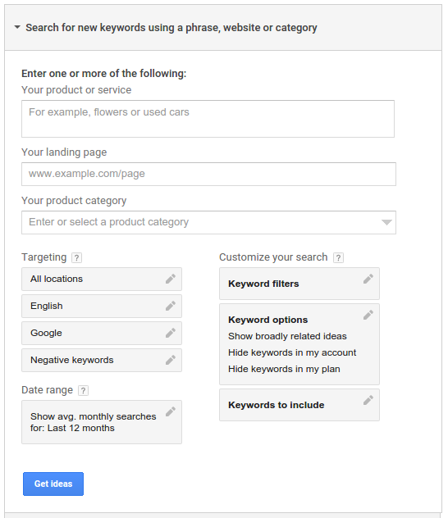

Each of the input fields may be translated to a matching TargetingIdeaSelector setting (for instance, SearchParameter) to achieve functionality similar to that of the Keyword Planner[9]:

| Keyword Planner | AdWords API |
| --- | --- |
| Your item or service | RelatedToQuerySearchParameter |
| Your touchdown page | RelatedToUrlSearchParameter |
| Your product classification | CategoryProductsAndServicesSearchParameter (refer to our Product and Services Categories taxonomy or IDs) |
| Location targeting | LocationSearchParameter |
| Language Targeting | LanguageSearchParameter |
| Network Targeting | NetworkSearchParameter |
| (Monthly Search Volume) Date Range | Choose AttributeType. TARGETED_MONTHLY_SEARCHES |
| Average monthly searches for keyword filters | SearchVolumeSearchParameter |
| Competition for Keyword Filters | CompetitionSearchParameter |
| Keywords to Include/Exclude | IdeaTextFilterSearchParameter  ExcludedKeywordSearchParameter |

Finally, change the TargetingIdeaSelector.requestType property to IDEAS[10].

**Discover the latest trends and search volume.**

The parameters mapping resembles other comparable functions in the following ways[9]:

| Keyword Planner | AdWords API |
| --- | --- |
| Enter keywords here. | RelatedToQuerySearchParameter |
| Location targeting | LocationSearchParameter |
| Network targeting | NetworkSearchParameter |
| (Monthly Search Volume) Date Range | Choose AttributeType. TARGETED_MONTHLY_SEARCHES |

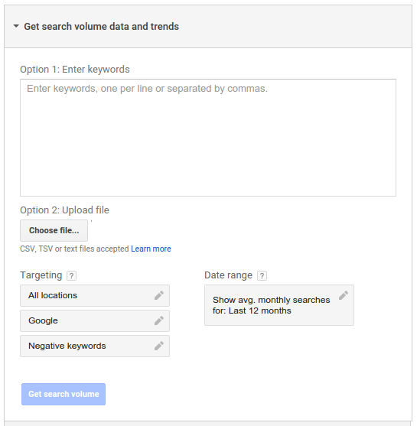

Finally, specify the STATS request type for the TargetingIdeaSelector. Multiply keyword lists to get new keywords.

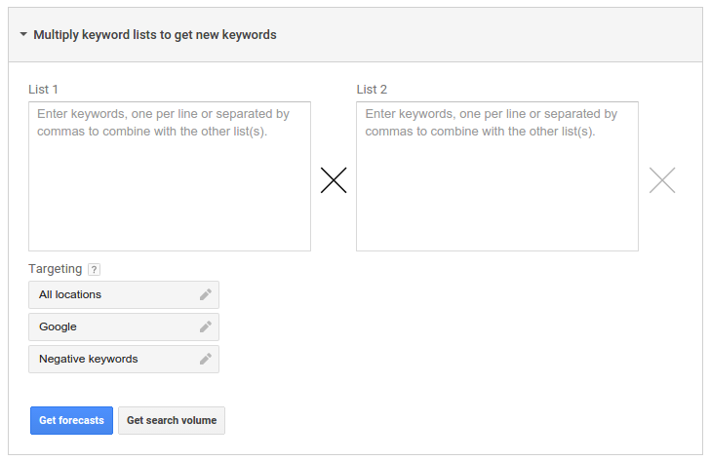

AdWords API doesn't automatically combine keywords. The combined keywords list must be produced programmatically, and the TargetingIdeaSelector must be specified[9].

| Keyword Planner | AdWords API |
| --- | --- |
| List 1 and List 2 | Combine the two lists programmatically and then use the RelatedToQuerySearchParameter. |
| Location targeting | LocationSearchParameter |
| Network targeting | NetworkSearchParameter |

**Using the Keyword Planner as a map**

To get Google Ads Keyword Planner forecasts, utilize the TrafficEstimatorService to input or upload keywords[10].

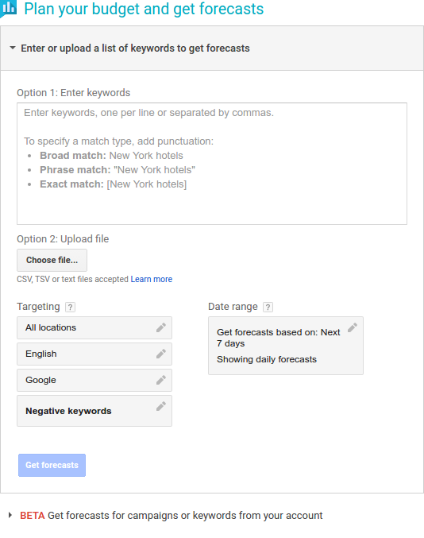

To use TrafficEstimatorService, you must supply an already-running campaign or develop a fictitious campaign with ad groups and keywords[9].

| Keyword Planner | AdWords API |
| --- | --- |
| Enter Keywords | KeywordEstimateRequest |
| Location targeting | Use the Location criterion in CampaignEstimateRequest.criteria. |
| Language Targeting | Use the Language criterion in CampaignEstimateRequest.criteria. |
| Network targeting | CampaignEstimateRequest.networkSetting |
| Date Range | Not Supported |

**Reports' Mapping to the Google Ads UI**

The Google Ads UI reports are mapped to the AdWords API[9].

**Typical terms**

Table following lists UI terms and their API translations.

| UI | API |
| --- | --- |
| Columns | fields |
| Date Range | dateRange |
| Filters | predicates |
| Segmentation | Certain fields cause segmentation. |
| Pagination | paging |
| Download Formats | downloadFormat |

**Columns**

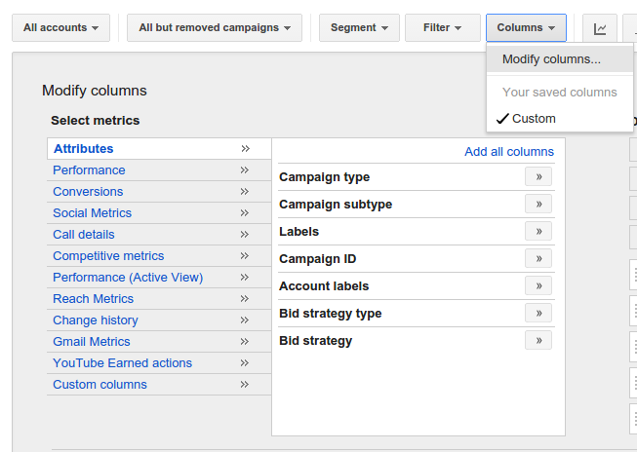

The fields API property and columns UI menu let you edit report columns. Name and Display Name refer to the field name in your API report specification and UI.

**Filtering**

Date Ranges

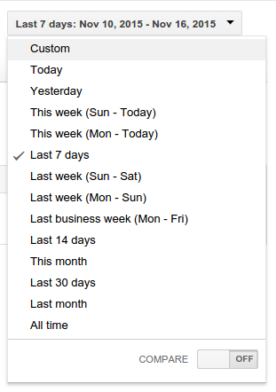

**Filters**

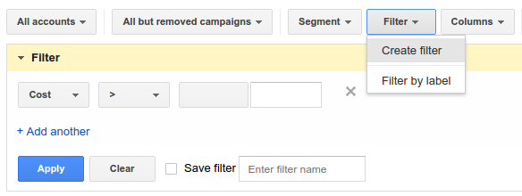

**Segmentation**

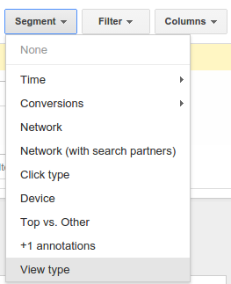

**Pagination**

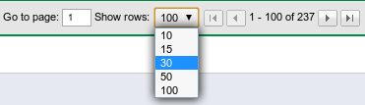

Options at the bottom of each data table let you switch between pages and set the number of results to show from a predefined range (UI)[11].

**Ordering**

Choose a column to sort UI results by.

**Download Formats**

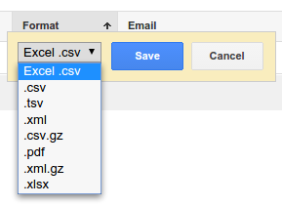

UI provides many report forms (csv, tsv, xml, etc.). API supports most file formats. API and UI reports share columns. Report types include impressions, clicks, and conversions. The following sections map account-level assets or items that may be shared across campaigns.

**Report on Bid Strategies**

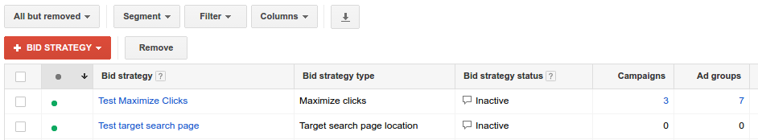

Select Bid Strategies from the Shared library drop-down menu on the left. API's Bid Goal Performance Report matches Bid Strategies data[11].

**Reports about budgets.**

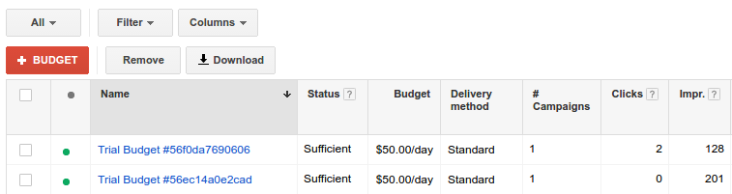

Left-click the Shared library tab, then Budgets to see the report. API's Budget Performance Report matches Budgets data[11].

**Reports on campaigns**

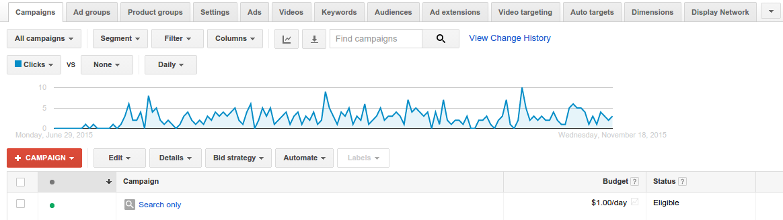

To access the Campaigns report, click Campaigns to the left of Ad groups. When viewing a campaign, the Campaigns tab is missing. Choose All campaigns from the top-left menu.

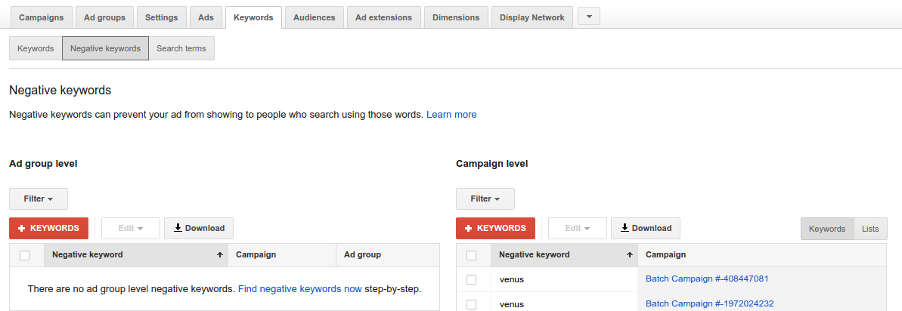

To display negative keywords, click Keywords > Negative. Negative keyword data is in the API's Campaign Negative Keywords Performance Report[11].

**Report on Placement Exclusions.**

View Negative placements table. The API contains exclusions data. CampaignCriterionService provides placement and exclusion details. Scroll down the Display Network tab to see Negative Placements[11].

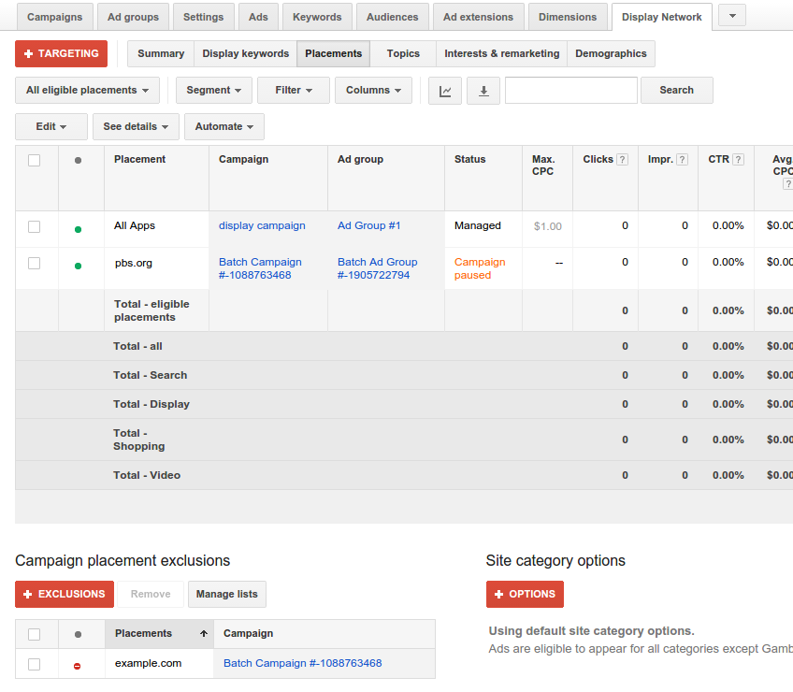

**Schedule for Campaigns Ad Target Report**

To see the Campaign Ad Schedule report, select Settings > Ad schedule. API's Campaign Ad Schedule Target Report contains campaign ad schedule data[10].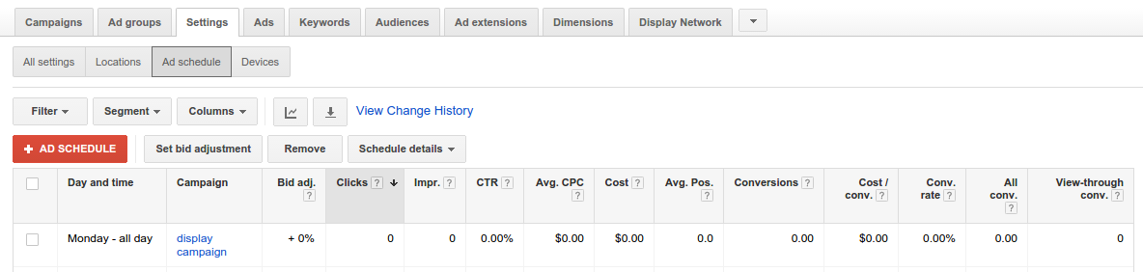

**Location Target Report for Campaigns.**

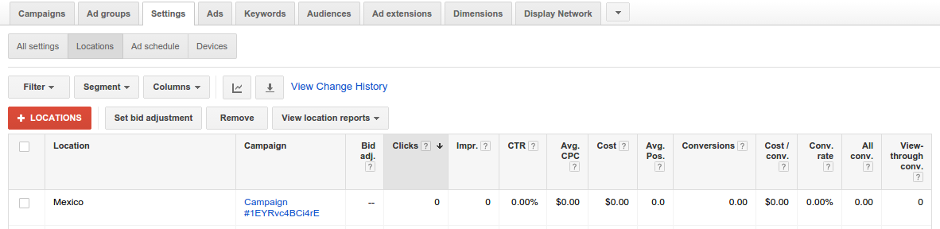

To access the Campaign Location Target report, select Settings > Locations. API's Campaign Location Target Report contains Campaign Location Target data[10].

**Ad Groups**

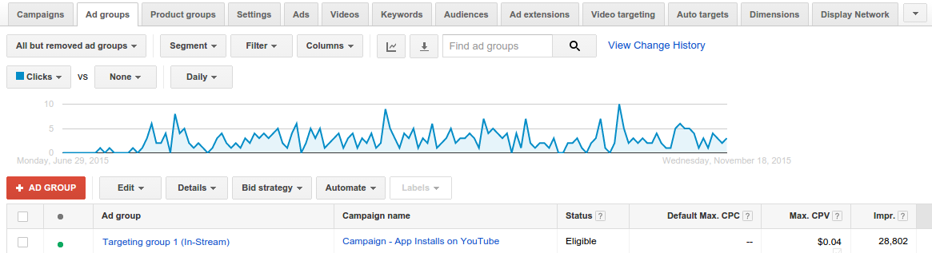

Get the Ad Groups report from the leading Ad groups. API AdGroup Performance Report matches AdGroups report[8].

**Report on Product Groups**

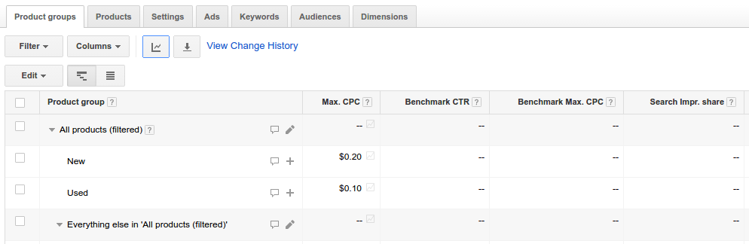

Choose an ad group from a Shopping campaign and visit the top Product Groups page. In the API, Product Groups is Product Partition[[8].

**Ad report**

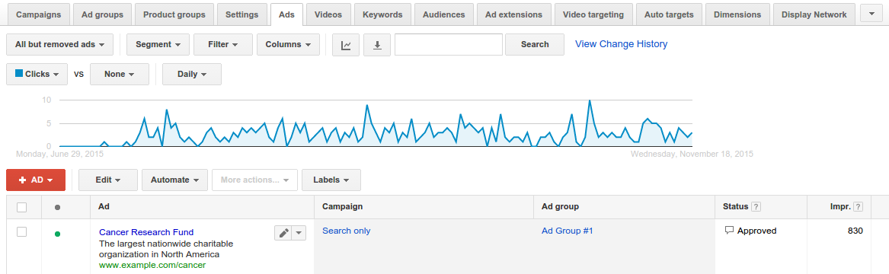

Get the Ads report from the Ads tab. API Ad Performance Report is Ads report[8].

**Report on Ad Extensions**

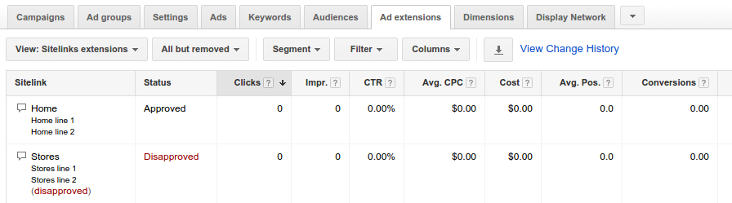

Go to the Ad Extensions page and pick a view to get the report. If the Ad extensions tab isn't visible, click the right arrow and pick it. Ad extension report corresponds to Placeholder Feed Item Report and API Placeholder Report[8].

**Report on Call Details**

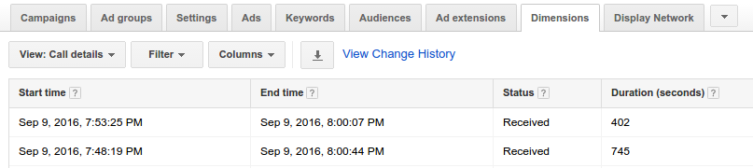

See Call Details by clicking the top Dimensions tab. API's Call Metrics Call Details Report is the Call Details report[8].

**Category Report without Keywords**

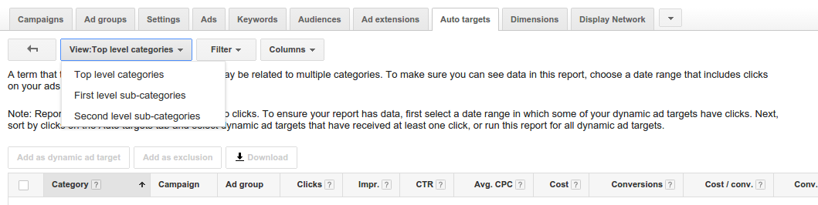

Select All on the top Auto targets page to get the Keywordless Category report. Picking ONLY Category 0 in the API report is like selecting Top level categories. Multiple Category selection has no Google Ads UI equivalent[8].

**Report on keywordless queries**

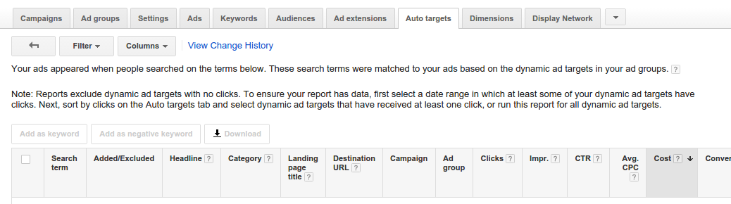

On the Auto targets page, choose All in the Get search words... list box to see the Keywordless Query report. API's Keywordless Query Report contains Keywordless Query data[10].

**Report on Keywords**

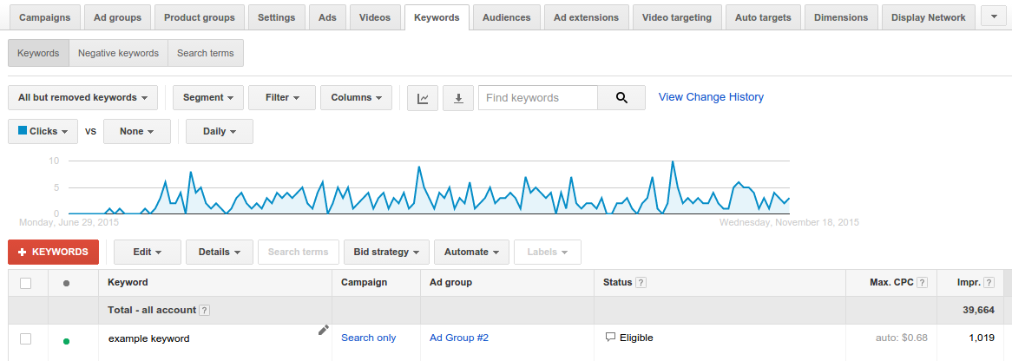

Go to the top Keywords tab to get the Keywords report. The Keywords Performance Report in the API corresponds to the Keywords report[8].

**Report on Displayed Keywords**

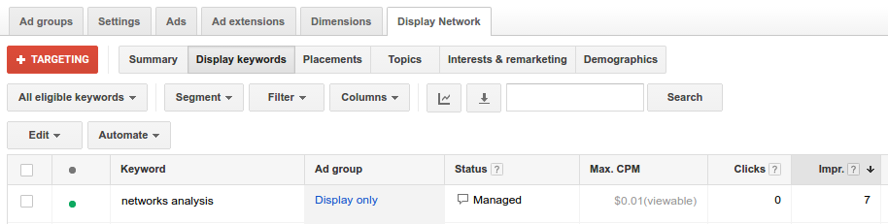

After choosing Display Network, click Keywords to receive the Display Keywords report. Display Keyword Performance Report in API is Display Keywords report. Other terms aren't included in API reports[8].

**Report on Automatic Placements.**

Only this report, not AdGroupCriterionService, provides API automated placements data. Automatic placements served your ads based on parameters other than locations. API's Automatic Placements Performance Report segments Display traffic by domain[11].

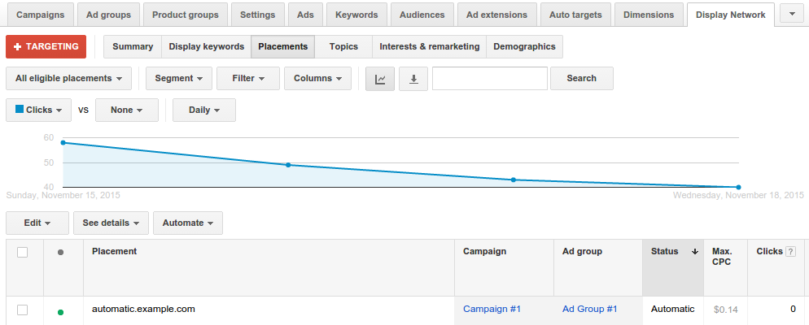

**Managed Placements Report**

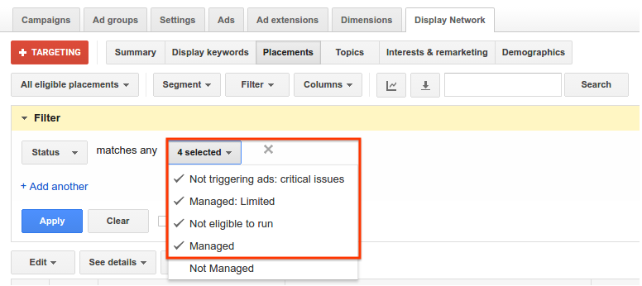

The Managed Placements report is the API's Placement Performance Report. AWQL query produces same report with UI values. Using auto-targeting, the API will also show traffic from other websites[11].

**Topics Report**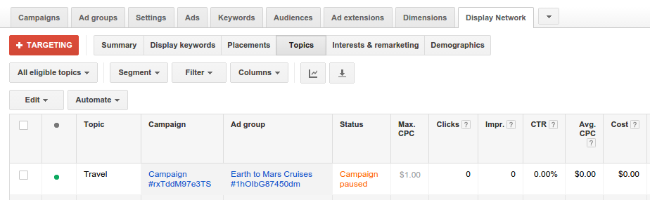

After clicking Display Network, click Topics to see the report. If you can't see Topics, click the right arrow. One row per topic pools all statistics[8].

**Audience Survey**

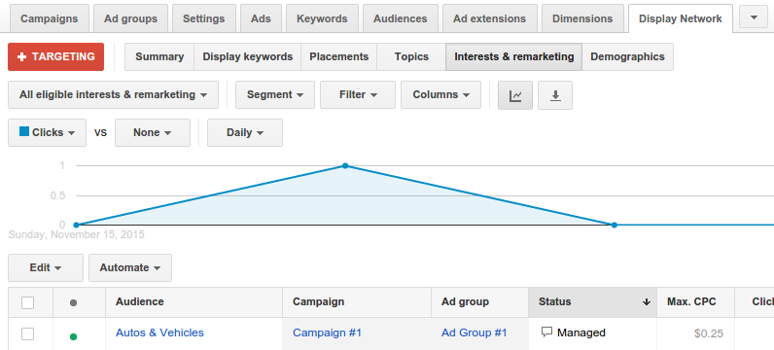

API Audience Performance Report is Audiences report. After choosing Display Network, click Interests & remarketing to get audience data. If you're searching for a certain audience, click the right-most down arrow[10].

**Gender Analysis.**

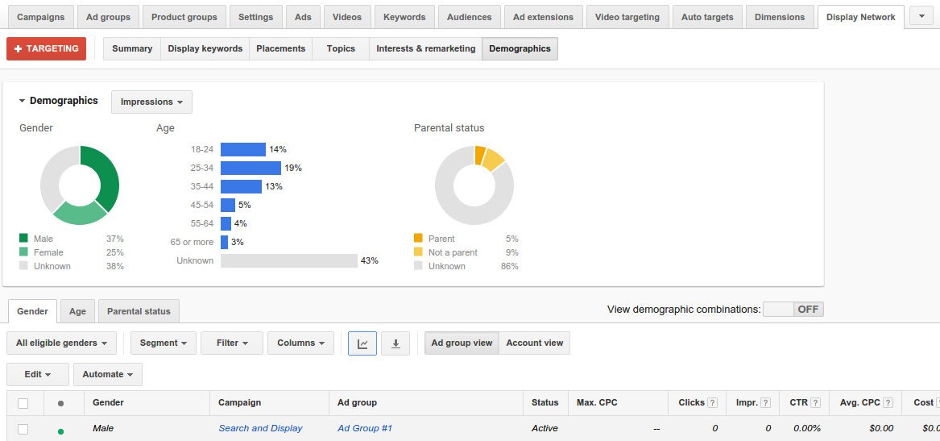

For gender information, choose Display Network, Demographics, and Gender. API's Gender Report and Gender Performance Report are the same[10].

**Report on Age/Report on Age by Age Group.**

View the Age Range report by clicking Display Network, Demographics, and Age. API Age Range report is Age Range Performance Report[9].

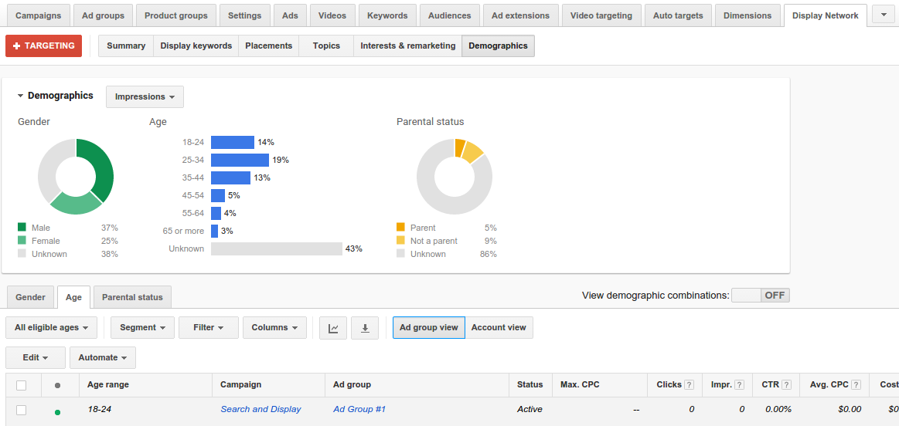

**Report on parental status.**

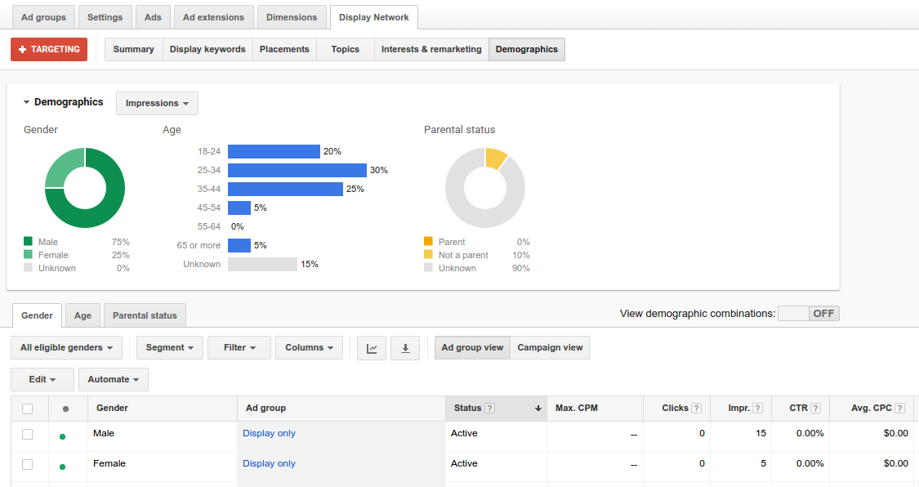

View the Parental Status report by clicking Display Network, Demographics, and Parental Status. API Parental Status report refers to Parental Status Performance Report[10].

**Report on Top Content.**

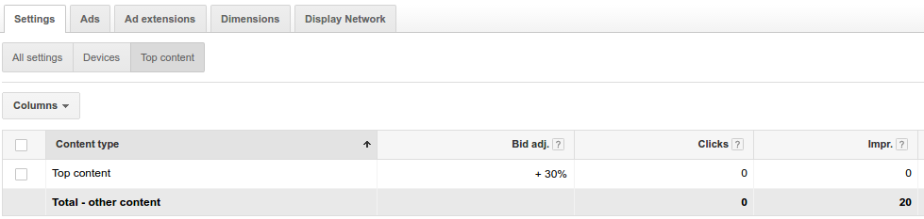

To see Top Content, choose an ad group from a Display Network campaign. Select Settings, then Top content. Top Content Performance Report in API matches Top Content report[10].

**Report on Destination URL**

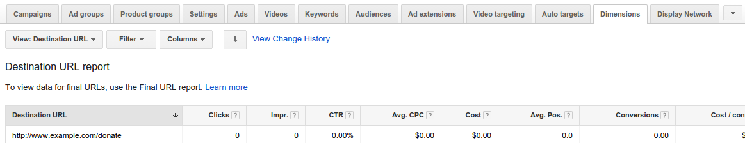

Choose Destination URL from the Dimensions tab to see the report. Destination URL report is API's Report on Destination URLs[8].

**Final Report URL**

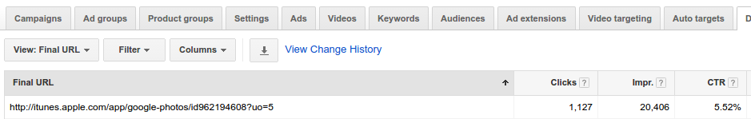

On the top Dimensions page, click Final URL to see the report. Final URL Report matches API's Final URL Report[8].

**Link Report**

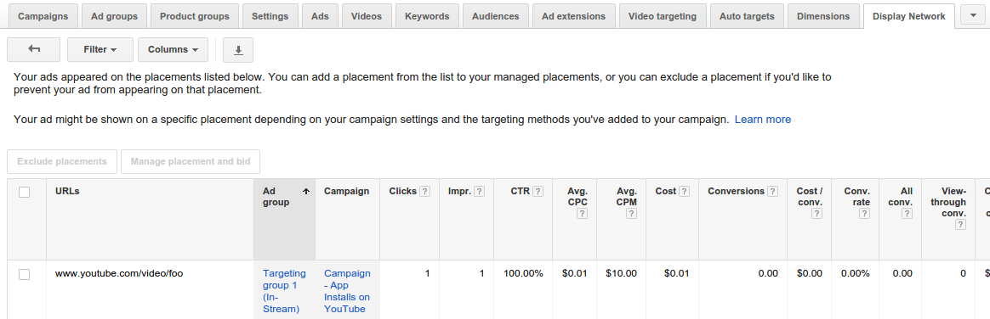

To see the URL report, go to Display Network > Placements. By clicking See details->All, you may extend your managed placements. URL report is API's URL Performance Report[8].

**Report on search terms.**

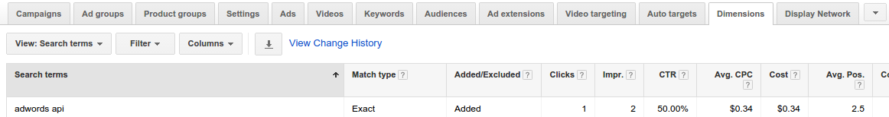

Choose See Search words from the Dimensions menu to get the Search Terms report. Search Terms report is API's Search Query Performance Report[9].

**Organic and Paid Report.**

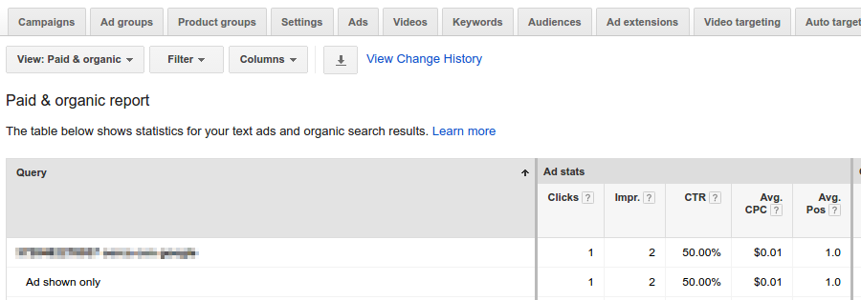

To view Paid and Organic, click Dimensions > Paid & Organic. Paid and Organic API report is Paid Organic Query Report[9].

**Geological Report**

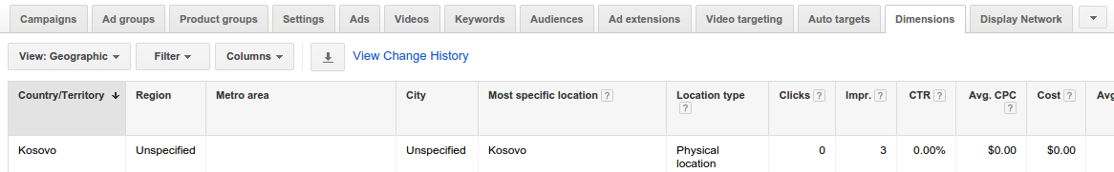

View the Geographic report by clicking the Dimensions tab and selecting Geographic. Geographic report transforms to API Geo Performance Report with given predicates. API report documentation provide details[9].

**Report on User Locations**

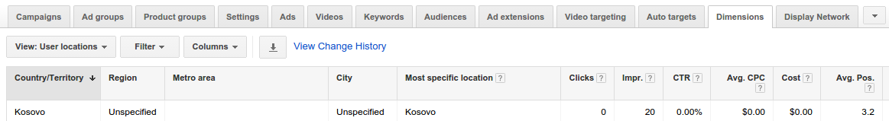

Choose the User Locations report from the Dimensions tab. With defined predicates, the API converts User Locations to Geo Performance[9].

**Clicks Report for Free**

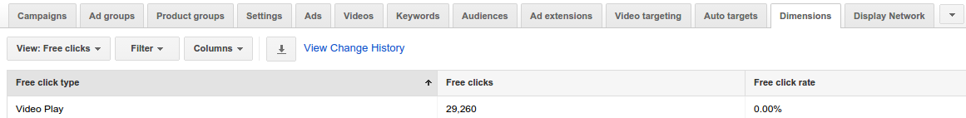

Report usage examples using the Click Performance Report or other aggregated reports. ValueTrack choices match AdWords API fields, although not necessarily with the same content. When auto-tagging is enabled, each URL is given a GCLID that may be used to link ad clicks to Google Analytics rows[9].

**How ValueTrack parameters map to report fields** [8]:

| ValueTrack Parameter | Field(s) in Click Performance Report | Other Report Fields | Description |
| --- | --- | --- | --- |
| {adgroupid} | AdGroupId | * AdGroupId * TargetingAdGroupId | The ad group ID. (Use this when you've set up your tracking info at the account or campaign level and want to know which ad group served your ad.) |
| {adposition} | Maps to a combination of:   * Page * Slot   Note that currently there isn't a field that maps to the ad's location (for example "top", "side", etc.) | Slot | The position on the page where your ad appeared, with a value like "1t2" (this means page 1, top, position 2). |
| {campaignid} | CampaignId | * CampaignId * BudgetPerformanceReport.AssociatedCampaignId * TargetingCampaignId | The campaign ID. (Use this when you've set up your tracking info at the account level and want to know which campaign served your ad.) |
| {creative} | CreativeId | * CreativeId * AdId * AdPerformanceReport.Id | A unique ID for your ad. |
| {device} | Device | Device | The type of device the click came from. |
| {feeditemid} |  | FeedItemId | The ID of the extension that was clicked. |
| {keyword} | CriteriaId  Note that the text query can be found using the criteria ID. | * KeywordPerformanceReport.Criteria * CriteriaPerformanceReport.Criteria * DisplayKeywordPerformanceReport.Criteria | For the Search Network, the keyword from your account that is matched to the search query. For the Display Network, the keyword from your account that is matched to the content. |
| {loc_interest_ms} | AoiMostSpecificTargetId |  | The ID of the location of interest that helped trigger the ad. |
| {loc_physical_ms} | LopMostSpecificTargetId | GeoPerformanceReport.MostSpecificCriteriaId | The ID of the geographical location of the click. |
| {lpurl} |  | * FinalUrlReport.EffectiveFinalUrl * SearchQueryPerformanceReport.FinalUrl * FinalUrls * AdPerformanceReport.CreativeFinalUrls | The final URL. It will be escaped unless you put {lpurl} at the beginning of your tracking template. If {lpurl} is not at the beginning of your tracking template, the following characters are escaped: ?, =, ", #, \t, ', and [space]. |
| {matchtype} |  | * KeywordMatchType * PaidOrganicQueryReport.QueryMatchType * SearchQueryPerformanceReport.QueryMatchTypeWIthVariant | The match type of the keyword that triggered your ad. |
| {merchant_id} |  | ShoppingPerformanceReport.MerchantId | The ID of the Google Merchant Center account directly owning the clicked Shopping Ad. |
| {placement} |  | * PlacementPerformanceReport.Criteria * CriteriaPerformanceReport.Criteria * AutomaticPlacementsPerformanceReport.DisplayName | The content site where your ad was clicked (for keyword-targeted campaigns), or the matching placement targeting criteria for the site where your ad was clicked (for placement-targeted campaigns). |
| {product_channel} |  | ShoppingPerformanceReport.Channel | The type of shopping channel through which the product featured in the clicked Product Listing Ad is sold. |
| {product_country} |  | ShoppingPerformanceReport.CountryCriteriaId | The country of sale for the product in the clicked ad. |
| {product_id} |  | ShoppingPerformanceReport.OfferId | The ID of the product featured in the clicked ad, as indicated in your Merchant Center data feed. |
| {product_language} |  | ShoppingPerformanceReport.LanguageCriteriaId | The language of your product information, as indicated in your Merchant Center data feed. |
| {product_partition_id} |  | ProductPartitionReport.Id | The unique ID for the product group the clicked product ad belongs to. |
| {store_code} |  | ShoppingPerformanceReport.StoreId | With a campaign using the local shopping channel, you’ll see the unique ID of the local store. |
| {targetid} | [CriteriaId](https://developers.google.com/adwords/api/docs/appendix/reports/click-performance-report#criteriaid) | * CriterionId * AudiencePerformanceReport.Id * KeywordPerformanceReport.Id * CriteriaPerformanceReport.Id * DisplayKeywordPerformanceReport.Id | The ID of the keyword (labeled "kwd"), dynamic search ad ("dsa"), or remarketing list target ("aud") that triggered an ad. For example, if you add a remarketing list to your ad group (criterion ID "456") and target the keyword ID "123", the {targetid} would be replaced by "kwd-123:aud-456"  . |

**Use case view**

**Adapting Text Ads**

AdWords lets users add dynamic data to adverts using customizers, countdowns, and IF functions. Advertisements might incorporate strings, prices, numbers, and a countdown to a given day or time. Users may build up a feed with targeting options for campaigns, ad groups, and/or keywords, then create ads that reference the feed[15].

**Custom ad makers**

We must add the date attribute in a function to show a countdown in Google Ads. Google Ads populates the ad based on the feed item's name, selling price, and finish date. First, feed items may be targeted to a campaign, ad group, or keyword. You set the feed's order when you created it. The feed below has two STRING attributes and one DATE TIME property. These properties are directly retrieved from mutating. You need the feed and property IDs to use in your ad[15].

**Make specific FeedItems.**

Creating a Feed item with these characteristics limits the feed to a campaign, ad group, keyword, or location. If many feed items meet a context, the system chooses one at random. All advertisements in that ad group will utilize these feed components for dynamic replacements[13].

**The feed in an advertisement**

The API checks ad customizer-related ads. No feed with the desired name will allow the ad. If you delete a feed while advertising are using it, the adverts will cease. Every ad feed must link to the same Feed[16].

**Include a countdown**

Using COUNTDOWN, you may monitor the user's time zone event's remaining time. If this field is set to 5 days before the time, the ad won't run. You might change the language to Spanish and show the ad 3 days before the specified date[16].

**Include an IF function.**

IF functions let you tailor your ad according to the user's search device. Remove default text[16].

| Dimension | Criteria | Syntax | Example |
| --- | --- | --- | --- |
| device | mobile | {=IF(device=mobile,text to insert):optional default text} | {=IF(device=mobile,"Quick, Easy, Mobile Booking"):"Best price guarantee"} |
| audience | Any valid user list name in your account (if list name matches multiple lists in advertiser account, we will randomly pick any) | {=IF(audience IN (userlist1,userlist2),text to insert):optional default text} | {=IF(audience IN (returning visitors,cart abandoners),30%):25%} |

**Ad specifications**

Ad parameters allow dynamic updates to numerical ad data without resubmission. The insertionText property's line length constraints are a general guideline and don't account for character widths. Character combinations may be within the character limit but beyond the

display length limit[13].

**Functions Matching**

CustomerFeed, CampaignFeed, and AdGroupFeed API objects enable you match feed item criteria. These features apply to a function that selects FeedItem objects with feedItemIds 1000001, 1000002, or 1000003.

RequestContextOperand with contextType=FEED ITEM ID, lhsOperand

driver = IN

(1000001, 1000002, 1000003) rhsOperand

Instead of creating operand and operator objects, set the function's functionString.

IN(FEED ID,1000001,1000002,1000003). You can combine fundamental functions to create new ones, but there are limits[16].

**Typical feed items**

The following feed items from fictitious feed ID 12345678 are used in the example[16].

| FeedItem ID | Attribute 0 Name | Attribute 1 Line 2 | Attribute 2 Line 3 | Attribute 3 Final URLs |
| --- | --- | --- | --- | --- |
| 1000001 | Mars cruise | Travel at light speed | 140 million miles | [http://www.example.com/mars] |
| 1000002 | Venus cruise | Travel at light speed | 162 million miles | [http://www.example.com/venus] |
| 1000003 | Jupiter cruise | Lunch included | 365 million miles | [http://www.example.com/jupiter1, http://www.example.com/jupiter2] |
| 1000004 | Moon cruise | Free pretzels | 238,900 miles | [http://www.example.com/moon] |

**Types of functions:** You can use this function type to only show certain ad extensions (placeholder kinds) to desktop or mobile visitors[14].

| Field | Valid Value |
| --- | --- |
| lhsOperand | RequestContextOperand with contextType = DEVICE_PLATFORM |
| operator | EQUALS |
| rhsOperand | a *single* ConstantOperand of either Mobile or Desktop  (case-sensitive) |

This function type selects feed items by feedItemId. The function string below selects the first three feed items by ID (Mars cruise, Venus cruise, and Jupiter tour).

| Field | Valid Value |
| --- | --- |
| lhsOperand | RequestContextOperand with contextType = FEED_ITEM_ID |
| operator | EQUALS or IN |
| rhsOperand | one or more ConstantOperands   * must be exactly 1 ConstantOperand for EQUALS * max of 20 ConstantOperands for IN |

**Processes of identity (always true or always false)**

This function creates a true-or-false condition. Using IDENTITY(true), you may choose all feed items. This function string makes no feed choices. Disable ad extensions for a campaign using this capability[14].

| Field | Value |
| --- | --- |
| lhsOperand | Each boolean value (true or false) is stored in a single object.  ConstantOperand. |
| operator | IDENTITY |
| rhsOperand | *none* |
| String example that performs a function | |
| IDENTITY(false)  **Decisions about identity (always correct or incorrect)**  The function may construct a true-or-false condition. Using IDENTITY(true), you may choose all feed items. We choose nothing from the feed in the following function string. This tool removes ad extensions from a campaign, client, or ad group[14].   | Field | Value | | --- | --- | | lhsOperand | ConstantOperand's booleanValue may be true or false. | | operator | IDENTITY | | rhsOperand | *none* | | Function string example: IDENTITY(false) | |   **Function operator rules**[16]  Below are function operator validation criteria.  IN operator  The rhsOperand can only have 20 ConstantOperand objects.  Driver EQUALS  rhsOperand must have one ConstantOperand.  AND operator  lhsOperand must have 2+ FunctionOperand objects. Misusing rhsOperand.  Operator INCLUDES ANY  rhsOperand must have one to three ConstantOperand objects.  **Operator information**  You may use any of the function types or function combinations for a matching function, except CustomerFeed is for location extensions. lhsOperand must have 1 ConstantOperand with booleanValue. Misusing rhsOperand. CustomerFeed supports all placeholders except Call and Message**[13]**  **CustomerFeed must be the location placeholder type.**  Any combination of function types may be used to define CampaignFeed and AdGroupFeed functions. ConstantOperand location placeholders must use CustomerFeed[16].  **Targeting choices for FeedItems**  Programmers match clients, campaigns, and ad groups and target feed items. These targeting criteria determine which feed items are used. Google Ads only serves site connections from Feed Items if both FeedItem targeting and AdGroupFeed matching are met[16].  **Table 1**   | The impression attributes include desktop user, ad group ID 12345, and keyword 7890. | FeedItem won't be utilized since Desktop doesn't match AdGroupFeed. | | --- | --- |   **Table 2**   | Mobile user, keyword 8910, and ad group ID 12345 are examples of impression attributes. | Word(7890) won't be used since it doesn't match FeedItem targeting criteria. | | --- | --- |   **Table 3**   | The impression features include a mobile user, keyword 7890, and ad group ID 12345. | FeedItem will be used because its attributes match the AdGroupFeed matching function. | | --- | --- | | |

**Data View**

Google Keyword Planner gives us access to Google's keyword database. "Top of page bid" displays the average amount paid to appear at the top of search engine results. This term has fierce competition. We will be reviewing the data view that is included topics such as Multiple Purposes, Monthly Average of Searches, Search for High-Value Keywords, Recognize the User Base's Origins, Examine seasonal trends, Easily Create Ads, How to Use Google Keyword Planner Step by Step, New Keyword Research, Forecast the volume of searches, Bonus Advice, Trends in search volume, Pro Tip for Keyword Planner, Plan Overview, Techniques for Google Keyword Planner, Examine Suggested Bid to Discover Profitable Keywords and View the Devices That People Are Using[1].

**Multiple Purposes**

Google Keyword Planner can help you choose keywords and estimate their advertising costs.

**Monthly Average of Searches**

A word that perfectly describes our service is useless if no one uses it. We want to find long-tail keywords with many monthly searches. We should find middle-ground words.

**Search for High-Value Keywords**

As customers, not every phrase is important. If we want to market anything, we should use commercial words. Using "top of page huge" criterion, you may find the best keywords your competitors have bought.

**Recognize the User Base's Origins**

Google Keyword Planner may reveal your audience's gadgets. Take advantage of the fact that your target market enjoys searching on smartphones.

**Examine seasonal trends**

Statistics show how user interests change over time. Using this data, you may change your strategy before your product's peak season. It also recommends seasons based on user searches. This lets you provide special rewards to customers.

**Easily Create Ads**

Keyword research is important for creating Google Ads campaigns. These campaigns need keyword research. If you've done your homework, you may add keywords to your ads.

**How to Use Google Keyword Planner Step by Step**

Sign into Google Ads. After logging in, click "Tools" on the top right. "Tools" has the Keyword Planner. The Keyword Planner gives you two options. "Get search volume and forecast" or "Find new keywords"

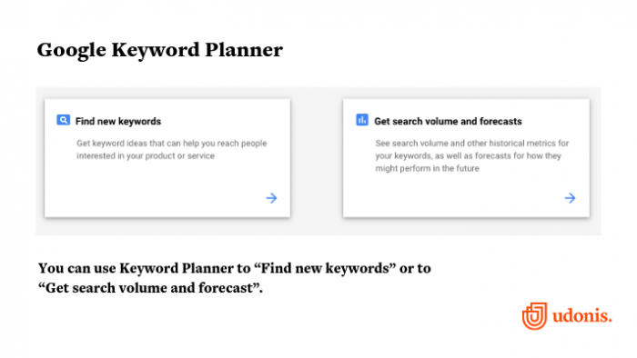

Google Keyword Planner offers two alternatives.

**New Keyword Research**

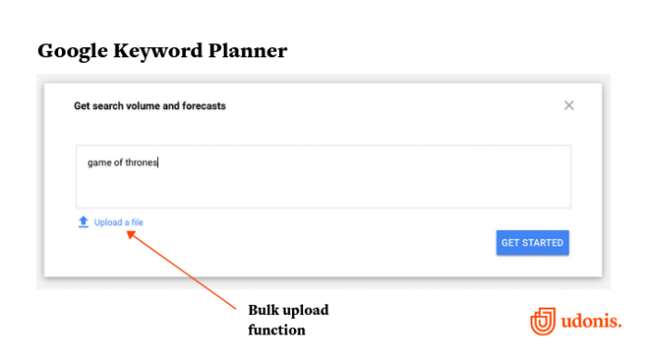

Google Keyword Planner's find new keywords feature.

Choose this option if you need help selecting keywords for a new or current campaign. You may search for keywords using a website URL, a phrase, or product-related terms. After entering your query, click "Get Started."

**Forecast the volume of searches.**

Some keywords perform year-round, others seasonally. Paid social media and PPC advertising are likewise seasonal. Google Keyword Planner compares keyword searches over time. You won't receive additional keyword ideas, but you may filter seasonal or popular ones.

**Bonus Advice**

You may add several words or phrases using bulk insert. This tool lists all search terms during a certain time period. You may specify the search period at the top. You may search for a date range or the past year. Plan options let you pick a language, search networks, and search location.Filters narrow searches. Filter keywords, competitiveness, and top page bid.Blue for total searches, red for mobile. This graphic indicates how often your keyword is

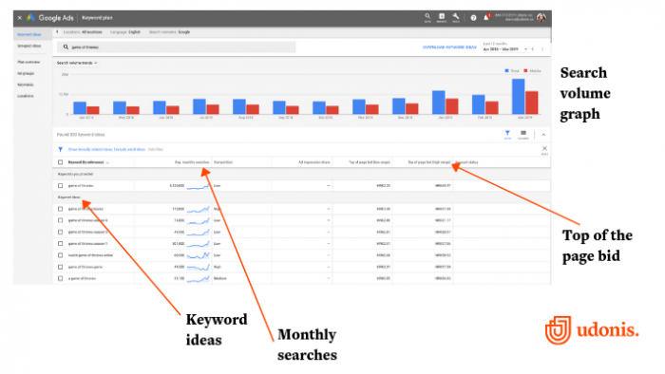

Google Keyword Planner Overview

searched on mobile devices. Google has emphasized mobile traffic in recent years.

**Trends in search volume**

Add 2 drop-downs to search volume trends. Mobile, desktop, and tablet search percentages are available. Find the busiest areas by location. Suggestions appear under your search term. Improve keywords with downloads. Track a term's popularity by hovering over monthly searches. The contest shows the term's popularity. "Low, medium, high" appears. Low-competition themes have fewer ads than competitive ones. SEO ignores low and high top-of-page bids, but they're useful for advertising.

**Pro Tip for Keyword Planner:**

Download keyword suggestions for a spreadsheet with all the results. After that, upload all the results to a Google Spreadsheet on your Drive to filter and choose the most relevant ones. Downloaded data may be imported using "replace data at specified cell." Create a spreadsheet with all the keywords.

**Plan Overview**

In the Plan Overview section, you'll see your keyword plan. This lets you compare words and compile a report.

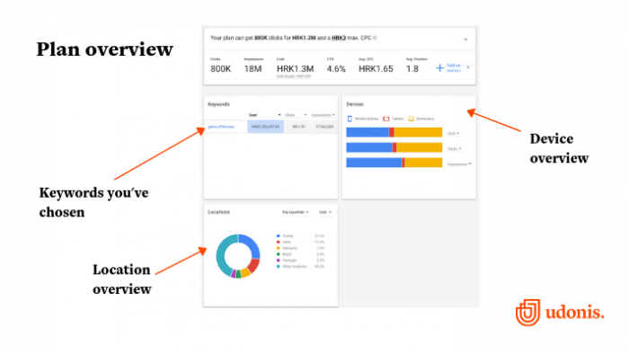

**Techniques for Google Keyword Planner**

Here are various techniques many people don't know about.

**Examine Suggested Bid to Discover Profitable Keywords**

How can you tell which are deserving of your patronage? by examining the columns for proposed bids?

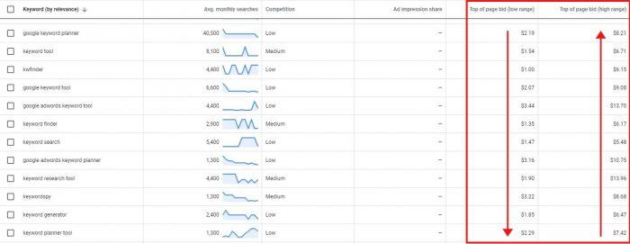

Even if they're PPC-related, these signs may help you. Imagine ranking organically for such keywords if consumers were willing to pay a much for one click. To divide this column, click the header. Put the most lucrative keywords first.How to find these queries in Keyword Planner. Under Filter > Keyword text > contains, enter who, what, why, when, where, etc.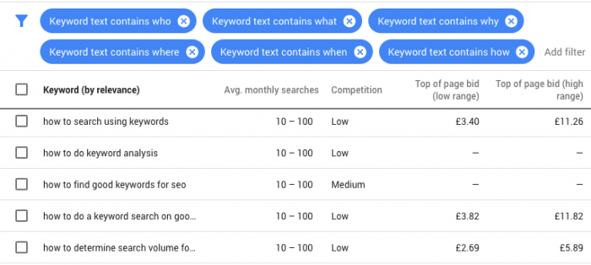

**View the Devices That People Are Using.**

Since computers, tablets, and smartphones have varied screen sizes, optimizing your site may be difficult. Visit the Plan Overview to add a keyword. Check Devices' Impressions bar. Roll over to see how many imprints each gadget makes.

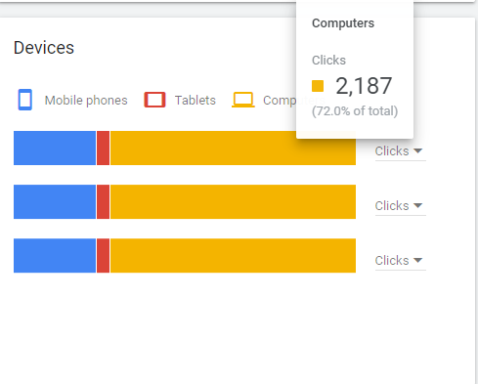

**5.** **Analysis and Design**

**5.1 Functional requirements:**

A comprehensive breakdown of the four functional requirements for the Google Keyword Planner tool is provided [1].

**Type 1: Concepts for ad categories and keyword searches.**

The user may generate keyword ideas by inputting up to 50 keywords and a single target site or product category. Pick the language and either "Google" or "Google and search partners" as applicable. Unfortunately, there is no way to restrict results to just those that are "directly related" to your query. Changing the results' overall theme requires more or fewer keywords. The planner might sometimes be filled with jargon that doesn't add anything to the research. Planner outputs include suggested keywords and ad groups, as per normal. Nonetheless, the only indicators provided are search volume, competition, and cost per click.

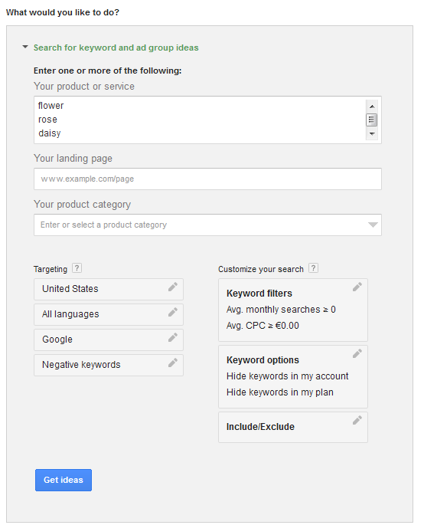

**Ideas for using a keyword planner**

**Type 2: Test the Efficiency of Keywords You Provide or Upload.**

Checking the search traffic and prospective account performance of keywords is possible. Here, you may input up to 1,000 keywords manually or upload a CSV file with up to 10,000 keywords. In addition to location, you may choose between "Google" and "Google and search partners." Although the language is not a choice during the upload process, it may be used as a filter once the first results have been shown. This type does not provide new keyword recommendations; to see them, choose type 1. In this format, "Get estimates" and "Get search volumes" are treated separately. When the option to "Get search volume" is selected, data on searches, competition, and cost per click (CPC) are shown. After entering the offer and daily budget, if you choose "Get estimates," the planner will provide you projections for the clicks, impressions, placements, costs, CTR, and CPC of the keywords.

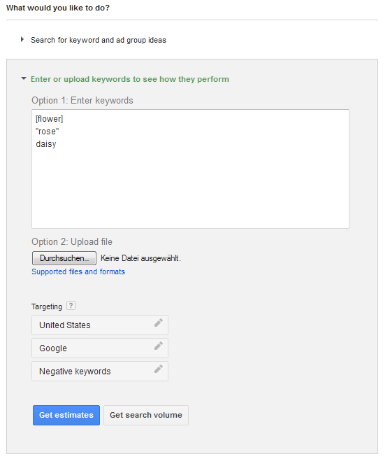

**Projections for the target keywords in the keyword planner**

**Type 3: multiply lists of keywords.**

A package is represented by this data type. When merging several keyword lists, the merging can only go in one way (A and B = AB, but not: AB and BA). There should be no more than 1,000 keywords in the combined list; much more than that, and we won't be able to get any meaningful search traffic or projections. Preferences for location and "Google"/"Google and search network" may be specified, however, language cannot. But it's easy to make changes down the road if needed. No creative thinking is accomplished by this kind.

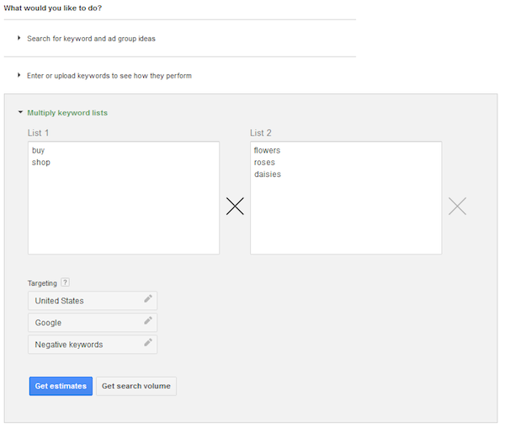

**Multiplying Keyword lists in the keyword Planner.**

**Type 4: Local Targeting**

Besides choosing whole nations, you may also choose specific regions (like Louisiana's Shreveport) or even certain cities (e.g., New York). This is a huge step forward, especially for regional SEO experts or advertising that target a specific geographic area. If you're looking to group nations together on the basis of language, this is a great resource. It takes numerous processes to gather both global and local search trends, such as the Google search results and the Google search network.

In addition, the search volumes for mobile devices and desktop computers are combined into a single graph. Therefore, the data simply applies to any and all gadgets. To eliminate any confusion, the English terms are removed from the list when the German language is chosen. This eliminates the possibility of distinguishing between variables and conducting a more thorough study.

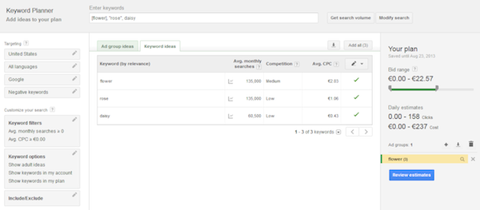

**5.2 Non-functional requirements [2]:**

1. **Both in terms of physical appearance and acceleration.**

It's more aesthetically pleasing, less complicated, and easier to use. There has also been a reduction in the amount of time it takes for Planner and Ads pages to load. There are now two ways to measure success: The proportion of total keyword-related organic search impressions that your website received. Using this metric, you can see how your website's pages typically do in organic search results when compared to results from other websites.

If you score well for the keywords and connect your Google Search Console (Webmaster tools) and Ads account, you'll have access to both. Navigate to "columns" and then "edit columns" to add them to your setup.

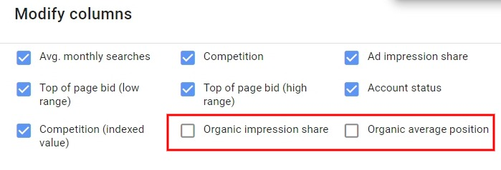

alter Keyword Planner columns

1. **A more rapid download time.**

In contrast to the time-consuming method in the past, today you may download your keyword data with a single click. You may now download your keyword suggestions with a table that breaks out average monthly searches by month for the time period you choose.

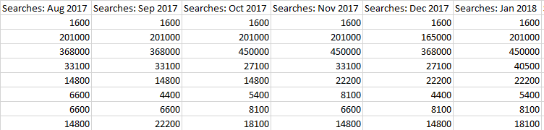

**The time report's monthly searches are broken down by month.**

1. **The Role of Other Ranking Factors.**

Google's search algorithms are constantly updated to take into consideration more than simply keywords. For instance, Google gives preference to websites that load quickly and provide easy access to their content, while penalizing those with features like pop-ups that detract from the user experience. If you want your website to rank well and be useful to visitors, you need to do more than just focus on keywords.

1. **The Performance of Google's Ads Planner.**

Every 24 hours, Google Ads Performance Planner is updated with new information on things like search volume, ad competition, bid prices, seasonality, and more. It's all in service of making our Google Ads tool more trustworthy by considering historical data with live metrics. As end-users, we benefit from receiving an accurate prediction of the rate of conversion. If you boost your budget by X euros, you can improve your clicks, conversions, or the value of Y conversions, claims Google's performance planner. Investment and other modifications like clicks, conversions, and the value of conversions may be measured with great accuracy.

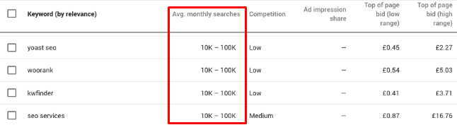

**Google's performance planner**

**5.3 Use case requirements [3]:**

Four criteria should be met by the keywords you choose to focus on: substantial search traffic, high relevance, good conversion value, and moderate competition. If you're missing even one of them, your SEO efforts are doomed to fail. You must ensure that the folks you wish to attract may really be found using your desired search phrases.

1. Search volume: Low search volume keywords are useless to optimize for. Investigate which keywords get a high volume of searches.
2. Relevance: Ideally, your chosen keywords would be an exact fit for your service or product. Get in touch with those that are seeking you.
3. Conversion value: The value of conversion may be increased by selecting search phrases that are more likely to result in desired actions (such as purchases or participation) than in passive discovery.
4. Competition: In a competitive situation, one must have a sober outlook. Aim for keywords that, once optimized, you have a good chance of seeing your website appear at the top of Google's search results.

**Conducting Keyword Analysis Is Part of User’s Homework**

It's not easy to choose the best keywords. If users have done their homework, they probably have hundreds of possible keywords to work with, along with a staggering quantity of information. (Not doing keyword research will render your target keywords useless). Find the most crucial information first. Luckily, Google's Keyword Planner makes this data easily accessible and free of charge. The monthly search volume and competitiveness score for a term is the most crucial metrics for an organic search strategy. Google Ads strategy development should also take into account the proposed bid for ad space.

* The average monthly volume of searches for a certain keyword term. (The monthly search volumes in the United States are used in the following example, but you may change this to any country or region you choose.)
* The level of rivalry for Google ad placement for this phrase is represented on a scale from 0 (lowest) to 1 (highest) (highest). Keep in mind that the level of competition in Google Ads isn't always reflective of the level of rivalry in organic search. Increase your competition score by Googling the crucial phrase. Do you believe you could take those pages full of high-quality results, or are they already there?
* The proposed bid is an approximation of the CPC that would be charged by Google AdWords for the specified search phrase.

Now that you have this information, you can choose the right keywords to attract the individuals who are actively seeking you out.

**Useful Keywords/ keywords selection to Use as an Illustration.**

In North Carolina, a blacksmith shop makes a significant portion of its income from the sale of hand-forged iron knives fashioned from railroad spikes. A common use for these knives is as wedding party gifts. For the sake of expanding their company, the blacksmithing enterprise paid for keyword analysis to determine which SEO phrases would be most effective.

Here is a small subset of the information they gathered from their keyword research on possible search keywords. Which of these phrases do you believe meets all four of the following criteria: search volume, relevancy, conversion value, and competition?

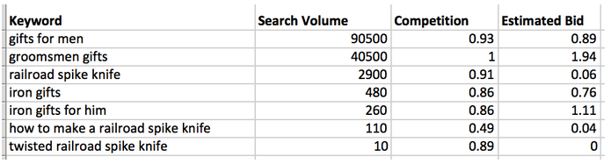

Although "gifts for guys" and "groomsmen presents" have huge search volumes, they are also so general that the shop's website is unlikely to appear at the top of Google results. It might be more appropriate to choose a site that offers a wider variety of presents for guys or groomsmen. Furthermore, there is a lot of rivalry for use of these phrases. 'Iron presents' has more potential since it is more synonymous with their offerings. The tagline "Iron presents for him" is especially appealing given the company's focus on male consumers. This is because these phrases are extremely relevant and have high conversion values, making them effective SEO targets despite their lower search numbers. There is a decent possibility that they may result in sales.

On the other side, "how to create a railroad spike knife" isn't worth pursuing since it won't generate many sales. Priority keywords should, in most cases, be phrases that get at least 30 searches each month. Due to an average of just 10 monthly searches, the phrase "twisted railroad spike knife" is not a high priority. To describe knives made by the blacksmith shop, it seems reasonable to use the term "twisted railroad spike knives." The "railroad spike knife" stands out as the best option here. It's quite popular, with an average of 2,900 monthly searches. It's a dead ringer for the stuff made by the blacksmiths. And it'll almost certainly result in some business. The keyword has a lot of competition, yet it's still worthwhile to optimize your site to rank for it.

**To strike a balance**

While it's ideal to locate keywords that excel in all four areas, this is very unlikely to happen. Don't get your hopes up about finding the perfect keyword that will bring in plenty of traffic from individuals who are primed to take action and has not yet been targeted by anybody else. In practice, you should consider these four factors when selecting keywords that have a chance of bringing about positive SEO results. Like the blacksmith who opted to go for a term with plenty of competition, you could settle for a keyword that falls short in one or two areas but excels in others.

**5.4. Design diagram:**

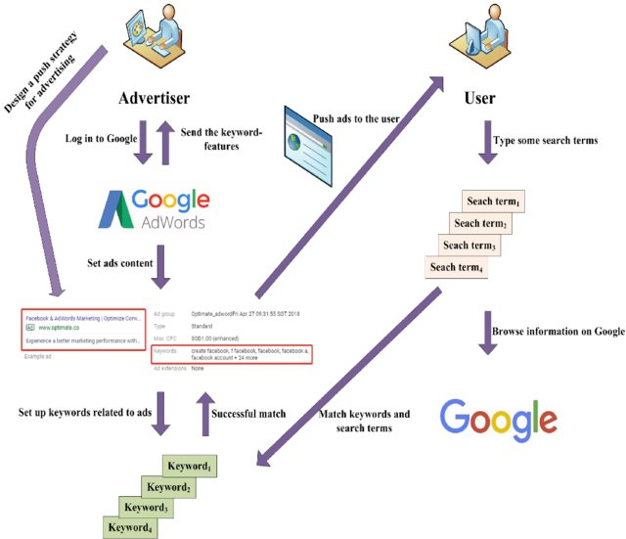

**Ads by Google's process flow diagram**

The work process of Google Ads is mainly divided into five measures. First, the advertiser sets the content of the advertisement according to their own needs. Second, the advertiser selects keywords on the system according to the advertisement content. Third, the set keywords are matched with the terms searched by the user in the search engine. In case of a high degree of matching, Google Ads will promote the ads to more relevant users. Fourth, Google Ads will send the keywords-features to the advertiser when the keywords are input into the Google Ads. Fifth, the advertisers adjust the strategy according to the features of the keyword. If these keywords are not ‘good’, they will be removed by advertisers from Google Ads. The specific process is shown in the above figure [4].

**5.5 Sequence diagram :**

**WORD EMBEDDING**

A model can only take in numerical data as input, hence natural language cannot be fed directly. As a result, we have the introduction of word embedding. By using word embedding, we may transform individual words into vectors. The process of word embedding allows for the numerical representation of natural language. Some linguistic issues may be investigated in this manner. Word embedding has recently become a standard technique for solving NLP(natural language processing) issues. It has several potential applications in the field of natural language processing, including but not limited to text categorization, document clustering, voice tagging, entity identification, and emotion analysis. Word2Vec and GloVe are the two most used approaches to embedding words. Also, Facebook's FastText released a few years ago, has seen widespread usage as an embedding tool for words due to its speed and efficiency.

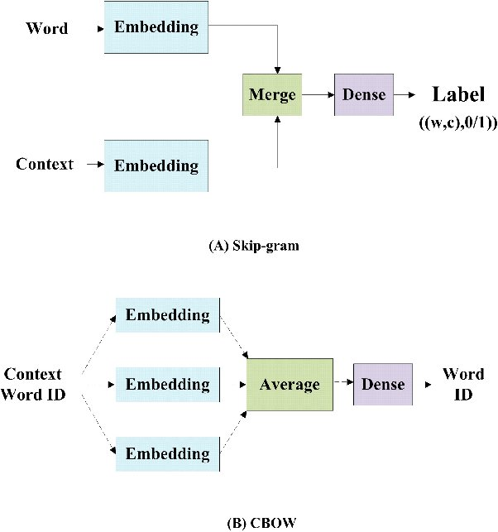

**Both skip-gram and CBOW Word2Vec models.**

Since the fundamentals behind the three most popular word embedding techniques are essentially the same, we will only introduce Word2Vec in depth here. The figure above shows that Word2Vec has two distinct types: skip-grams and CBOWs (CBOW). There are benefits to each of these organizational models. Training on the CBOW model is quicker, but the skip-gram model is more accurate for predicting rare words. Therefore, the skip-gram model works better than the alternatives for producing pre-trained word embeddings in this investigation. The Google Word2Vec tool was proposed in 2013. In order to learn the vector representations of words, this tool takes the use of two primary model designs based on neural networks: the continuous bag-of-words (CBOW) model and the continuous skip-gram model. Both the CBOW architecture and the skip-gram make predictions about subsequent words depending on the present word. As can be seen in the above diagram, the method is presented in great depth[4].

**PROPOSED METHOD**

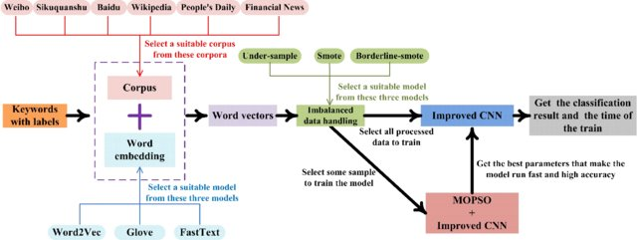

**A representation of the algorithm's logic in a flowchart.**

Here are some of Google Ads' keyword-choosing difficulties.

1) Due to financial restraints, an advertisement can't include a huge list of keywords.

2) The keywords may include a variety of languages.

Finally, there is the problem of too many "bad" keywords and not enough "good" ones.

4) The standard keyword categorization method does not provide desirable results [8, 15, 40].

Five) The procedure for choosing keywords should be fast and accurate.

6) Optimisation is required for more than one goal. To address these issues, we offer a combined strategy. This process consists of five distinct phases.

1. Word embedding is used to get the word vector, which in turn increases the number of characteristics for the target keywords.
2. Deciding the corpus to use to address the keyword-posed language-mixing dilemma.
3. Third, resampling is used to achieve statistical parity.
4. Advancing CNN by recommending an algorithmic enhancement.
5. Using a more advanced MOPSO to optimize the structure of the CNN network.

The diagram above depicts the suggested method's flowchart, and the subsections above introduce each step in depth[4].

**REASONS FOR CHOOSING CORPUS**

Ads on Google often include keywords that span many languages. To address the issue of having many languages present in the same data set. Using the aforementioned word embedding techniques, this article transforms these keywords into word vectors from a variety of national language corpora. This allows for feature extraction from keywords that may include many languages. This study uses a term that is written in both Chinese and English, thus it is searched in corpora that include both languages. These corpora include Sikuquanshu, Weibo, Baidu, Wikipedia, and others. Furthermore, these corpora need to have sufficient advertising information since the aim of this study is about the problem of advertising keywords. If you try to use corpora other than the ones you've created word vectors for, you may find that some of your keyword terms aren't there.

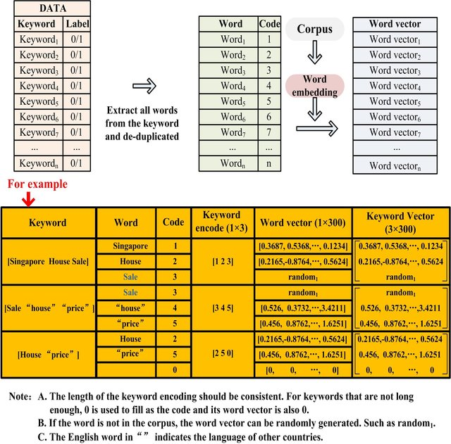

**The flow/process through which keywords are transformed into vectors.**

In this situation, the random value must stand in for the word vectors. Note that the length has to be set to a consistent length since the number of words in the keyword varies. If the value falls short of the required length, the value 0 may be substituted in its place. The enhanced CNN that addresses these issues is explained below. Additionally, various applications will need to choose unique corpora. In this study, we will assess and choose the most suitable corpus for future research. The accompanying diagram depicts the process of transforming a list of keywords into a vector representation of those terms.

In reality, only a tiny fraction of all possible keywords are useful to marketers. However, Google Ads provides a wide variety of terms for marketers to choose from. Because of the asymmetry in the data, direct classification would have a bad outcome in this situation. Therefore, resampling is used to address this issue in this research. The three most common techniques for dealing with this issue are the smote, the borderline-smote, and the under-sampling. By independently testing these three approaches, we can settle on the one that works best for resampling [4].

**THE IMPROVED CNN (Convolutional neural network)**

This research uses a CNN to choose keywords because of its popularity in dealing with NLP issues and its ability to automatically train the network and extract characteristics. There is a need to enhance the conventional CNN since the keywords under study in this research need not only the extraction of language-specific features but also the addition of certain associated properties of the keywords already present in the network. In this part, we go deep into keyword selection once we've covered the first three processes. It's important to set a maximum length for keywords in this case as their average length varies widely. The optimal length of the keyword should be determined by the specifics of the use case. For our application, the maximum keyword length is 15, thus that's what we're using everywhere. If the keyword is less than 15 characters, the empty spaces will be filled with 0.

After the keyword has been extended to its maximum length, each individual word must be encoded. Encoding the keywords requires collecting and de-duplicating the words found in each keyword, and then encoding each individual word using the same method e.g. 1, 2, 3, 4, 5, etc. Every search term may therefore be represented by one of 15 unique codes in a vector.

The next step is to use the technique of word embedding. Different code numbers represent various words in the preceding procedure. Once the corpus and word embedding are chosen, each code may be transformed into a word vector. Each code is then embedded as a word in a 300-dimensional vector using the word vector embedding technique. If the corpus does not include any examples of the keyword, then the word is transformed into a 300-dimensional word vector at random. As a result, after using the word vector technique, we transform each term into a 15 x 300 matrix.

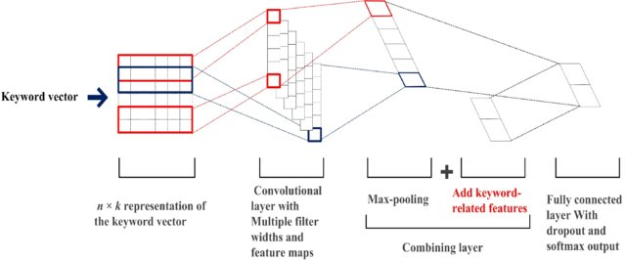

**An outline of the proposed convolutional neural network's fundamental structure.**

The previous figure recaps the preceding three stages. This matrix may then serve as input to the refined CNN. The word vector is a corpus-based word vector, although the corpus has nothing to do with the application. So, using CNN will help you acquire the model for choosing keywords via repeated training of each neural layer's weight. Plus, this approach may help the marketer zero down on the best keywords to use. Two suggestions are made. CNN's neural layers are first initialized at random, thus. It is recommended to (2) combine the CNN-extracted features and the keyword-related features for the final softmax layer before performing the final classification. Keywords include qualities like CPC, CPM, and matching degree that marketers care about, hence these are the features that were chosen for this research. These three characteristics were chosen because they are easily accessible without requiring a significant time commitment and because marketers favor them when evaluating keyword quality. The diagram above depicts the fundamental CNN architecture[4].

**THE MOPSO-BASED IMPROVED CNN (Convolutional neural network)**

The above-mentioned enhanced CNN allows for the selection of keywords. However, CNN's application for keyword selection results in a complicated network structure with several parameters. The essential issue is how to choose a network architecture that can efficiently extract keywords from a large set of inputs. This is why network optimization software like MOPSO is so important.

This section provides an overview of the MOPSO optimization procedure for CNN.

This implementation refines the classic MOPSO method. This request has dual purposes, and their interconnections are inherently at odds with one another. The classification impact is more essential than the model's training duration in this particular application. As can be seen in Fig. 1, there are a few key tweaks that need to be made to the MOPSO before it can be considered "better

First, the criteria can't be fulfilled until all the particles in the Pareto front have been collected and sorted in accordance with the primary goal. From the Pareto front, the particle in the center is chosen as the optimal particle (knee point). Subsequent developments will include the introduction of the intermediate particle (MO selection). The best particle in the second objective that fulfills the first objective range is located up front after a certain number of iterations have been completed and the range of the first goal has been defined. In order to train a CNN, its parameters are taken from the best particle (Final MO selection).

MO selection in this research is based on locating the non-dominated solution first, as seen in Fig. 1A. The particles in the non-dominated solution are then ranked, with the middle particle being deemed the optimal choice. Everyone can be the best particle if there are two in the center spot. This approach is simple and fast, making it ideal for this task.

When the termination requirement is met, as seen in Figures 1B and 1C, the Final MO selection is performed in order to choose the best particle from the Pareto front. There are ten sub-goals under f1, starting with I and going all the way to f10. The precise number of components needed will, of course, be determined by specific use cases.

The more the importance placed on the first goal, the greater the number of components that must be chosen. For this task, the particle with the lowest train time within a 10% error rate has to be chosen, since it is the highest tolerance allowed. If particle1 is the top performer in f1, then I will be chosen as the interval. The range III will be chosen if particle5 is the best particle in the f1.

Pareto front examples are situations in which some particles fulfill the necessary conditions. If the best classification error of the particles is 1%, then the range of the first item is between 1% and 10%. Once the range has been established, the ideal item to feed into the CNN is the one with the shortest train time inside the range.

Algorithm 1 demonstrates that to begin, particles x are created at random inside the reachable region. GHA and PHA are the global best (gbest) and personal best (pbest) historical archives, respectively.The MO selection procedure is then used to choose the gbest from GHA and the pbesti from PHAi, where I is the generation number. Additionally, x is modified in light of equation (1). (2). Then, we will refresh PHAi and GHA. The non-dominated relationship is used to first sort particles in PHAi and GHA. The MO selection approach is used to eliminate unneeded solutions if the number of non-dominated solutions exceeds a threshold value.

In addition, the number of iterations is used as the final criteria in this work. Final MO selection is utilized to acquire the best particle and the best parameter set from the best particle is delivered to the CNN when the iteration count exceeds the predetermined number of times.

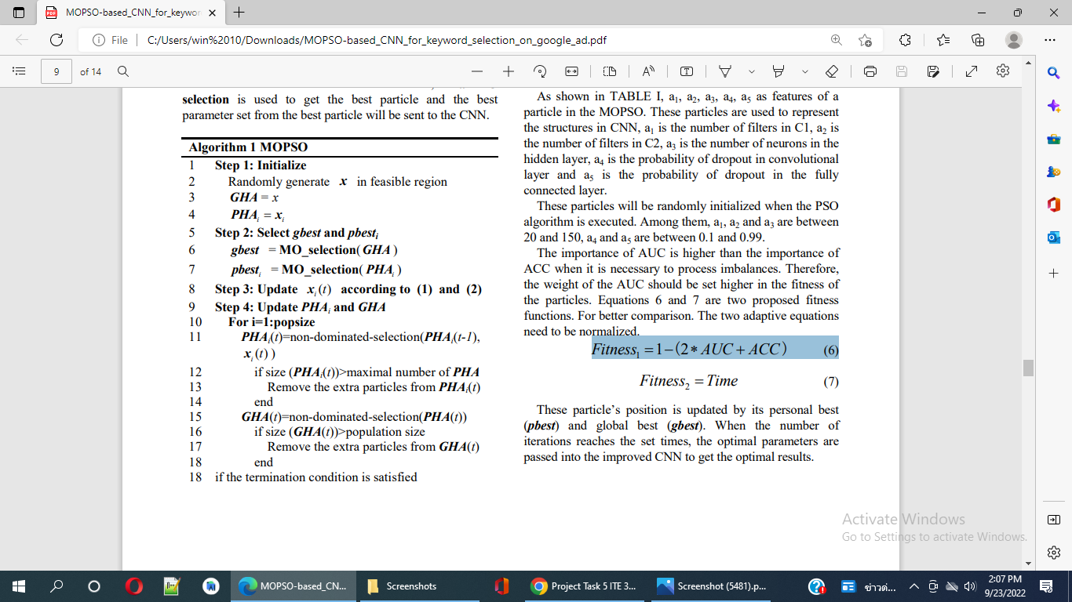

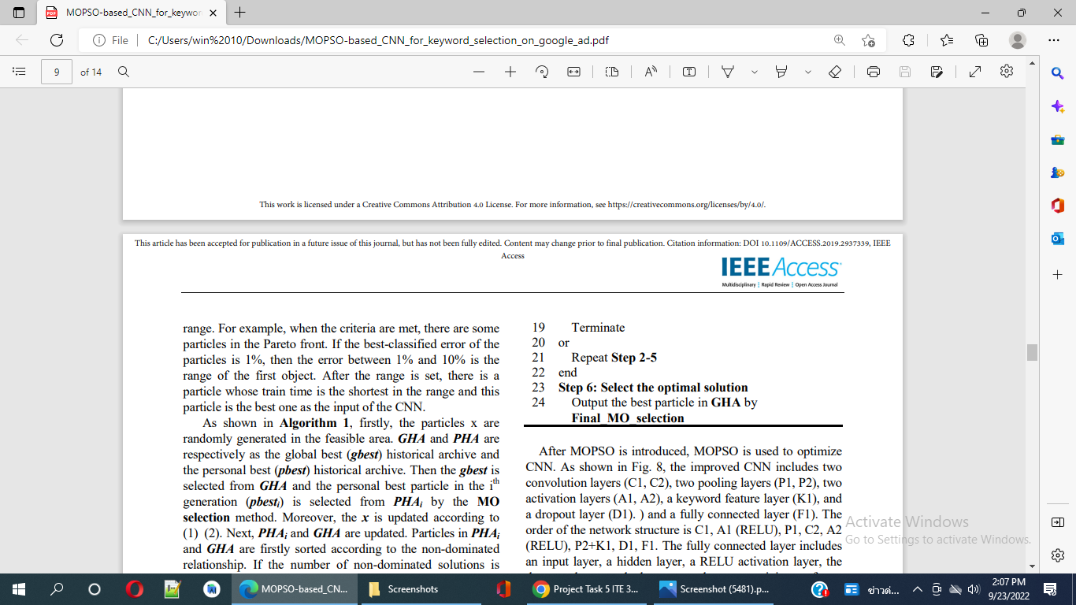

Once MOPSO has been presented, it will be utilized to improve CNN. We can see the components of the enhanced CNN in Fig. 2: two convolution layers (C1, C2), two pooling layers (P1, P2), two activation layers (A1, A2), a keyword feature layer (K1), and a dropout layer (D1). together with a layer that is entirely interconnected (F1). C1, A1 (RELU), P1, C2, A2 (RELU), P2+K1, D1, F1 are the nodes in the network in that order. The network's nodes and connections are listed as follows: C1, A1 (RELU), P1, C2, A2 (RELU), P2+K1, D1, F1.

An input layer, a hidden layer, a RELU activation layer, a dropout layer, and an output layer with softmax activation make up the fully connected layer. The pooling layer has a VALID kernel size of 31, and it is of a VALID type. The MOPSO will reveal how to choose the settings.

A particle in the MOPSO has the characteristics listed in TABLE I: a1, a2, a3, a4, and a5. CNN structures are represented by particles where a1 is the number of filters in convolutional layer 1, a2 is the number of filters in convolutional layer 2, a3 is the number of neurons in the hidden layer, and a4 and a5 are the probabilities of dropout in the convolutional layer and fully connected layer, respectively.

When the PSO algorithm is run, these particles will be initialized arbitrarily. For example, a1, a2, and a3 may range from 20 to 150, whereas a4 and a5 can be anywhere from 0.1 to 0.99. When analyzing discrepancies, AUC is more valuable than ACC. It follows that the AUC should be given more importance in determining the particles' fitness. Two potential fitness functions are given in Equations 6 and 7. For the sake of contrast. It is necessary to normalize the two adaptive equations.

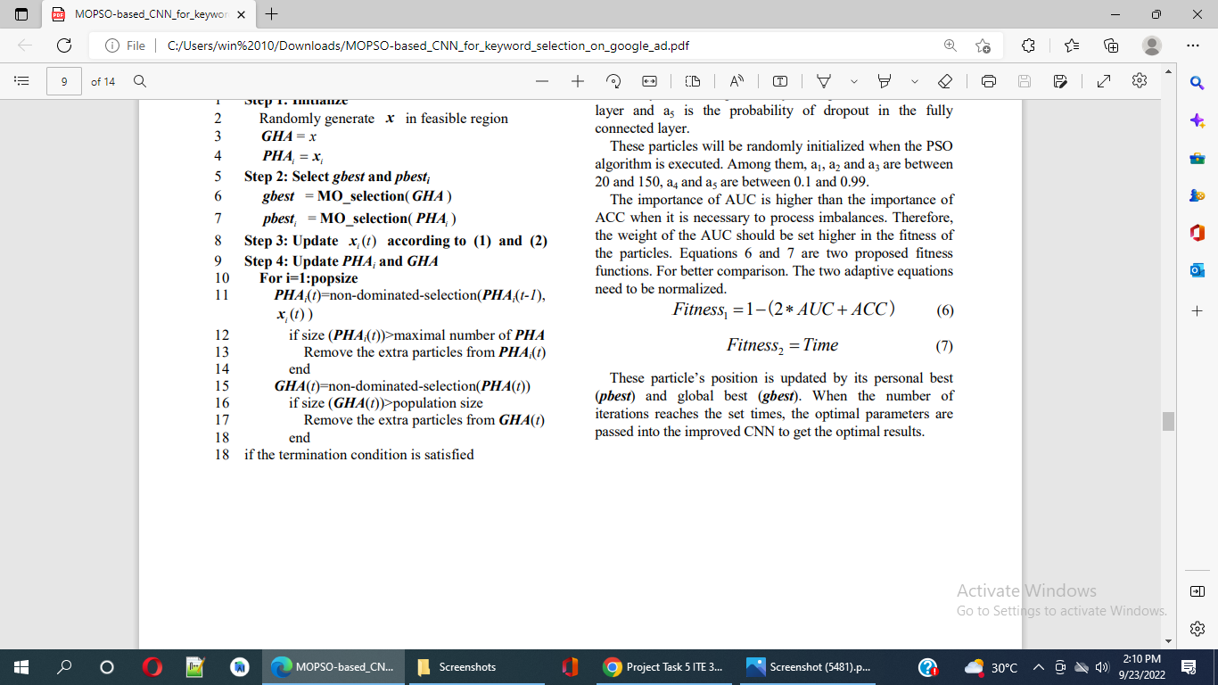

Using its pbest and gbest, each particle's location is constantly updated . After a certain number of repetitions, the best parameters are fed into the refined CNN to provide the best output[4].

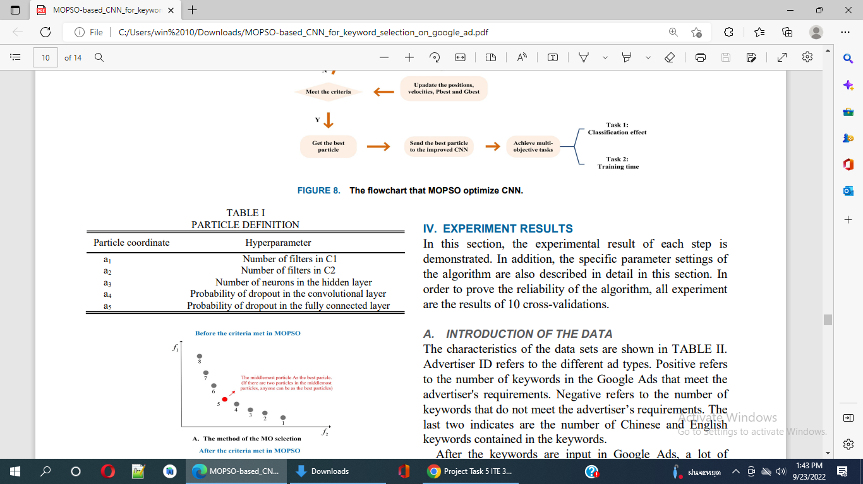

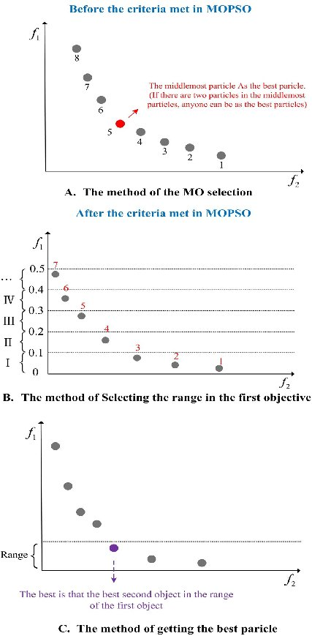

**Figure 1: The procedure for deciding which particle is optimal.**

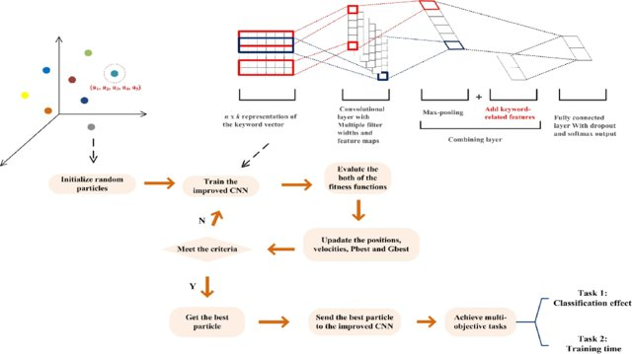

**Figure 2: A depiction of the procedure in the flowchart through which MOPSO enhances CNN**

**6. Architectural View Decomposition**

**6.1. Use-Case view**

**Formalizing Reports on Keyword Success/Failure.**

Keyword performance reports from Google Ads might be useful to users. Information on "Impressions," "Cost per Conversion," "Average CPC," and similar metrics may be seen for a single Keyword or a set of Keywords. Reporting on the success of a single Keyword or a set of Keywords is possible using either Basic or Custom Metrics.



All of the accessible Basic Metrics include "by Keyword" in their names. Among them are the reports "Cost by Keyword," "Clicks by Keyword," and "Conversion Rate by Keyword." Select Google Ads from Databox's Data Source drop-down menu to get a list of these Metrics in Data Manager > Metrics. To remove any metrics that are categorized as "by Keyword," type "by Keyword" into the search field.

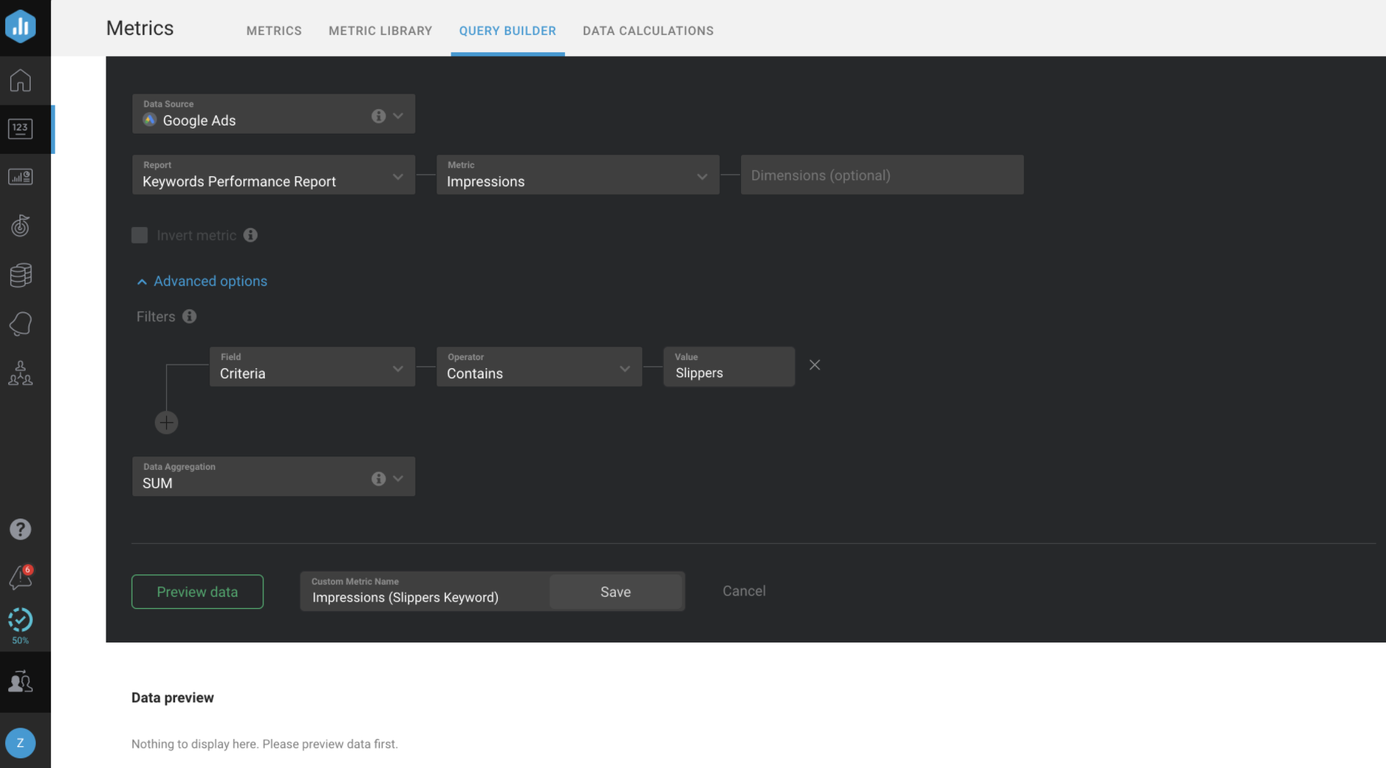

The performance of a single Keyword inside your Account can only be seen by configuring the user data block in such a manner that asks you to pick a certain Dimension (Keyword).

Using the Google Ads Query Builder, you can also develop custom Metrics to report on the success of a single Keyword or a set of Keywords. Select the Keyword Performance Report from the Report menu to see information relevant just to keywords.

Since you've decided to look at the "Keyword Performance Report," "Criteria" will be "Keywords." The following Custom Metric may be used to track the number of times your "Slippers" keyword was seen online.

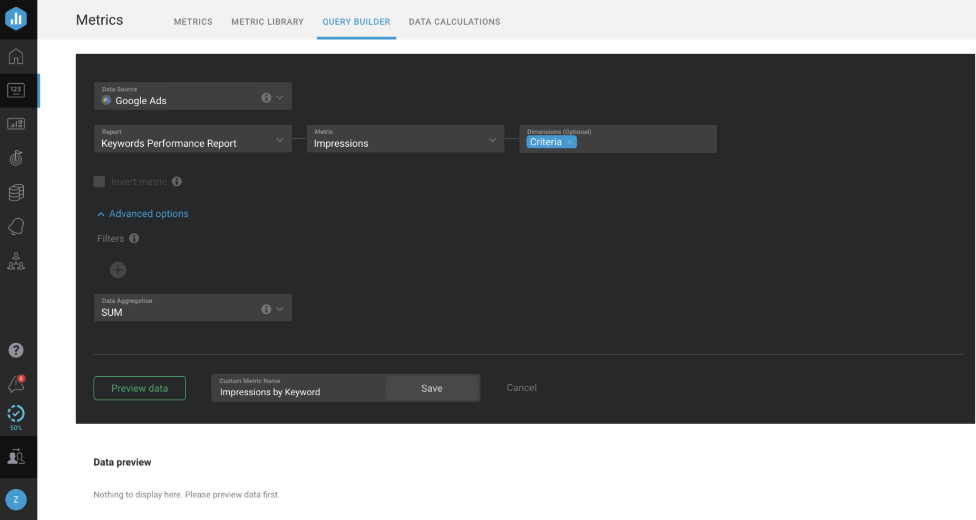

The Professional and Performer tiers both have access to Query Builder. Use this procedure to ask for a free demo of Query Builder. Use the "Criteria" Dimension in the filter if the user just wants to report on the performance of a particular Keyword [2].

## 

## 6.1.1. Use-Case Realizations:

## I. formulate Alternatives

## 1.1 A Keyword Optimization Framework

The purpose of this study is to provide a computational framework and optimization algorithms at three levels: the market level (i.e., II), the campaign level, and the ad group level, with the purpose of comprehending keyword choice scenarios over the whole lifetime of search advertising campaigns (i.e., III). We assume the existing set of keywords relevant to the study topic (the output of level I). Though this study does not get into fine-tuning keywords (level IV), it does compute the advertising performance and keyword-related performance of actual advertising campaigns as feedbacks for judgments at higher levels.

As shown in the following, this research proposes a hierarchical programming framework called the Multi-level Keyword Optimization Framework (MKOF) that takes into account keyword choices over the whole duration of search advertising campaigns. As shown in Figure 2, U* is the best option for the choice at the keyword level, which is beyond the scope of this investigation. We use real-world data to derive V, which represents keyword-level feedback like the performance of certain keywords. A further breakdown of the figure's symbols and their meanings follows. Each stage of keyword selection (market, campaign, and ad group) is represented as a separate problem in the MKOF framework. Payoffs from the lower-level model are fed back into the higher-level model as a consequence of the higher-level model's output. Therefore, the MKOF is a computational framework with several levels and a closed loop.

The diagram illustrates a computational framework for MKOF, or multi-level keyword optimization, applicable to paid search promotions.

* + 1. Market Level: Keyword Selection at the Market Level (Keyword Targeting): If we indicate by Ka the set of domain-specific keywords available to an advertiser a, where a = 1, 2,..., r, and assume that this advertiser operates in n1 search markets, we get,

𝜑: K𝑎 → 𝑥𝑎, … , 𝑥𝑎, … , 𝑥𝑎 , i ∈ {1,2, … , 𝑛 },

1 i 𝑛1 1

where 𝑥𝑎 represents the group of keywords chosen for the i-th search engine market.

* + 1. Campaign Level: Keyword choice at the campaign level is an advertiser's attempt to choose keywords for each campaign from the keyword set selected for a given search market.

ф: 𝑥𝑎 → 𝑦𝑎 , … , 𝑦𝑎 , … , 𝑦𝑎 , j ∈ {1, 2, … , 𝑛2},

i i,1

i,j

i,𝑛2

where 𝑦𝑎 represent the group of keywords for the jth advertising campaign in the i-th search engine market.

The selection of which advertising campaigns a keyword should be linked to depends on the keyword's and campaigns' shared features and significance.

* + 1. Adgroup Level: The purpose of adgroup-level keyword choices is to divide a campaign's keyword pool into more manageable chunks called adgroups, which may be written as,

†: 𝑦𝑎 → 𝑧𝑎 , … , 𝑧𝑎 , … , 𝑧𝑎 , 𝑙 ∈ {1, 2, … , 𝑛3},

i,j

i,j,1

i,j,𝑙

i,j,𝑛3

where 𝑧𝑎 represents the collection of search terms used by the lth ad group in the jth campaign in search market i.

Adgroups are the fundamental building block of search advertising campaigns, and they include all of the terms that are relevant to that particular ad set. One or more advertisements and a common set of keywords are included in each ad group[1].

**Mathematics of the Keyword Optimization Framework**

## Formulation

The mathematical underpinnings of the MKOF structure are laid forth below. For sponsored search ads in particular, we take into account keyword selections across the whole campaign lifetime and create the following MKOF framework as a three-level programming model[1].

**Model 1 (Market Level Model).** *Let* ℎ(1): 𝑛1+𝑝 → *be the relevance function at the market level,* 𝑔(1): 𝑛1 → 𝑚1 *be constraints at the market level,* ƒ(2): 𝑆1 → 𝑝 *be the optimal relevance function at the campaign level,* 𝑆1 < 𝑛1 *, then the keyword optimization at the system level can be modeled as,*

ƒ(1) ➟ 𝑚𝑎𝑥𝑥 ℎ(1) (𝑥, ƒ(2)(𝑥))

𝑠. 𝑡. 𝑔(1)(𝑥) ≤ 0, (1)

𝑥 ∈ X < 𝑛1 *.*

**Model 2 (Campaign Level Model).** *Let* ℎ(2): 𝑛2+𝑞 → *be the relevance function at the campaign level,* 𝑔(2): 𝑛1+𝑛2 → 𝑚2 *be constraints at the campaign level,* ƒ(3): 𝑆2 →

i i

𝑞 *be the optimal relevance function at the adgroup level, where* i ∈ {1, … , 𝑝} *and*

𝑥 ∈ 𝑆1 = {𝑥 ∈ X, 𝑔(1)(𝑥) ≤ 0}*,* 𝑆2 < 𝑛2 *, then the keyword optimization at the campaign level can be modeled as,*

ƒ(2)(𝑥) ➟ 𝑚𝑎𝑥𝑦 ℎ(2) (𝑦i, ƒ(3)(𝑦i))

i i i i

𝑠. 𝑡. 𝑔(2)(𝑥, 𝑦i) ≤ 0, (2)

𝑦i ∈ 𝑌 < 𝑛2 *.*



**Model 3 (Adgroup Level Model).** *Let* ℎ(3): 𝑛3+𝑟 → *be the relevance function at the*

*adgroup level,* 𝑔(3): 𝑛2+𝑛3 → 𝑚3 *be constraints at the adgroup level,* ƒ̂: 𝑆3 → 𝑟 *be the relevance function between keywords, adgroups and campaigns. where* i ∈ {1, … , 𝑝} *,*

j ∈ {1, … , 𝑞} *,* 𝑦 ∈ 𝑆2 = {𝑦 ∈ 𝑌, 𝑔(2)(𝑥, 𝑦) ≤ 0 } *, and* 𝑧 ∈ 𝑆3 = {𝑧 ∈ 𝑍, 𝑔(𝑥, 𝑦, 𝑧) ≤ 0 } *where* 𝑔(·) *denotes constraints related to keywords, then the keyword optimization at the adgroup level can be modeled as,*

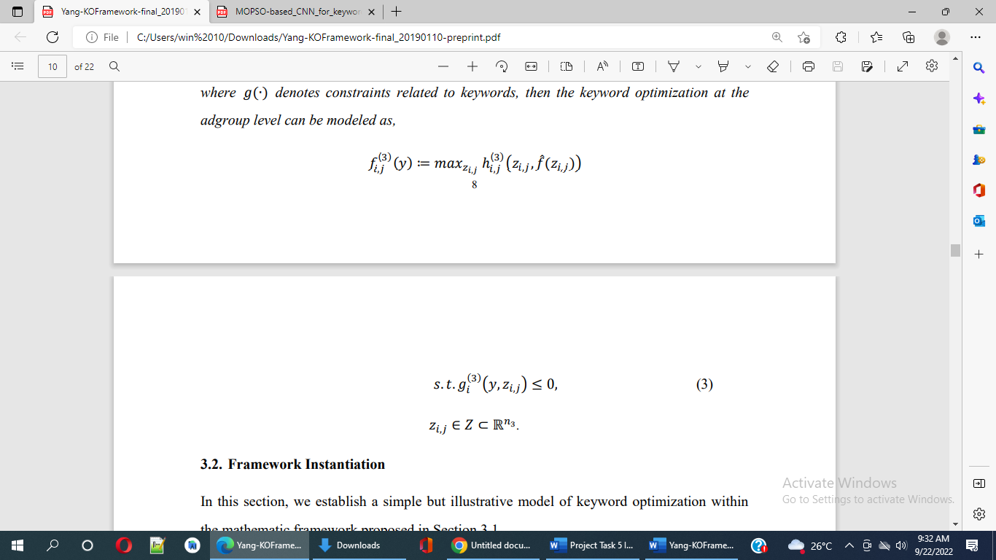



**Framework Instantiation**

Here, we use the previously established mathematical framework to create a basic yet instructive model of keyword optimization.

An advertiser's goal in sponsored search advertising is to acquire a list of highly-trafficked and semantically-related phrases. Advertising performance and the potential ecology of search advertising are both impacted by relevance . For instance, a better click-through rate and quality score1 result from a greater degree of congruence between targeted keywords, adverts, and advertised items or services. Getting a good ROI from search advertising campaigns is a question of relevance2, too. Keywords should be used to enhance the advertiser's return on investment in the campaigns. For this reason, we base our choices for which keywords to use in paid search ads on their relevancy. An advertiser's goal in making keyword choices is to identify a group of highly relevant keywords that will bring in the most revenue (or services). Therefore, while selecting keywords, it is necessary to strike a balance between how well they perform and how much money they bring in.

We create an iterative approach to approximate the optimum, i.e. a collection of keywords maximizing both the relevance and profit across several search markets, because of the lack of comprehensive information in the keyword targeting choice. An enlargement and a contraction make up the backbone of this plan's two primary procedures. Let's call the process of growing a graph from the keyword pool graph the expansion operation 1. Take the reference keyword graph as an example; then, using the keyword pool graph, add additional closely related terms. Let 2 represent the pruning procedure that removes low-performing keywords from the enlarged keyword network. The process of growing and reducing is repeated. At the end of each cycle, we assess the quality of the newly minted Target Keyword Set (the weighted relevance and the payoff). To illustrate, let Hk1 represent the reference keyword set (H0 represents the advertiser-supplied seed keywords), Hk represent the Target Keyword Set, He represent a sub-graph of Hk1 obtained using the trimming policy, and represent the revenue per unit budget, which can be calculated based on the past (or predicted) performance of ad-campaigns. Then, the final version of Hk for a specific search market is denoted by x, and (2)(Hk) stands for the weighted relevance of Hk at the market level. See below for a model of market-level keyword optimization[1].

ƒ(1) ➟ ∑𝑛1 ƒ(2)(𝑥)

𝑠. 𝑡. He = 𝜋1(𝐻𝑘−1)

𝐻𝑘 = 𝜋2(𝐻𝑒, 𝛾) (4)

𝐻𝑘−1, 𝐻𝑒, 𝐻𝑘 < 𝐻

∑𝑛1 𝑏i − 𝑏 ≤ 0

where f (2) is the highest possible relevance score in the ith search market for that particular campaign, and it is expressed as,

f (2)(𝑥) ➟ max ∑𝑛2 f (3)(𝑦) (5)

i j=1 i,j

s. t. ∑𝑛2 𝑏i,j − 𝑏i ≤ 0

where ƒ(3) is the highest relevance score for the jth campaign in the ith search market at the ad group level, and is defined as,

ƒ(3)(𝑦): = max ƒ̂(𝑧i,j) + ƒ̂(𝑧i,j,𝑙)

∑𝑛3 ƒ̂(𝑧i,j, 𝑧i,j,𝑙)

ƒ̂(𝑧i,j) = 𝑙

⁄𝑛3

(6)

∑𝑧i,j,𝑙∑𝑧i,j,𝑙 ƒ̂(𝑘

, 𝑘 )

ƒ̂(𝑧i,j,𝑙) =

𝑘𝑎

𝑘𝑏

𝑎 𝑏 ⁄ 2

𝐶|𝑧i,j,𝑙|

where (zi,j) represents the relevance score between a campaign and adgroups inside it and (zi,j,l) represents the relevance score between keywords within an adgroup. The former verifies that the advertising subject is reflected in the keywords given to the campaign, while the later assumes that the relevance of the keywords within a set are organized in an optimal way. One set of keywords that is closely related to the campaign will have a higher value of (zi,j), but it may not be moderately divided into several groups; another set of keywords will have a high value of (zi,j,l), but may not perform well if one or more clusters of keywords are not closely related to the campaign.

**Solutions**

Following is a set of algorithms for solving problems in the previously published MKOF framework and instantiated optimization models. It is important to note that the focus of this study is not on optimizing a single keyword strategy, but rather on the potential benefits of a broader keyword optimization framework that takes into account the fundamental advertising structure and a chain of various keyword-related decisions throughout the entire lifecycle of advertising campaigns.

Assume that you have identified the Target Keyword Set. To create the campaign-level keyword set yi,j, we choose a subset of keywords from the Target Keyword Set (called Keyword Assignment). Every term in the Target Keyword Set may be used in more than one campaign's keyword set. This is analogous to solving a multiple-choice knapsack problem (the goal of which is to maximize overall relevance for each campaign within a certain budget). In this analogy, keywords serve as the scavengables and each campaign represents the rucksack. Each adgroup in campaign j is given its own set of keywords (zi,j,l) from the campaign-level keyword set yi,j (called Keyword Grouping). To put it simply, a keyword in yi,j can only ever be part of one adgroup zi,j,l. Adgroups help marketers target the correct people with their ads by grouping together phrases that are conceptually similar. Well-organized keyword groups help an advertiser boost the performance of her ad groups and increase the relevance of her account, which in turn leads to reduced pay-per-click (PPC) costs. Keyword grouping, in which the aim is to increase the relative importance of keywords inside a given ad group, may be thought of as a kind of clustering issue. Clustering keywords involves representing each term as a vector made up of its surrounding keywords. To organize the keywords for a campaign, we use a k-means clustering technique. The solution process for the complete framework is shown in Algorithm 1[1].

**First Algorithm (the solution for the entire MKOF framework)**

Inputs include the graph of domain-specific keyword pools, the seed keyword set, the number of campaigns, the budget limitation for each campaign, and any other relevant factors obtained from the data (e.g. impressions, clicks, CPC, CTR, and revenue per click).

The best keyword combinations for various depths of search (i.e., market, campaign, and adgroup). After pruning the original set of seed keywords from the reference keyword set Hk1, you will have your final set of keywords, Hk. Find a solution for the campaign-wide issue of the "multiple-choice knapsack." Ad group level clustering issue solving and relevance score determination. Campaign-level relevance scores need to be determined. Market-level relevance scores should be determined. Determine Hk's incremental value and importance using the formula.

If the incremental reward is too large ( > ), then go to step 1. If the terminating condition is not met, the output will be the final target keyword set at the market level (i.e., xi = Hk), the assigned keyword set at the campaign level (i.e., yi,j), and the results of the keyword grouping (i.e., zi,j,l).

Keep in mind that any computations using a keyword set make use of the connections between those keywords. We model Hk1 and Hk as keyword graphs, where keywords are represented by nodes and the connections between them by edges. Semantic (e.g., is-a) and statistical (e.g., co-occurrence) connections between keywords are both possible (e.g., co-occurring). The graph algorithms often used to determine correlations are used to determine relevance. Specifically, we utilize the statistical co-occurrence graph of keywords, where the presence or absence of an edge between two terms shows how often they appear in the same search query, to examine the relationship between keywords (i.e., 1 if yes, 0 otherwise). The importance of a pair of keywords is found by taking the inverse of their geodesic distance, or (ka, kb) = 1 / d(k, k).

To sum up, the steps in our methodology for optimizing keywords are as follows: (1) Keyword Targeting (1 2) (2) Keyword Assignment (3) Keyword Grouping (4) Keyword Ranking.

Analyzing (f(3)(y) f(2)(x) f(1)) If the additional benefit is negligible,

i,j I

At this point, we have completed the full process of optimizing our keywords and have both the Target Keyword Set and the Keyword Structure at our disposal.

An easy greedy algorithm may be able to get close enough to the optimal solution in the MKOF framework to be useful (or the semi-optimum). Given that He = 1(Hk1), there are more terms in He than in Hk1. In this way,

𝑝𝑟𝑜ƒi𝑡(𝐻𝑒) ≥ 𝑝𝑟𝑜ƒi𝑡(𝐻𝑘−1). In addition, proit(Hk) proit(He) since the operation of Hk = 2(He, ) eliminates the terms that provide zero or negative profits. Profit is not decreasing with each iteration, since proit(Hk) > proit(Hk1). Thus, for each subset Hx, pro-it(H*) > pro-it(Hx). With this in mind, the MKOF framework's iterative algorithm might provide a rather stable collection of keywords (H*) after a certain number of rounds. By having this quality, we know that Algorithm 1 can converge to the best possible solution in a finite amount of repetitions[1].

**II. Evaluate Alternatives**

**Experimental Validation**

**Data Preparation and Experimental Setup**

Using two real-world datasets consisting of field reports and records of search advertising activities, we undertake computational experiments to test our framework and instantiation techniques for keyword choices in sponsored search advertising. There are two main goals that will be considered in the assessment. The first will compare the effectiveness of our framework and the instantiated keyword techniques with that of two reference implementations. To further confirm various aspects of our approach, we provide additional information about these keyword judgments.

There are a total of 129 and 121 keywords in the two data sets. In the next studies, we use both of these groups of keywords as our pool of domain-specific keywords. The dataset keeps track of the number of impressions, clicks, cost-per-click, and CTR for each term. Click-through rates may be calculated using data collected from previous search advertising efforts. Google Adwords' Keyword Planner and other tools were used to compile data on how often two or more keywords appear together (e.g., WordTracker). To illustrate a certain domain's keyword pool, we may then build a binary undirected graph of keywords.

We've set up the following tests to see what happens. Our keyword framework takes as inputs a pool of keywords relevant to a given domain, the advertiser-supplied reference keyword set, the number of campaigns, the budget constraint for each campaign, and the number of ad groups, from which it derives the Target Keyword Set (at the market level) and the Keyword Structure (at the campaign and ad group levels). To further understand how real-world operations compare to our experimental outcomes, we use a dataset consisting of three campaigns and two groups from a search engine advertising account (Case-1). In the same vein, we investigate an alternative setup with two campaigns and two groups in the Case-2 experiment.

**Comparisons**

To prove the efficacy of our approach, we compare two reference strategies to our own keyword optimization framework (MKOF) and its instantiation strategies. For the sake of analysis, we deployed two control techniques. The BASE1-Origin strategy represents the company's historical advertising approach. To demonstrate the efficacy of keyword assignment and grouping tactics, our approach assigns the Target Keyword Set to a predetermined search advertising framework. As a second baseline tactic, BASE2-Ratio takes a heuristic approach based on the correlation between click-through rate and cost-per-click. Based on the click-through-rate to cost-per-click ratio, it chooses the best n keywords. Our technique begins by selecting the top n keywords from the pool of domain-specific keywords to generate the target keyword set, and then it uses these keywords to allocate broad categories to campaigns (e.g., the multiple-choice knapsack and k-means clustering algorithm). In order to help marketers optimize advertising efficiency, BASE2-Ratio uses a well-established heuristic (the click-through-rate to cost-per-click ratio) since CTR is a significant aspect in determining the quality score for sponsored search ads. Better quality might mean more clicks at reduced prices. Since our technique and BASE1-Origin share a same set of target keywords, a comparison between the two allows us to gauge the efficacy of our keyword assignment and grouping methods. To assess our keyword targeting technique, we compare it to BASE2-Ratio, which uses a different set of target keywords but the identical remainder of the process. In Case 1, we have three keywords pertaining to the company name, while in Case 2, we have two keywords pertaining to the major product. Our MKOF and two baseline methods are compared in Table 1.

| Strategy | Payoff | |
| --- | --- | --- |
| Case-1 | Case-2 |
| MKOF | 11,938,036 | 61,585 |
| BASE2-Ratio | 10,387,413 | 57,992 |
| BASE1-Origin | 11,108,298 | 57,605 |

Table 1: Comparison between the MKOF and two control techniques.

The following are some of the findings revealed by examining Table 1.

The return on investment (ROI) for our MKOF strategy is 7.5% (14.9%) greater than the BASE1-Origin in Case-1 (the BASE2-Ratio). Our MKOF strategy has a 6.9% (6.2%) greater return than the BASE1-Origin in Case 2. (the BASE2-Ratio). As a result, we know that our MKOF approach has a higher ROI than any of the two reference tactics.

Since our technique outperforms the BASE2-Ratio, we can conclude that our MKOF framework's keyword targeting strategy (at the market level) is capable of discovering a better target keyword set using just a minimal reference keyword set as a starting point.

By comparing the target keyword set with BASE1-Origin, the keyword assignment (at the

campaign level) and keyword grouping (at the ad group level) process may determine an improved method for assigning and grouping the keywords[1].

**III. Make Decision**

**Methodology and Characteristics.**

Our MKOF approach is described in further depth, along with its process and characteristics, in the accompanying series of experiments. One (at the market level) Method of Keyword Targeting After 11 cycles of Algorithm 1's expansion and trimming of the seed set of keywords, the resulting target keyword set has 80 terms. Six iterations are required to get the desired set of 109 keywords in Case 2. (II) Assigning Keywords to Campaigns: In Scenario 1, we divide up the ideal keyword pool across three different ad campaigns, assigning 25 to the first, 36 to the second, and 52 to the third.

The second scenario is splitting the collection of keywords for advertising purposes across two different campaigns, with 59 keywords going to Campaign 1 and 71 keywords going to Campaign 2. (III) Ad group-level keyword grouping: Campaign-1 has two groups of keywords (i.e., 7 and 18), Campaign-2 has two groups of keywords (i.e., 27 and 9), and Campaign-3 has two groups of keywords (i.e., 41 and 11). Case-1 yields the ideal keyword grouping result. Case 2 yields the ideal keyword grouping result, with 41 and 18 keywords split between two groups in Campaign 1, and 49 and 22 keywords split between two groups in Campaign 2.

Following is a diagram depicting the development of the total payout as our MKOF framework iterated over the two trials.

The following phenomena are shown in the figure.In both circumstances, our MKOF technique generates a total payout that grows slowly over the course of each iteration and converges to a near-optimal value in a limited number of iterations. This observation lends credence to the claim that our MKOF approach is capable of rapid convergence, yielding a list of keywords that strikes a good balance between total relevance and total profit at the near-optimal level.

As the iterative process progresses, the incremental payout tends to decrease in both examples. One probable reason for this is that the incremental value of increasing the size of the advertising budget relative to the size of the target set across the keyword graph decreases. In economics, this is explained by the concept of declining marginal utility[1].

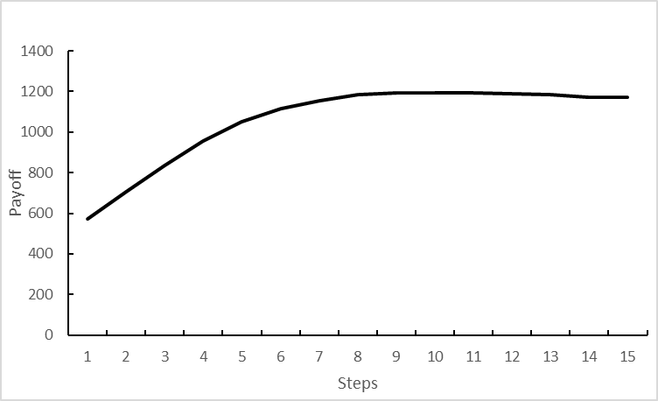 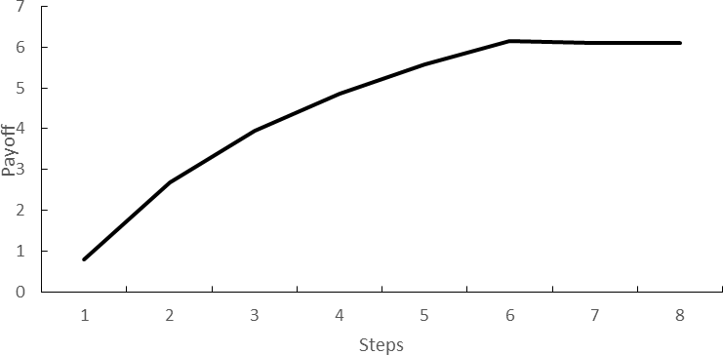

* 1. Case-1 b) Case-2

Figure 3. Evolution of the total payoff

**Discussions**

In conclusion, the experimental findings support our suggested computational framework as a practical answer to the problem of keyword choices in sponsored search advertising. Comparing its overall return to that of two control techniques, it clearly performs better. In addition, our suggested computation architecture offers a reliable experimental setting and a closed-loop decision chain that can put into action a wide range of keyword strategies across the whole lifetime of sponsored search advertising campaigns.

This study contributes to the field of methodology and also offers valuable management insights for sponsors of search engines. The first thing that marketers need to do when employing a new advertising medium like sponsored search advertising is to discover the correct target keyword set covering the target market rather than only concentrating on the performance indices of individual keywords. Second, in order to make online procedures easier, search engines establish numerous ad structures and standards. If marketers do not take advertising structures into account when selecting keywords, ad performance may suffer. Third, there's a need for a holistic perspective to be able to comprehend the many facets of the sponsored search advertising lifecycle and make informed selections about keywords[1].

**Results and Suggestions for the Future.**

In this research, we present an innovative hierarchical computational framework for optimizing keywords in sponsored search advertising, taking into account all stages of an ad campaign's existence. Here, we provide the MKOF framework in the form of a series of optimization models, together with a collection of methods for solving them. We use two real-world datasets of search advertising campaigns in our computer studies to verify its efficacy. The experimental findings reveal that our strategy consistently beats two baseline methods in terms of total payout, suggesting that it can reliably approximate the optimum solution.

We are currently working to expand our framework and strategies in the areas of (a) advertising competition and game-theoretic approaches for keyword decisions; (b) effective algorithms specified for various keyword-related decisions; (c) co-optimization with other parties; and (d) co-optimization with other parties[1].

**6.2. Design View**

**6.2.1. Overview**

**The Google Ads workflow**

The Google Ads procedure may be broken down into five key steps. To begin, the advertising is tailored to the specific demands of the advertiser. Secondly, the advertiser uses the system to choose keywords that correspond to the ad's subject matter. Third, the user's search queries are compared to the predetermined keywords. When there is a close match, Google Adverts will show the ads to more relevant people. When an advertiser enters keywords into Google Ads, the service will provide the advertiser with information on related features related to those keywords. The fifth step is that marketers modify their tactics based on the characteristics of the term. If marketers decide that these keywords are not "good," they may simply delete them from Google Ads. Specifically, as seen in the image below[5]:

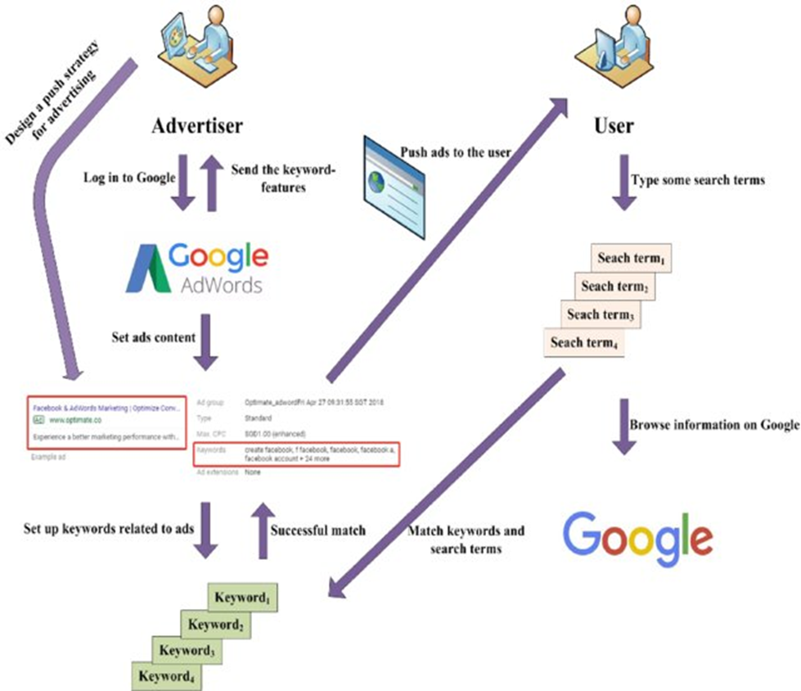

Flowchart of Google Ads' operations

**Keyword Decision Scenarios**

The sponsored search advertising lifecycle is punctuated by decision points for AdWords keywords. Many variables in this procedure may impact the keywords chosen. It can be seen from the following figure that there are often four distinct circumstances when choosing keywords:

1) Domain-specific keyword pool generation: Within a domain or industry (such as clothes), an advertiser must construct and manage a pool of relevant keywords from which a set of keywords for her search advertising campaigns to market certain items or services may be selected. In this stage, we generate a list of keywords as the result (we call it the domain-specific keyword pool).

When an advertiser wants to promote a product/service (or multiple products/services together) (for example, boots) on a given search engine, she needs to select a more accurate set of keywords from the domain-specific keyword pool in order to fit better with the specific products/services and the specific search engine. This is known as keyword targeting (the Market-level Keyword Optimization). During this procedure, we take into account the search engine's functionality, the product's characteristics, and our ideal customers. Keyword targeting, or market-level keyword optimization, is the term for this method. The final product is a group of words known as the Target Keyword Set.

Thirdly, categorizing and assigning keywords (optimizing at the campaign and ad group levels): several advertising campaigns, each of which consists of multiple subsets (we call this the basic search advertising structure). Once Keyword Targeting has created a set of keywords (the Target Keyword Set), the advertiser must divide that set into smaller subsets for use in individual campaigns, and then further divide those subsets into larger groups for use in individual campaigns. To optimize keywords at the Ad Group level, you'll want to use Keyword Grouping, and at the Campaign level, you'll want to use Keyword Assignment. The resulting "Keyword Structure" is the output.

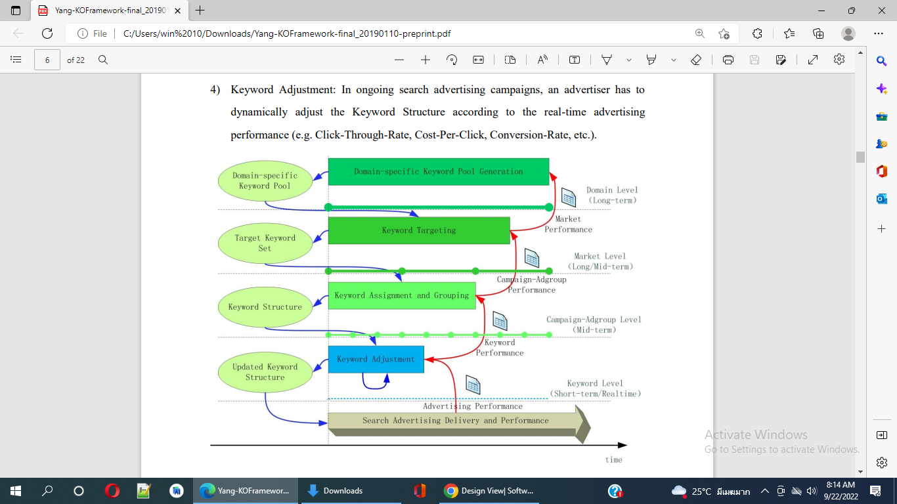

Keyword decisions in sponsored search advertising

There is a recursive decision-making process based on keyword selection in sponsored search advertising. That is, the outcomes of higher-level choices serve as inputs for subsequent, lower-level decisions, while the outcomes of lower-level operations serve as feedback for higher-level decisions. Therefore, it is important to provide a unified computational framework to help marketers optimize their term selections across all of their sponsored search campaigns[1].

**6.3. Component View**

**6.3.1. Overview**

**Google Ads Account Structure & Setup**

In order to be successful with online advertising campaigns, advertisers need to be acquainted with the Google Ads account's unique structure. Below is a diagram depicting the optimal layout for such a bank account. At the account level, advertisers may change things like payment details and time zone. Each profile has conducted campaigns, some of which have been run inside specific ad sets. The advertising with their target keywords, demographics, interests, etc. makes up the ad groups. A Google Ads keyword tool, sometimes called the Google Ads Keyword Planner, is also available. Using an email address and password, an advertiser may create a Google Ads account. Signing up for Google Ads is a breeze. It is required that this email address be associated with a Google account (registered on Gmail). Use this login for access to all Google services, including Ads.

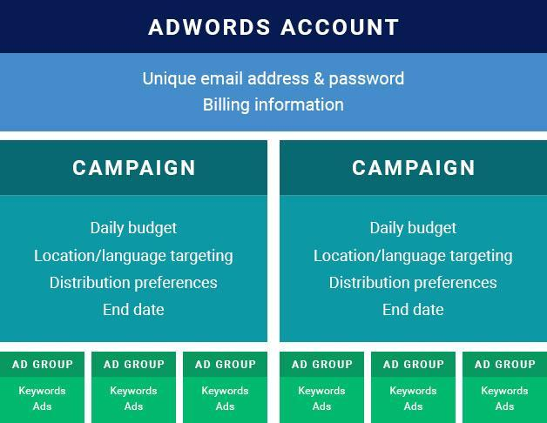

Signing into Google Ads is quite easy. The fact that your email address can only be used with one Google service after it has been linked to an account. Since this is the case, we will not be able to handle even a small number of Ads accounts. If that's the case, we'll need to set up a new Google Ads Manager account. After an account has been created, the advertiser must provide their billing information and choose a time zone. Once you've picked your time zone, it can't be altered again, but billing preferences will stick around indefinitely.

Pay close attention to these requirements while setting up the account. Here, marketers have the option of making payments either manually or automatically, using a debit or credit card. Customers may use them to pay in advance for their Google Ads marketing effort. If the advertiser agrees to pay $150, then that amount will be subtracted from the total cost of the campaign. Advertisers' credit cards are automatically debited either immediately after their advertisements are shown or once every 30 days after the most recent charge, whichever comes first[4].

**6.4. Deployment View 5**

The search engine results page (SERP) is customized to display a variety of content kinds above organic web listings. The SEO keyword target list has to be updated on a regular basis, with a primary emphasis placed on terms that have the most potential upside. Utilize GKP for a comprehensive solution whether you are building an initial set of SEO keyword lists or revising the high-value keyword list[3].

**7. Implementation View**

**7.1. Overview**

**A. Google keyword planning tool overview:**

Google AdWords is the name of a digital marketplace that Google curates for online advertising. On websites connected to Google, advertisers contend for the privilege to display fast advertisements, listings for goods and services, and videos to viewers.

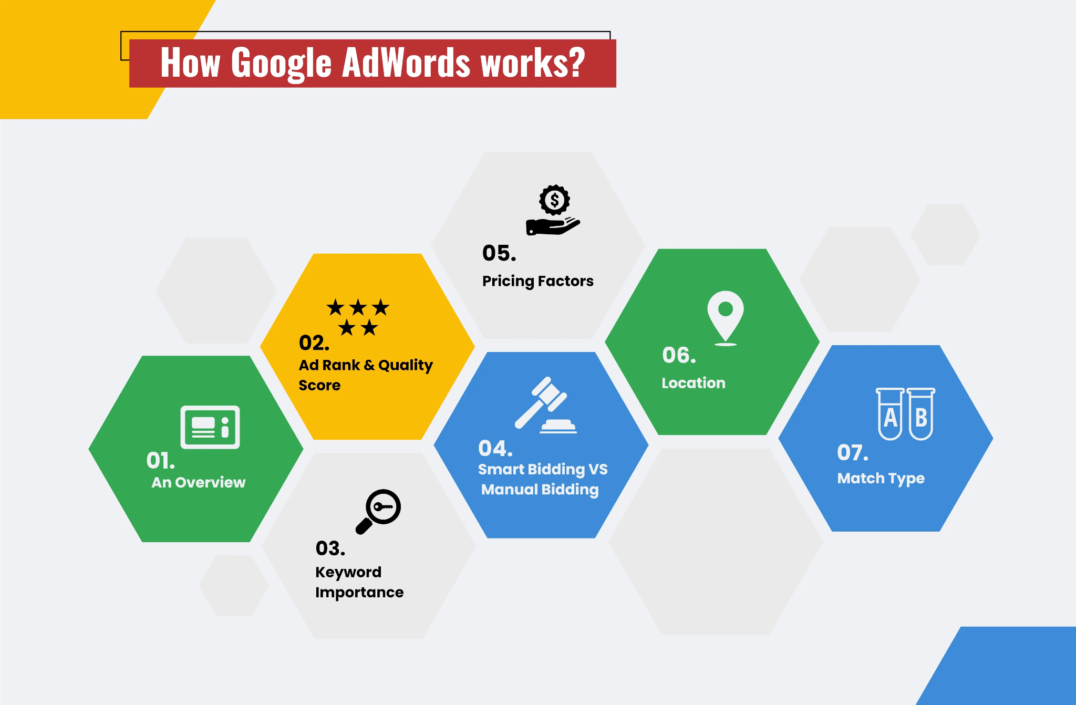

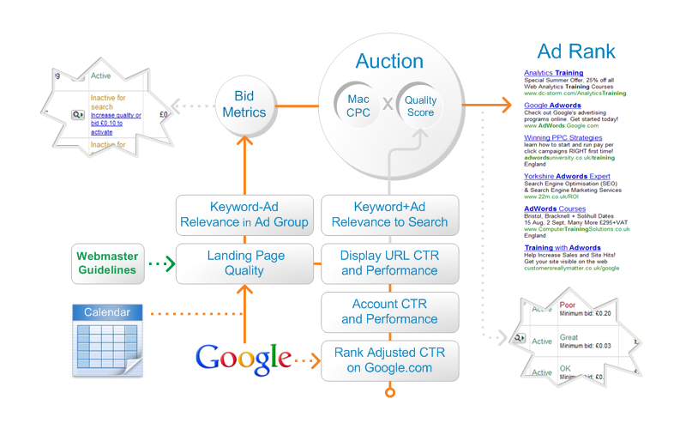

Key concepts for utilising Google Keyword planning tool and its implementation

Google ads—typical PPC search advertisements—are displayed as search results when a potential customer puts in a pertinent term or phrase. Users will be sent to a page with many pertinent search results if they Google "purchase shoes online.". The word ADS will be written on top of the search result that is shown at the top of the SERP. That is a Google advertisement that always appears as the top SERP result. Let's take a closer look at the many elements that go into selecting high-quality Google Ads to make users’ Google Ads appear first in the SERPs[1].

**7.2. Layers**

**B. Ad Rank & Quality Score:**

Ad rank in Google AdWords indicates where the user’s ad will appear on the search results page. The value of the user’s ad's Ad Rank indicates how and where it will appear in relation to other advertisements as well as if it will appear at all.

The value of the Ad Rank depends on two things:

The Price Offered Quality Rating Quality Score: Users’ ad quality score indicates the overall quality of their ad (keywords, landing sites), as well as its relevancy. Google examines users’ click-through rates to establish their quality score (CTR). Users’ ad quality score increases, which results in cheaper costs and better ad placements. It's vital to understand that the quality score of their ad is merely a combined estimation of their entire presentation in ad auctions and cannot be utilized to determine ad ranks during auction periods. Relevant Landing Pages, clickthrough Ratio Expectations, and their advertisement's level of relevance determine the Quality Score of their advertisement[1].

**C. Keyword Importance:**

The cornerstone of Google AdWords is keywords. Any Google Advertising specialist will inform them of the significance and relevance of keywords in the creation of high-quality PPC ads as well as in the bidding and pricing procedures. The method used by Google Ads is called keyword bidding. Advertisers participate in the keyword bidding process with the express objective of displaying adverts to their users when the consumers input the appropriate term. Because Google uses an auction approach, all marketers place bids rather than outright purchases for keywords. To ensure that marketers with large spending may succeed with PPC. PPC specialists should concentrate on doing in-depth keyword research to identify the most worthwhile keywords to bid on[1].

**D. Manual Bidding Vs Automated Bidding:**

The significance of keywords in effective Google AdWords is now clear. For the right to use keywords relevant to their business and sector, advertisers must place a bid. Two methods are used in the keyword bidding process:

1. Manual Bidding:

When internet marketers who are Google Ads experts control their keyword bidding using Google Ads and make judgments and take human actions without the use of machine learning or intelligent solutions Advertisers in this situation rely on their gut feeling, experience, keyword research, and performance. The Manual Bidding Process should be used when they are on a tight budget. Users’ clientele isn't that large. Want complete control over your campaign so that you can quickly alter it as needed. Allow enough time to observe the campaign.

2. Smart Bidding:

The Smart Bidding keyword approach, sometimes referred to as Automated bidding, employs algorithms for bid optimization in accordance with the objectives and specifications of your PPC campaign. Users’ advertising bids are automatically determined based on their propensity to generate a click or a conversion. Automated Strategies are created to accomplish particular corporate objectives. When to use smart bidding is when: Their budget is very big. They have significant PPC accounts to manage. The amount of time they spend on campaign monitoring should be maximized. They have certain commercial objectives[1].

**E. Pricing Factors:**

Unfortunately, there is no set cost for each Google Ad user generated. Instead, everything is determined by their campaign type, goals, budget, and set of targeted keywords. Using an auction approach, Google Adwords pricing is determined. In order for the targeted keywords to display on their Google AD, they must bid using the auction model after choosing their campaign goals, specifying their budget, and doing so. The advertiser selects the highest bid amount willing to pay for a single click on their ad in accordance with the Google Adwords Pricing Model.

They have a choice between three payment methods with Google Ads:

1. CPM: Cost Per Mile, the cost associated with having their advertisement seen by 1,000 people.

2. CPE: Cost Per Participant is the total sum they pay if someone responds to their advertisement and completes a specific activity.

3. CPC: The most popular payment option, is the cost per click (CPC) for Google Ads.

Users may now enter the auction after selecting their payment method. How is the auction conducted? It's as simple as placing bids on the appropriate keywords. The following describes how the Google Adwords Auction operates: Web users typically enter a keyword for a search query as a single word or a phrase, which are referred to as short-tail or long-tail keywords, respectively. Google utilizes its superpowers to determine whether the searched term contains any keywords for which there are active bids. The auction starts when marketers place bids exclusively on the search query's keywords. Each advertiser must create a list of keywords relevant to the offerings, services, and goods their company makes before joining the auction.

Create ad groups and campaigns using the keywords so that users may write relevant PPC advertisements that will encourage Google users to click. Google will then determine their AD rankings, which will inform them if their ad qualifies for inclusion in the paid results area. An easy way to comprehend the procedure is AD Rank= CPC Bid x Quality Score.

Users’ keywords, advertising, and landing pages' quality are referred to by the term "Quality Score." CPC Bid also refers to the highest sum users are willing to offer for a certain term. Therefore, if users achieve a High Ad Rank, they won the Google Adwords Pricing auction, and their advertisement will undoubtedly appear as a paid result. Following that, Google will determine how much users pay for each ad click[1].

**F. Location:**

PPC specialists that work with Google advertisements must be cautious with location information and strive to be as location-specific as possible. Users must choose a specific area for their advertisements to appear after setting up their Google AdWords account. Google will only show its advertisements in the places they choose. It is crucial that users describe their business location and, if users are selling items, the delivery destinations as well. Keep in mind that Google's only goal is to provide customers with relevant search results[1].

**G. Keyword Match Type:**

The keyword match types users choose for their advertisements inform Google what to match them with. It informs Google whether users like their advertisements to precisely match a search query or whether they want them to be seen by anybody who enters a semi-related search query.

Broad Match: This option, which is the default, utilizes any term together with your keyword in any sequence. The terms "Vegetable Pizza" or "Vegetable Pizza Mumbai" will be equivalent.

Modified Broad Match: Allows you to focus on certain keywords inside a keyword phrase, indicated by a "+" symbol. For instance, "+Veg Pizza In Mumbai" might result in "veg pizza" or "veg and pizza.".

Phrase Match: Finds queries that contain users’ keyword phrases in the specified sequence, together with any additional terms that may come before or after. For instance, searching for "Best Veggie Pizza" may get results like "Deliver Best Veggie Pizza" and "Best Veggie Pizza & Pasta." Exact Match: The keyword phrase is maintained in its textual and chronological sequence. For instance, searching for "Best Veg Pizza In Mumbai" will only show results for "Best Veg Pizzas," not other pizzas[1].

**In conclusion,** creating successful campaigns requires an understanding of the underlying principles of AdWords. We described the Google results page, Quality Score, the AdWords auction, and Latent Semantic Indexing (including features like Instant and the integration of Google+ into their SERPs) (LSI). Knowing how Google's platform functions will help users skip the costly learning curve that new advertisers must go through and will help their company dominate Google's results page as well[2].

**8. Data View**

**Explain data view**

In contrast to raw data, a data view is a logical organization or display of information. To make data more useful, understandable, and engaging for humans, views are often developed. It's possible, for instance, to arrange comments on an article according to criteria like the authority of the commentator or the comments' position in user rankings. This improves the quality of a website by hiding irrelevant or spam comments and promoting the best ones. A view is an abstraction that stands outside of the physical organization and information contained in data stores. Low-quality comments, for instance, may be hidden away in a data warehouse and never seen by end users[1].

| Overview: Data View |
| --- |

| Data Definition (1) | A data structure or representation that is distinct from a data repository. |
| --- | --- |
| Definition (2) | A virtual table-like result set from a stored query in a database. |
| Value | Makes data more manageable or helpful. |
| Related Concepts | Types Of Information/Data |

**ER-model of data stored in a relational database**

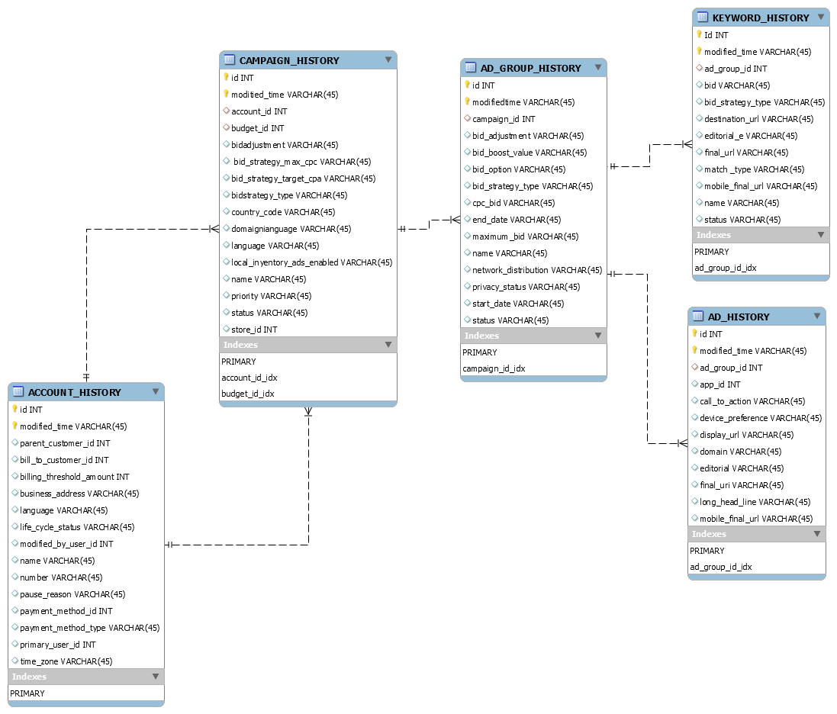

**Explain Database view (showing all components and behavior relevant to storing data)**

With keyword results, the Google AdWords Keyword Tool offers a number of statistics. We may choose the terms that are most likely to provide high-quality leads within our budget using this information. Here is a brief explanation of each category of statistics[2]:

**Projected Ad Position:** Based on the maximum cost-per-click (CPC) that we enter in the generated estimates using a different maximum CPC bid field, this column displays the estimated position for advertisements showing up on each term.

**Estimated Average CPC:** Based on the maximum CPC that we enter in the generated estimates using a separate maximum CPC bid field, this column displays the estimated average cost-per-click (CPC) for each term.

**Competition from Advertisers:** This column displays the global amount of advertisers competing for each term in relation to all other keywords on Google. The shaded bar shows a broad low-to-high quantitative scale that may be used to estimate how difficult it is to run ads for a certain keyword.

**Local Search Volume [Last Available Month]:** The number of search requests that roughly match each term is displayed in this column. In the most recent month for which Google has statistics, this number refers to searches made on Google and the search network. We'll notice not enough data if Google doesn't have enough information for a specific term.

**Global Monthly Search Volume:** This column displays the corresponding keyword's approximate monthly search volume. This figure refers to queries made over the last 12 months on Google and other search engines. It encompasses all international and linguistic traffic. We'll notice not enough data if Google doesn't have enough information for a specific term.

**Search Volume Trends:** This column displays changes in Google search volume over the previous 12 months for each keyword. Each bar in the graph represents how well the term performed overall over the previous 12 months. This figure is particular to the nation and language we are targeting. If Google doesn't have enough data for the desired country and language, we won't receive any results.

**Highest Volume Occurred In:** This column displays the month in which, for the targeted nation and language, each term saw the greatest volume of Google searches during the previous 12 months. We won't see any data if Google doesn't have enough information on the nation and language we've chosen.

**Specifications**

**Functionality:** Logically, there are two types of AdWords API web services[2]

**• Campaign Data Services:** Uses these online services to manage campaigns, ad groups, criteria, and other AdWords-related data. Campaign data services include AdGroupService, AdService, CampaignService, and CriterionService.

1. AdGroupService: AdGroupService is in charge of all activities involving an ad group as a whole. Creating an ad group is one of the main operations.

a) Adding Ad Groups with Targeting Criteria and Ads.

b) Revisions to Ad Groups.

c) Getting Ad Groups Information.

2. AdService: We can create advertisements, link them to ad groups, edit them, and delete them using AdService.

a) Making ads is an operation.

a) Making ads is an operation. updating the ads.

c) Learning more about advertisements.

3. CampaignService: We may carry out campaign-wide activities using this web service.

a)Creating a campaign is one of the main operations.

b) Changing up campaigns

d) Obtaining campaign information.

c) Campaign pauses.

d)Conversion Optimizer can be enabled.

4. CriterionService: To control which advertisements are selected for display, use keyword and placement targeting. We may obtain, add, edit, and delete the criteria connected to an ad group using the CriterionService. It also enables us to obtain basic data for the parameters related to an ad group. Operations: a) Developing Websites and Keywords

b) Updating Websites and Keywords

c) Learning more about websites and keywords

**• Utility Services:** Manages our AdWords accounts and helps us adjust our advertisements wisely by using these online services. Utility services include AccountService, InfoService, KeywordToolService, ReportService, SiteSuggestionService, and TrafficEstimatorService.

1. AccountService: We may access and change information about our AdWords accounts via the Account Service.

2. InfoService: The Info Service enables us to get some fundamental data about how we use our APIs.

3. KeywordToolService: Using seed keywords we supply or terms from a website's URL, the Keyword Tool Service enables us to produce new keywords. Traffic statistics for each term are provided, including the relative levels of advertising competition, search volume, etc.

a) Producing keyword variants depending on a seed keyword is one of the main activities.

b) Generates keyword variants using terms from your website.

4. ReportService: To create reports regarding the effectiveness of AdWords campaigns, use ReportService.

5. SiteSuggestionService: This service offers four methods to acquire website suggestions: by category, by themes we choose, by URLs, or by demographic data from the Google Network.

6. TrafficEstimatorService: This service offers operations for calculating ad group, campaign, and keyword traffic.

**Inventory-based Ad Management**

Users that promote many items online may need to regularly carry out the following ad management chores to keep their advertising approach in accordance with their sales and marketing plan:

* When a product is out of stock, we must halt your promotion for that product and resume it when we have additional stock.
* We want to run online advertising that notifies potential buyers about the discount details and coupon codes since we're organizing a discount sale for a product.
* If our clients are more inclined to buy on mobile than desktop, we want to push a certain product to those people by placing a larger bid on the mobile platform.

These procedures typically take a long time to do manually because

* It might be challenging to maintain track of the inventory details and manually update the adverts because the inventory data is often kept in a database on our application server and has a tendency to vary during the day.
* The number of advertisements we need to monitor expands along with the number of items you market to the point where manual tracking is challenging or impossible.

Users can automate some of these operations with the use of the inventory-based ad management script[3].

**Similar use cases**

Despite the fact that the script was built with a product and inventory supply in mind, it may be applied to a number of use cases that are similar[3]:

* We manage a number of online courses and want to base our advertising decisions on the availability of seats.
* We manage a network of hospitals and clinics, and we want to publicize the average wait time for an appointment with a doctor at each facility.
* We conduct a tour and want to promote based on how many seats are still available and whether or not the consumer is using a mobile device to search. This takes the assumption that a mobile user browsing during your business hours is probably trying to purchase a ticket right away, thus it makes sense to bid higher for that user.

**Script capabilities**

The following functions can be carried out by the inventory-based ad management script:

* Get information about your inventory stock from a distant database or a Google Cloud SQL database and enter it into a Google spreadsheet.
* Fill the Google spreadsheet with statistics from various product reports.
* Based on the guidelines laid down in the Google spreadsheet,
  + Make product-specific ad groups active or inactive.
  + Put a mobile bid modifier on an ad group for a certain product.
  + Make advertising for discounts in ad groups that are product-specific.
  + Advertisements for discounts should be updated dynamically with the most recent discount rates and coupon details.

In addition, based on the inventory stock facts, Google Spreadsheet formulae may specify other criteria to determine the discount %, mobile bid modifier, when to switch the discount on or off, etc[3].

**Prerequisites**

The inventory-based ad management script assumes certain things about how user accounts and user goods are structured[3].

* Every product ought to have a special code. The script makes use of the code to, among other things, locate the ad group connected to the product and sync inventory data from the remote database to the spreadsheet.
* Every ad for a given product is contained in a related ad group.
* A Google Ads label has been added to the product-specific ad group, and its wording has been customized to match the product code.
* Information about the inventory stock is accessible in a Google Cloud SQL database or a remote SQL database. This database is accessible to the script.

See the procedures for setting up or creating a database below.

**How it works**

The key interactions between the script and the various components are depicted in the figure below.

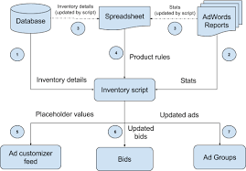

The script begins by extracting statistics from Google Ads reports and inventory information from the database. After that, it uploads these numbers to the spreadsheet to check for any product codes that match. The calculations in the spreadsheet are altered as a result, and the product rules are revised. The script then adjusts the advertising and bids in accordance with the revised product regulations after downloading them from the spreadsheet. So that the advertisements are delivered with the most recent values, the ad customizer feed is updated with the most recent placeholder values from the database and spreadsheet. Below is a detailed explanation of each of these interactions[3].

**Accessing the database to retrieve stock information.**

By connecting to a SQL database on a user server or a Google Cloud SQL database, the inventory-based ad management script gets the inventory data for your items. After then, this

information is kept in a Google Spreadsheet. Data from the database and rows in the Google spreadsheet are matched using the product code.

For ease of use, the script presupposes that the database contains a table named items with the following schema[3]:

| **Field Name** | **Field type** | **Meaning** |
| --- | --- | --- |
| code | string | The particular item code. |
| stock | number | Details about this item's supply in the inventory. |

The script executes the query on the distant database and feeds the outcomes into the spreadsheet's Stats tab. It's OK for the user database to have a different schema; the user only has to adjust the query so that the query data set meets the above-mentioned structure. Select code, and stock from items.

**Retrieving product statistics.**

The script extracts the spreadsheet's whole list of items and their corresponding ad groups. The following step runs a report on the seven-day performance of the ad groups. The spreadsheet's Stats tab receives the results and loads them there [3].

**9. Testing**

**9.1. Expected Test scenarios**

Expected Test scenarios List with test steps and outcome [1]:

| Test Scenario | Test Steps | Expected results |
| --- | --- | --- |
| Consider new/different keyword | 1. Open a Google Ads account and log in. 2. Under "Planning," click the setting button, then select Keyword Planner. 3. Click Find fresh keyword ideas. 4. There are three techniques to find fresh keyword suggestions: 5. Begin with keywords: Enter terms that are associated with user items or services. A comma and a space can be used to divide numerous sentences. 6. Enter the user domain, and Google will try to filter terms that are unrelated to the user's offering. 7. Begin with a website: Enter any website, and Google will search for terms relevant to the site's content.   C. Preview keyword suggestions in ad groups: Keyword Planner will attempt to categorize keywords in order to find new keywords for the user's top campaigns automatically.  5. Select Get results by clicking it. | Obtain keyword ideas for user products, services, or websites. |
| Editable user keyword list. | * To alter filters, Click the filter icon above the results table. * **User results can be filtered by:**   Keyword text  Typical monthly searches.  Page-top bid (low range).  Page-top bid (high range).  Competition.  Organic impression share.  % of ad impressions.  Delete keywords from the user account.  Use categories connected to user keyword suggestions to refine the user list.   * By default, all categories are chosen. * Uncheck the boxes next to the categories that users want to take out of the user's list of keyword suggestions to restrict their search. | In order to fine-tune the suggestions that are most pertinent to user campaigns, users may now change their list of keyword suggestions using filters and categories. |
| Get predictions for search volume. | 1. Log in to account for Google Ads. 2. Under "Planning," click the setting button, then select Keyword Planner. 3. Click Get predictions for search volume. 4. Following the steps below, type or paste a list of keywords into the search box or upload a list of keywords from a CSV file: 5. Then choose Upload a file. 6. Click From your PC, choose a file. Examine the templates offered for adding keywords.   i. Include a list of keywords in user file: There should only be one column in your file, with the header "Keyword."  ii. Post thier whole keyword strategy: Download the template to add thier keyword along with optional information like a campaign, area, ad group, etc.  c. Click "Submit.".  5. Click on Get started. | Plan with keywords included, then view forecast. |

**9.2 Unit Test**

The client library used for this document allows it to obtain Google Ads campaigns. Getting the necessary OAuth2 credentials is the first step in enabling API access. Add the authorization and account information after that to a configuration file. When the configuration file is finished, the user is prepared to utilize the API to begin keyword research for their companies, organizations, or other relevant terms.

**Set up options for the client library.**

In order to start doing keyword research, provide the following details in the user client library's configuration file[2]:

**Token for developers.**

Their program may access the API with the help of a user developer token, which is not limited to a single Google Ads account. When a user's token is authorized, they are able to use it for requests against any of their Google Ads accounts, even if those accounts aren't connected to the token's Google Ads management account.

Their OAuth credentials from the management account are used to approve the accounts they administer. To handle all of the sub-accounts under a management account, just one set of credentials is needed.

For production Google Ads accounts, only authorized tokens can connect to the API; pending tokens can only connect for test accounts.

By logging into their manager account and then going to the API Center (TOOLS & SETTINGS > SETUP > API Center), they may receive their developer token.

**Important Points:** A business should only provide one developer token. After being used with a developer token, a Google Cloud project is locked to that token and cannot be used by another.

**Client's customer ID.**

The account number of the Google Ads client account users wish to control via the API is known as the client customer ID and often takes the form 123-456-7890.

The client customer ID may instead be specified programmatically rather than in the configuration file. The user can utilize a client customer ID from a production account rather than a test account once the user developer token has been validated.

**Client secret and client ID for OAuth2.**

The OAuth2 client ID and client secret are used for OAuth2 authentication, allowing the user app to act on behalf of the user account. They link the user client app to a project in the Google API Console. They allow users to create OAuth credentials for managing Google Ads users and identify user apps to Google.

**Access and refresh tokens for OAuth2.**

The user app must first receive an OAuth2 access token that gives it access to the API before it can use it to access private data.

The OAuth2 access token is automatically managed for users if they are utilizing client libraries. If not, try obtaining tokens using the OAuth Playground.

OAuth2 access tokens have a finite lifespan. As a result, the OAuth2 access token is automatically generated by the client libraries using the OAuth2 refresh token. The steps for creating the refresh token are in the access and refresh token.

**Database model**

**Gaining entry to the database to get stock information**

The inventory-based ad management script obtains the inventory information for your goods by establishing a connection to a SQL database on a user server or a Google Cloud SQL database. After that, a Google Spreadsheet is used to store this data. The product code is used to link rows in the Google spreadsheet with data from the database.

The script assumes that the database has a table named items with the following schema for convenience's sake:

| Function name | Inputs | Expected outputs /resulting outputs |
| --- | --- | --- |
| add code | string | The specific item code is true or false depending on matching from user input |
| Add stock | number | Information on the availability of this item in the inventory is kept on the data server. |

The script runs the query on the remote database and inputs the results into the Stats tab of the spreadsheet. The user just has to modify the query to ensure that the query data set adheres to the aforementioned structure if the user database has a different schema. Choose a stock from the goods and a code[3].

| **9.3. Functional Test**  The fundamental functions of an application are examined through functional testing, a sort of software testing, against a specified set of requirements. Functional tests determine if a given input produces the expected outcome regardless of any other details by using Black Box Testing methodologies. Test results are binary, passing or failing.  **The following table lists test scenarios that users must run along with the test procedures, with expected results listed as either correct or wrong[3]:**  **FUNCTIONAL TEST CASES** |
| --- |

| Sr No. | **Test Scenario** | **Test Steps** | **Expected results** |
| --- | --- | --- | --- |
| 1 | Enter a word in the search text box | 1. Launch https://www.google.com from any web browser.  2. Enter the text ‘Apple’ in the search text box.  3. Click the Search button | 1. On clicking the search button, it should redirect user to search results.  2. Search results should be relevant. |
| 2 | Press Enter from the text box | 1. Launch https://www.google.com from any web browser.  2. Enter the text ‘what is an Apple’ in the search text box.  3. Press the Enter key. | 1. On pressing the Enter key, it should redirect the user to search results.  2. Search results should be relevant. |
| 3 | Max length of search keyword | 1. Launch https://www.google.com from any web browser.  2. Enter text ‘Johny Johny yes papa, eating sugar no papa, telling lies no papa, open your mouth hahaha ’ in the search text box.  3. Press the Enter key | 1. On pressing the Enter key, it should redirect the user to search results.  2. Search results should be relevant. |
| 4 | Invalid values in the search text box | 1. Launch https://www.google.com from any web browser.  2. Enter text special characters ‘@#$%^’ in the search text box.  3. Press the Enter key | 1. On pressing the Enter key, it should redirect the user to ‘did not match any documents’.  2. Search results should give the message Suggestions:  a. Make sure that all words are spelled correctly.  b. Try different keywords.  c. Try more general keywords. |
| 5 | Visibility of long search text | 1. Launch https://www.google.com from any web browser.  2. Enter text ‘Johny Johny yes papa, eating sugar no papa, telling lies no papa, open your mouth hahaha ’ in the search text box. | 1. The input text should start scrolling towards the right-hand side.  2. On pressing the Enter key, it should redirect the user to search results. |

**9.4. Usability Test**

**The user cancels the process of configuring keyword search volumes by city that used a location filter.**

This graphic represents the usability test, which examines how easily and effectively the system operates for the user. The system has to operate quickly and do some tasks on schedule. The user wants to remove the ability to restrict keyword search volumes by city, according to the request. The work should be generated by the system in a quick and effective manner. The cancel process must be completed in less than 1 second in order to request the procedure in less than 2 seconds and complete the task[2].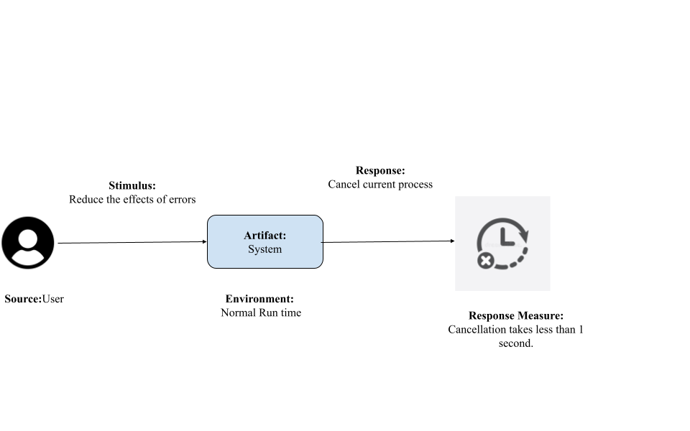

*Usability test diagram*

**9.5. Security Test**

The system's request and authorization will be tested throughout this testing. Users ask the system to edit the data that is related to the database once more. The system will determine if the condition is satisfied when it asks data by checking the user's authorization to alter the information. The server will fulfill the request, respond to the user's request for data, and display the request's status. The diagram for the security test is shown below.

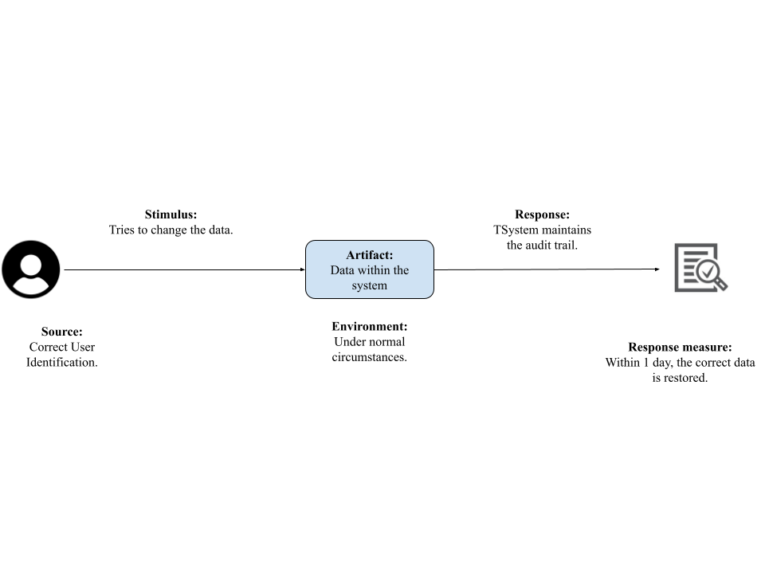

*Security Test Diagram[3].*

| **SECURITY TEST CASES** | | | |
| --- | --- | --- | --- |
|
|  | **Test Scenario** | **Test Steps** | **Expected results** |
|  | Detect automation. | 1. Start by typing http://www.google.com  2. Use an easy script to recursively search a text. | Google needs to detect this and offer a captcha to complete. |
|  | Redirecting from http to https | 1. Begin by going to http://www.google.com  2. Try the URL. | 1. Click https://www.google.com instead of http://www.google.com to go there  2. A current certificate must always be present. |
|  | Injection using SQL. | 1. Go to https://www.google.com  2. In the search field, type a SQL query.  3. Push the Search icon. | Google need to provide outcomes connected to the SQL queries. |
|  | The request for sign-in should be encrypted. | 1. Launch the developer tool in browser.  2. Open the website for Google.  3. Use Google account to log in.  4. Check the request and response from the API.  5. Log off.  6. Check the request and response from the API. | Without encryption, no sensitive information should be transferred. |

**9.6. Performance Test**

| Sr No. | **Test Scenario** | **Test Steps** | **Expected results** |
| --- | --- | --- | --- |
| 1 | Open many browsers or tabs. | 1. Launch many tabs in a browser.  2. Open www.google.com in a new tab. | System failure shouldn't occur. |
| 2 | Keep pressing the search button | 1. Write a script to repeatedly press the search button. Let's use a 500-ms click rate.  2. Execute the script from the Google search results page. | System failure shouldn't occur. |
| 3 | Adding text to the search box that is longer than 500 kb. | 1. Open www.google.com in a new tab.  2. Create a string that is at least 500 KB long and paste it into the search field.  3. Press the Search key. | To 500 KB, the string should be truncated. |

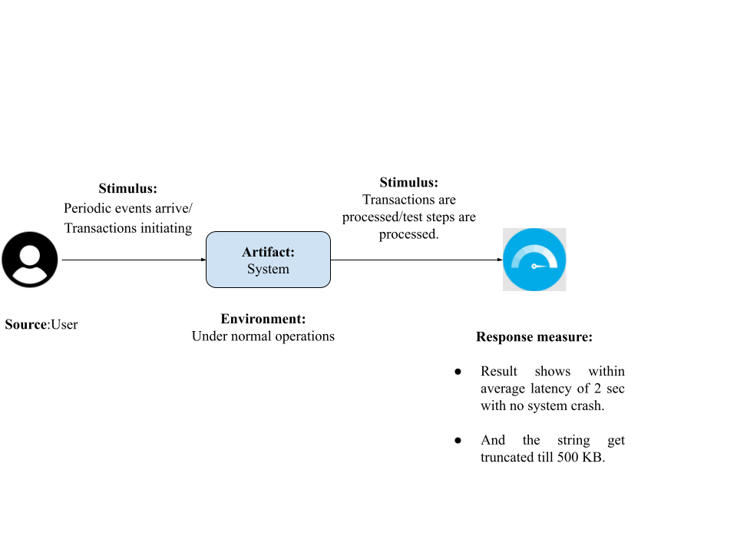

*Performance Test Diagram for the aforementioned test scenarios, test procedures, and anticipated outcomes[3].*

**9.7 Availability test**

**Test user landing pages availability for the effectiveness of keyword research[7]:**

**How it operates.**

Users may get a performance summary for the sites that their advertisements are delivering visitors to on the "Landing pages" page. All landing page URLs from Search, Display, Video, Search, and Shopping campaigns are included on this page.

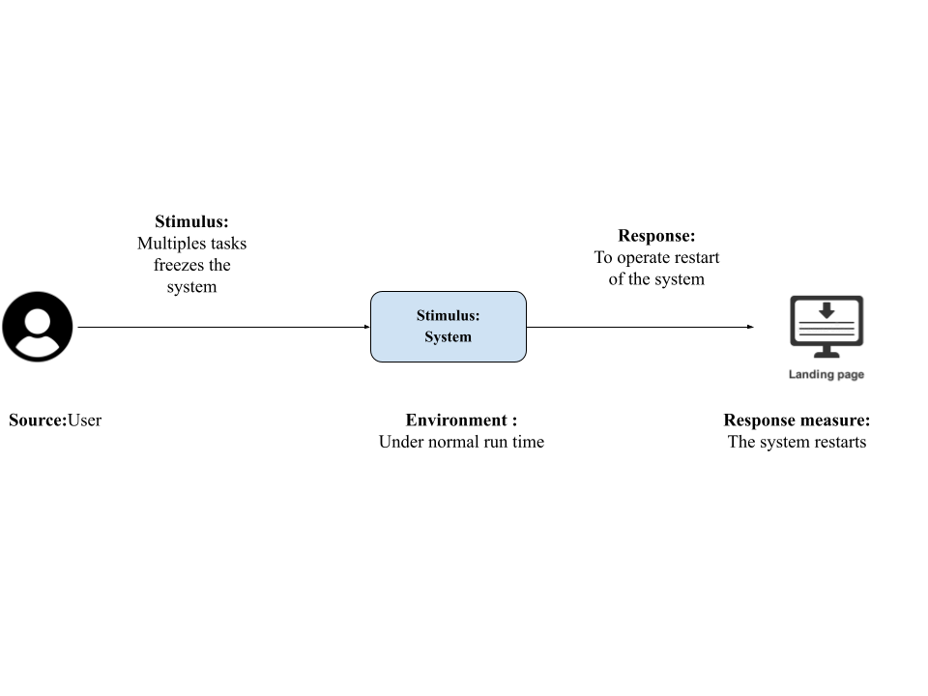

The purpose of the availability test is to evaluate a system's failure and reusability. In the illustration, the user is performing several activities at once, which increases the risk of a system freeze or crash. If the application does not react within 10 seconds, the system will complete the task. The program will automatically restart.

**Why are landing pages crucial for availability tests?**

A landing page on a user's website is the page that visitors arrive at after clicking one of their adverts. The secret to generating conversions from their Google Ads traffic is having effective landing pages.To understand how users are interacting with their websites, it's critical to often assess how well their landing pages are doing.

**10. Size and Performance**

**Size/volume: How many users can accommodate the system?**

Up to 20 Google Ads accounts (including manager accounts) can share a single email address, but a manager account is unquestionably the best option if users are in control of more than 20 accounts or want to quickly evaluate conversions or monitor performance across accounts from one location[1].

**Performance: Time to process the user’s request.**

A successful Google ad campaign will turn into a powerful campaign after at least 3 months of maturation. Google reviews and approves user accounts between 24 and 48 hours after the user initially activates their Google Ads account. Google needs an additional 7 days to acquire crucial information about users' businesses once they gain approval[2].

**11. Quality: Explain quality**

When customers are just starting out with a little marketing budget, Google Keyword Planner is a decent free choice. If users want to conduct pay-per-click (PPC) ads, it connects effortlessly with Google Ads[3]. A user may utilize Google Keyword Planner to get fresh keyword suggestions related to their goods/services and blog post themes and improve their search engine rankings [4]. Despite being a PPC tool, it is frequently used for SEO tasks, mostly since it is free and offers reliable term ideas directly from Google[5].

**12. Limitation of the system: If any**

Users are only allowed to enter 700 keywords into Keyword Ideas in Google Keyword Planner. Users can upload up to 3,000 keywords at a time to the forecaster, but there is a limit to the number of files they can upload to obtain search volume and trends. [6]. Filtering search volume by the device is no longer an option on Google. [7].

**13. Conclusion**

Any organization that plans to run its own Google Ads for its goods or services will find Google's Keyword Planner to be a very useful tool. It's a fantastic method for conducting keyword research and locating long-tail phrases that your Google ad campaigns may use as targets. The Google Keyword Planner tool is really helpful since it provides all the information users need to determine whether or not something will be a success before actually moving through with it. Additionally, it provides users with a decent indication of the cost of Google advertising as well as the expected volume of traffic that their keywords will receive on their search network.

**14. BIBLIOGRAPHY**

I Kabir, Fardina successfully completed the Google Keyword Planning tool. Pursuing program Bachelor of Information Technology, Stamford International University, ITE367 - Software Architecture and Modelling

Under the guidance of Course Lecturer Dr. Surekha Lanka.

I have gained knowledge from the below mention textbook.

Author of our software architecture Textbook

Len Bass, Paul Clements, Rick Kazman, “Software Architecture in Practice”, 3rd edition

Pearson, 2013.

Bass received his Ph.D. in Computer Science from Purdue University in 1970 under supervision of Paul Ruel Young with the thesis, entitled "Hierarchies based on computational complexity and irregularities of class determining measured sets." Bass was appointed Professor of Computer Science at the University of Rhode Island in 1970. In 1986 he moved to the Software Engineering Institute at the Carnegie Mellon University, where he started as head of the user-interface software group, and later focused on analysis of software architectures. Since 2011 he is Senior Principal Researcher at NICTA, National ICT Australia. Len Bass was awarded the Software Development Magazine's Jolt Productivity Award twice in 1999 and 2003.

Shaw's main area of research interest is software engineering, including architectural, educational and historical aspects. Shaw authored seminal works in the field of software architecture along with David

Garlan. Software Architecture, 1996

Shaw's most cited work "Software Architecture: Perspectives on an Emerging Discipline, "co-authored with David Garlan, examines the concept of "architectures for software systems as well as better ways to support software development." The book aims: "... to bring together the useful abstractions of systems design and the notations and tools of the software developer and look at patterns used for system organization... to illustrate the discipling and examine the ways in which architectural design can impact software design. Our selection emphasizes informal descriptions, touching lightly on formal notations and specifications and on tools to support them."

In this work Garlan and Shaw "describe an architecture of a system as a collection of computational components together with a description of the interactions between these, components—the connectors." A component is simply described as "the elements that perform computation." (Mary Shaw, n.d.)

(Hansson, Kjellberg, & Fernlund, 2009)  
 Mary Shaw. (n.d.). Retrieved 5 29, 2018, from Wikipedia: The Free Encyclopedia:

http://en.wikipedia.org/wiki/Mary_Shaw_(computer_scientist)  
 Mary Shaw. (n.d.). Retrieved 5 29, 2018, from Wikipedia: The Free Encyclopedia:

http://en.wikipedia.org/wiki/Mary_Shaw_(computer_scientist)  
 Hansson, K., Kjellberg, M., & Fernlund, P. (2009). Cysteine-rich secretory proteins in snake   
 venoms form high affinity complexes with human and porcine [beta]-   
 microseminoproteins. *Toxicon*, 54(2).

**15. Extended work**

In the meantime, if given the chance to work on the project, I would choose this topic and continue the research for the enhancement of the tool and completion of many other necessary features for users’ usage, as many researchers have discovered some shortcomings while using the tool, such as no indications of trends, no broad or phrase search, no filtering search volume by the device option, and so on, and they have preferred other alternatives to the tool because the alternatives have these features which Google Keyword Planning tool doesn’t have. Since the majority of the world's population has high expectations from Google due to its longstanding and excellent services, it would be beneficial to not let users experience any drawbacks when using the Google Planner tool, which could otherwise negatively impact Google's service value. Working on the implementation of those features and further improvement based on ongoing future research or trends over time can help develop the Google Keyword Planner tool as the best keyword research tool for marketing, user Search campaigns, PPC, SEO, and other relevant for the convenience of users and meeting users’ expectations as a fulfillment of great customer service that could uphold the integrity of Google brand as a trustworthy company since it was founded.

**References:**

(Introduction)

1. Use Keyword Planner - Google Ads Help [Internet]. Support.google.com. [cited 20 August 2022]. Available from: <https://support.google.com/google-ads/answer/7337243?hl=en>
2. Explore features - Google Ads Help [Internet]. Support.google.com. [cited 20 August 2022]. Available from: <https://support.google.com/google-ads/topic/10286611?hl=en&ref_topic=3181080,3126923>
3. How to Use The Keyword Planner Tool - Google Ads [Internet]. Ads.google.com. [cited 20 August 2022]. Available from: <https://ads.google.com/home/resources/using-google-ads-keyword-planner/>

(Architectural goals and constraints)

1. Carver, D. (2022). *How do keyword research tools generate their data?* The Content Technologist. Retrieved 21 August 2022, from <https://www.content-technologist.com/how-keyword-research-tools-work/>.
2. *WHAT OPERATING SYSTEM DOES GOOGLE SERVERS USE?*. LEMP. (2021).

Retrieved 21 August 2022, from <https://lemp.io/what-operating-system-does-google-servers-use/>.

1. Skow, J. (2021). *How to Use Google Keyword Planner (A Step-by-Step Guide)*. MonsterInsights. Retrieved 21 August 2022, from <https://www.monsterinsights.com/how-to-use-google-keyword-planner/>.
2. *How to Use a Keyword Planner Tool?* Simplilearn. (2022). Retrieved 21 August 2022, from

<https://www.simplilearn.com/how-to-use-google-ads-keyword-planner-tool-article>.

1. *Use Keyword Planner - Google Ads Help*. Support.google.com. (2022). Retrieved 21 August 2022, from <https://support.google.com/google-ads/answer/7337243?hl=en>.
2. *Understanding Google Monthly Keyword Search Volume | SEO Scout*. Seoscout.com. (2022). Retrieved 21 August 2022, from <https://seoscout.com/search-volume>.
3. *How to Use The Keyword Planner Tool - Google Ads*. Ads.google.com. (2022). Retrieved 21 August 2022, from <https://ads.google.com/home/resources/using-google-ads-keyword-planner/>.
4. *Recommended & Minimum Computer Configurations for Students (Windows) | UMass Amherst Information Technology | UMass Amherst*. Umass.edu. (2022). Retrieved 21 August 2022, from [https://www.umass.edu/it/support/hardware/recommended-minimum-computer-config](https://www.umass.edu/it/support/hardware/recommended-minimum-computer-configurations-windows) [urations-windows](https://www.umass.edu/it/support/hardware/recommended-minimum-computer-configurations-windows).
5. Goldman, D. (2015). *Google: The reluctant censor of the Internet*. CNNBusiness. Retrieved 21 August 2022, from <https://money.cnn.com/2015/01/04/technology/google-censorship/index.html>.

( Architectural Representation)

1. Entity Relationships | AdWords API (Deprecated) | Google Developers. Google Developers. Retrieved 26 August 2022, from https://developers.google.com/adwords/api/docs/guides/entity-relationships.
2. Objects, Methods, and Services | AdWords API (Deprecated) | Google Developers. Google Developers. Retrieved 26 August 2022, from https://developers.google.com/adwords/api/docs/guides/objects-methods#the_mutate_method.
3. API Structure | Google Ads API | Google Developers. Google Developers. Retrieved 26 August 2022, from https://developers.google.com/google-ads/api/docs/concepts/api-structure#:~:text=A%20Google%20Ads%20account%20can,your%20ads%20into%20logical%20collections.
4. The AdWords Query Language (AWQL) | AdWords API (Deprecated) | Google Developers. Google Developers. Retrieved 26 August 2022, from https://developers.google.com/adwords/api/docs/guides/awql.
5. Code Structure | AdWords API (Deprecated) | Google Developers. Google Developers. Retrieved 26 August 2022, from https://developers.google.com/adwords/api/docs/guides/samples-use-cases.
6. BatchJobService (v201809) | AdWords API (Deprecated) | Google Developers. Google Developers. Retrieved 26 August 2022, from https://developers.google.com/adwords/api/docs/reference/v201809/BatchJobService.
7. Batch Processing | Google Ads API | Google Developers. Google Developers. Retrieved 26 August 2022, from https://developers.google.com/google-ads/api/docs/batch-processing/overview.

(For Implementation View:)

1. Upgraded URLs | Google Ads API | Google Developers. Google Developers. Retrieved 26 August 2022, from https://developers.google.com/google-ads/api/docs/ads/upgraded-urls/overview.
2. Upgraded URLs | AdWords API (Deprecated) | Google Developers. Google Developers. Retrieved 26 August 2022, from https://developers.google.com/adwords/api/docs/guides/upgraded-urls.
3. Location Targeting | AdWords API (Deprecated) | Google Developers. Google Developers. Retrieved 26 August 2022, from https://developers.google.com/adwords/api/docs/guides/location-targeting#:~:text=Google%20Ads%20allows%20you%20to,a%20keyword%20in%20your%20campaign.
4. Required Minimum Functionality | Google Ads API | Google Developers. Google Developers. Retrieved 26 August 2022, from https://developers.google.com/google-ads/api/docs/rmf.
5. Required Minimum Functionality | AdWords API (Deprecated) | Google Developers. Google Developers. Retrieved 26 August 2022, from https://developers.google.com/adwords/api/docs/requirements.
6. Generating Targeting Ideas | AdWords API (Deprecated) | Google Developers. Google Developers. Retrieved 26 August 2022, from https://developers.google.com/adwords/api/docs/guides/targeting-idea-service
7. Estimating Traffic | AdWords API (Deprecated) | Google Developers. Google Developers. Retrieved 26 August 2022, from https://developers.google.com/adwords/api/docs/guides/traffic-estimator-service
8. Customizing Text Ads | AdWords API (Deprecated) | Google Developers. Google Developers. Retrieved 26 August 2022, from https://developers.google.com/adwords/api/docs/guides/ad-customizers.
9. Matching Functions | AdWords API (Deprecated) | Google Developers. Google Developers. Retrieved 26 August 2022, from https://developers.google.com/adwords/api/docs/guides/feed-matching-functions
10. Google Keyword Planner: Keyword Research in 2022 | Udonis. Udonis Mobile Marketing Agency. Retrieved 26 August 2022, from https://www.blog.udonis.co/digital-marketing/google-keyword-planner-keyword-research.

(Analysis & Design)

1. Alpar, A. (2013). *Google AdWords Keyword Planner vs. Keyword Tool: SEO & PPC Feature Comparison - Search Engine Watch*. Search Engine Watch. Retrieved 14 September 2022, from <https://www.searchenginewatch.com/2013/08/16/google-adwords-keyword-planner-vs-keyword-tool-seo-ppc-feature-comparison/>.
2. Mitrovic, B. (2019). *How to tame the new Google Keyword Planner?*. Inchoo.net. Retrieved 14 September 2022, from <https://inchoo.net/ecommerce/how-to-tame-the-new-google-keyword-planner/>.
3. Author, G. (2015). *What Makes a Good Keyword? | JB Media Group*. JB Media Group. Retrieved 14 September 2022, from <https://jbmediagroupllc.com/blog/tips-for-choosing-right-keywords/#:~:text=Your%20target%20keywords%20need%20to,conversion%20value%2C%20and%20reasonable%20competition>.
4. Liang, J., Yang, H., Gao, J., Yue, C., Ge, S., & Qu, B. (2019). MOPSO-Based CNN for Keyword Selection on Google Ads. *IEEE Access*, *7*. <https://doi.org/10.1109/access.2019.2937339>

(Architectural View Decomposition)

1. Yang, Yanwu & Jansen, Jim & Yang, Yinghui & Guo, Xunhua & Zeng, Daniel Dajun. (2019). Keyword Optimization in Sponsored Search Advertising: A Multilevel Computational Framework. IEEE Intelligent Systems. 34. 32 - 42. 10.1109/MIS.2019.2893590.
2. *Popular Use Cases: Google Ads - Databox Help Desk*. Help.databox.com. (2022). Retrieved 22 September 2022, from <https://help.databox.com/article/386-popular-use-cases-google-ads>.
3. *Keyword Research and Prioritization*. BrightEdge. (2022). Retrieved 22 September 2022, from <https://www.brightedge.com/solutions/keyword-research-prioritization>.
4. *Google Ads Overview: Everything You Need to Know*. Mobidea Academy. (2022). Retrieved 22 September 2022, from <https://www.mobidea.com/academy/google-adwords-overview/>.
5. J. Liang, H. Yang, J. Gao, C. Yue, S. Ge and B. Qu, "MOPSO-Based CNN for Keyword Selection on Google Ads," in IEEE Access, vol. 7, pp. 125387-125400, 2019, doi: 10.1109/ACCESS.2019.2937339.

(Implementation View)

1. *The Ultimate Guide: How To Use Google Adwords 2021*. GBIM. (2021). Retrieved 29 September 2022, from <https://www.gbim.com/ultimate-guide-google-adwords-2021/>.
2. *Google AdWords Training | London | East Anglia*. Rise-marketing.co.uk. (2022). Retrieved 29 September 2022, from <http://www.rise-marketing.co.uk/training/google-adwords-training-syllabus.php>.

(Data View)

1. Spacey, J. (2016). *Simplicable*. What is Data View?. Retrieved 29 September 2022, from <https://simplicable.com/new/data-view>.
2. Tusar, M. (2009). Google's keyword analysis tool and compare its various metrics for finding the most popular search terms on the web. Dspace.bracu.ac.bd. Retrieved 28 September 2022, from <http://dspace.bracu.ac.bd:8080/xmlui/handle/10361/735?show=full>.
3. *Inventory-based Ad Management | Google Ads scripts (Legacy) | Google Developers*. Google Developers. (2022). Retrieved 29 September 2022, from <https://developers.google.com/google-ads/scripts-legacy/docs/solutions/inventory-management>.

(Testing)

1. Use Keyword Planner - Google Ads Help. Support.google.com. (2022). Retrieved 4 October 2022, from <https://support.google.com/google-ads/answer/7337243?hl=en#:~:text=Discover%20new%20keywords,-A.&text=Enter%20words%20and%20or%20websites,to%20your%20Google%20Ads%20account.&text=%2C%20then%20under%20%22Planning%22%2C,Click%20Discover%20new%20keywords>.
2. Quickstart | Google Ads API | Google Developers. Google Developers. (2022). Retrieved 4 October 2022, from <https://developers.google.com/google-ads/api/docs/first-call/overview>.
3. Inventory-based Ad Management | Google Ads scripts (Legacy) | Google Developers. Google Developers. (2022). Retrieved 29 September 2022, from <https://developers.google.com/google-ads/scripts-legacy/docs/solutions/inventory-management>.
4. Lieback, R. (2022). 9 Creative Ways To Use Google's Keyword Planner Tool. Search Engine Journal. Retrieved 4 October 2022, from <https://www.searchenginejournal.com/googles-keyword-planner-creative-uses/447267/>.
5. Editorial Board, S. (2022). Test Cases For Google Search Engine & Google Chrome [ 2022 ]. SoftwareTestingo - Interview Questions, Tutorial & Test Cases Template Examples. Retrieved 4 October 2022, from <https://www.softwaretestingo.com/google-search-test-cases/>.
6. Evaluate the performance of your landing pages - Google Ads Help. Support.google.com. (2022). Retrieved 4 October 2022, from <https://support.google.com/google-ads/answer/7543502?hl=en>.

(Size and Performance, Quality & Limitation of the system)

1. About Google Ads manager accounts - Google Ads Help. Support.google.com. (2022). Retrieved 5 October 2022, from <https://support.google.com/google-ads/answer/6139186?hl=en#:~:text=Keep%20in%20mind%20that%20up,the%20best%20option%20for%20you>.
2. Dever, S. (2022). How Long Does It Take Google Ads to Work and How Does It Work?. Chatter Buzz. Retrieved 5 October 2022, from <https://www.chatterbuzzmedia.com/blog/how-long-does-it-take-google-ads-to-work-and-how-does-it-work/>.
3. Team, D. (2021). Google Keyword Planner: How Useful Is It For SEO?. Demandjump.com. Retrieved 5 October 2022, from <https://www.demandjump.com/blog/google-keyword-planner-how-useful-is-it-for-seo>
4. Skow, J. (2021). *How to Use Google Keyword Planner (A Step-by-Step Guide)*. MonsterInsights. Retrieved 5 October 2022, from <https://www.monsterinsights.com/how-to-use-google-keyword-planner/>.
5. Pavlik, V. (2021). *What Is Google Keyword Planner and How to Use It? | Mangools*. Mangools. Retrieved 5 October 2022, from <https://mangools.com/blog/google-keyword-planner/>.
6. Allazov, K. (2020). keyword planner daily limit searches - Google Ads Community. Support.google.com. Retrieved 5 October 2022, from <https://support.google.com/google-ads/thread/29767554/keyword-planner-daily-limit-searches?hl=en>.
7. *Pros and Cons of the Google Keyword Planner | Snap Agency*. Snap Agency. (2013). Retrieved 5 October 2022, from <https://www.snapagency.com/pros-and-cons-of-the-google-keyword-planner/>.